Table of Contents

# Abstract

The question of whether occupational asbestos exposure is an under-recognized cause of idiopathic pulmonary fibrosis arises because it is clinically and epidemiologically plausible, and consistent with fibre studies, case-control, and toxicological data. This thesis examines the question by means of a literature review and a novel hospital based case-control study, the idiopathic pulmonary fibrosis job exposures study (IPFJES).

In a literature review and meta-analysis of studies reporting on occupational exposures in idiopathic pulmonary fibrosis (IPF) I found significant associations with metal, wood, and stone dust, but not asbestos. However, there was considerable heterogeneity and confidence in the meta-analysis result is tempered by a high risk of bias arising from selection, lack of blinding, exposure misclassification, incomplete exposure data, and selective reporting of exposures. In a mortality analysis I found that the UK incidence of IPF continues to rise and appears to be correlated with mesothelioma mortality. I did not find clear evidence of an association between IPF, pleural mesothelioma, and asbestosis at a regional level.

In a critical review of methods for assessing occupational asbestos exposure I found support for the use of a job exposure matrix based on proportional mortality rates for mesothelioma and validated by quantification of asbestos fibre lung burden. I also found support for using a structured interview tool to provide a quantitative estimate of previous exposure which was validated using historic and simulated exposure data.

In a review of MUC5b and IPF I found evidence supporting a common MUC5b driven pulmonary fibrosis endotype and a candidate mechanism for occupational asbestos exposure contributing to this; alveolar macrophage NLRP3 inflammasome activation resulting in increased IL-1 driven airway MUC5b expression.

Occupational asbestos exposure alone was not associated with IPF in IPFJES. It was associated with dyspnoea independent of smoking and case status. It was associated with IPF in participants who also had smoking exposure and the strength of this association was greatest for participants with the minor allele of MUC5b promoter variant and when a stricter case definition (definite UIP rather than definite UIP or possible UIP) was used.

These studies suggest that occupational asbestos exposure in smokers, coupled with genetic susceptibility factors, may be an important cause of IPF.

# Acknowledgements

I am particularly grateful to Paul Cullinan for his clear thinking, patience, kindness, and generous support.

I am grateful to Paul Cullinan, Chris Barber, and Sara De Matteis for supervising my thesis. I am grateful to Onn Min Kon for being my mentor. I am grateful to all of the IPFJES participants, the IPFJES team and collaborators including Athol Wells, Toby Maher, Tony Newman-Taylor, Paul Blanc, Kristin Cummings, Denis Vinnikov, John Cherrie, Rupa Sisodia, Caitlin Fitzgerald, Audrey Byrne, Cosetta Minelli, Miriam Moffatt, Magda Wheatley, Sophie Fletcher, Gareth Walters, Lisa Spenser, Helen Parfrey, Gauri Saini, Nazia Chaudhuri, Alex West, Huzaifa Adamali, Paul Beirne, Ian Forrest, Michael Gibbons, Justin Pepperell, Nik Hirani, Kim Harrison, Owen Dempsey, Steve O’Hickey, David Thickett, Dhruv Parekh, Suresh Babu, Andrew Wilson, George Chalmers, Melissa Wickremasinghe, and Robina Coker.

I am grateful to Laura-Jayne Smith, Tom Yates, and Ehsan Ghorani for their friendship, support, and example. I am grateful to Alexandra Elbakyani, Linus Torvalds, Richard Stallman, Guido van Rossum, Wes McKinney, David Miller, Fred Kingham, and many other open source software developers and funders for providing and supporting the tools necessary to carry out my research. I am grateful to the Wellcome Trust (Wellcome Trust clinical research Training Fellowship grant 201291/Z/16/Z) and NIHR (CPMS ID 203355) for funding my work.

I am thankful to Zeinab, Ada, and Rosa for putting up with me and giving me so much joy and happiness. To my Mum, Dad, and Sister for their love and support.

# List of figures

# List of tables

Table 2.1: Overview of occupational IPF studies

Table 2.2: Rob-SPEO risk of bias scores for studies

Table 3.1: Regional IPF, mesothelioma, and asbestosis mortality 1974-2012. Mortality rate ratios.

Table 6.1: Participant demographic characteristics

Table 6.2: Patient clinical features (from case report form) and genotypes

Table 6.3: Centre control clinics and recruitment

Table 6.4: Occupational asbestos exposure (inferred by job title) and IPF risk (ever vs never)

Table 6.5: Occupational asbestos exposure (inferred by job title) and IPF risk (categories of exposure)

Table 6.6: Occupational asbestos exposure (cumulative fibre ml year estimate) and IPF risk

Table 6.7: MUC5b rs35705950, occupational asbestos exposure, smoking, and IPF risk

Table 6.8: Occupational metal, wood, and stone exposure and IPF risk

Table 6.9: Sensitivity analysis (limited to jobs that ended before 1980): Occupational asbestos exposure (inferred by job title) and IPF risk (ever vs never)

Table 6.10: Sensitivity analysis (limited to jobs that ended before 1980): Occupational asbestos exposure (inferred by job title) and IPF risk (categories of exposure)

Table 6.11: Sensitivity analysis (limited to jobs that participants spent 5 or more years in): Occupational asbestos exposure (inferred by job title) and IPF risk (ever vs never)

Table 6.12: Sensitivity analysis (limited to jobs that participants spent 5 or more years in): Occupational asbestos exposure (inferred by job title) and IPF risk (categories of exposure)

Table 6.13: Sensitivity analysis (limited to participants within 10km of the hospital): Occupational asbestos exposure (inferred by job title) and IPF risk (ever vs never)

Table 6.14: Sensitivity analysis (limited to participants within 10km of the hospital): Occupational asbestos exposure (inferred by job title) and IPF risk (categories of exposure)

Table 6.15: Cumulative ‘dose’ based on occupational asbestos exposure (inferred by job title)

Table 6.16: Ordinal logistic regression for mMRC score and ever exposed to asbestos

Table 6.17: Ordinal logistic regression for mMRC score and for categories of asbestos exposure

Table 6.18: rs35705950 MAF for genotyped cases, case subsets, and controls

Table 6.19: Logistic regression of ever smoking and ever exposed to occupational asbestos (inferred by job title) stratified by MUC5B rs35705950 genotype

Table 6.20: Logistic regression of ever smoking stratified by MUC5B rs35705950 genotype

Table 6.21: Logistic regression of ever having been exposed to occupational asbestos (inferred by job title) stratified by MUC5B rs35705950 genotype

Table 6.22: Sensitivity analysis logistic regression of ever smoking and ever exposed to occupational asbestos (inferred by job title) radiology (definite UIP/possible UIP)

Table 6.23: Sensitivity analysis of possible UIP logistic regression of ever smoking and ever exposed to occupational asbestos (inferred by job title) stratified by MUC5B rs35705950 genotype

Table 6.24: Sensitivity analysis of definite UIP logistic regression of ever smoking and ever exposed to occupational asbestos (inferred by job title) stratified by MUC5B rs35705950 genotype

# Abbreviations

* **IPF** Idiopathic pulmonary fibrosis.
* **MUC5B** Mucin 5B gene.
* **IPFJES** Idiopathic pulmonary fibrosis job exposures study.
* **BAL** Bronchoalveolar lavage
* **LTOT** Long term oxygen therapy
* **JEM** Job exposure matrix.
* **mMRC dyspnoea score** Modified Medical Research Council dyspnoea score.
* **RoB-SPEO** Risk of Bias in Studies estimating Prevalence of Exposure to Occupational risk factors.
* **PMR** Proportional mortality rate.
* **ONS** Office for National Statistics.
* **SOC** Standard occupational classification.
* **NS-SEC** National Statistics Socio-economic Classification.
* **SNP** Single-nucleotide polymorphism.
* **PCR** Polymerase chain reaction.
* **GWAS** Genome wide association study.
* **MR** Mendelian randomisation.
* **NLRP3** NACHT, LRR and PYD domains-containing protein 3.
* **IL-1** Interleukin 1.

# Introduction to thesis

## Occupational asbestos exposure as an under-recognised cause of idiopathic pulmonary fibrosis

Idiopathic pulmonary fibrosis (IPF) is a progressive, fibrotic lung disease which in 2016 was the recorded cause of death for approximately 5000 people in England and Wales. Its incidence, currently around 7.5/100,000 person-years, has increased by 5% per annum in the period 1979-2016.[1][2] The pathophysiology of IPF is complex, the outcome of host susceptibility factors, epithelial injury, and a dysregulated repair process. Several gene polymorphisms which result in a vulnerable alveolar epithelium have been characterized; they include abnormalities in mucin genes (eg MUC5B), surfactant protein genes, and telomerase genes (eg TERT and TERC).[3][4][5] The median age of onset is 70 years and the condition is more common in men (M:F ratio 1.6), manual workers, and those living in industrial areas[1], patterns that are not unique to the UK.[4][6] The prognosis is poor, with a median survival of three years.[7][8]

These epidemiological distributions of IPF are consistent with a long-latency response to occupational dust exposure; in particular, the incidence of IPF correlates strongly (if ecologically) with historic asbestos use.[9] Clinical, radiological, and histopathological findings in asbestosis and IPF are similar[10][11]. Mineralogical studies support the concept of asbestosis-IPF misclassification by revealing high fibre burdens in the lung tissue of patients diagnosed with ‘IPF’ and revision of the diagnosis to ‘asbestosis’.[12][13][14][15] MUC5b is the dominant constituent of the honeycomb cysts that characterise the pattern of lung scarring, usual interstitial pneumonia (UIP), which is seen in both IPF and asbestosis. The strongest risk factor identified in IPF to date, the MUC5b promoter variant rs35705950 results in increased airway expression of MUC5b[16][17] and is also associated with increased risk of asbestosis.[18] Toxicological studies have shown that asbestos exposure also results in production of IL-1, a key proinflammatory cytokine in IPF and a potent stimulus for MUC5b expression.[19]

Establishing whether occupational asbestos fibre exposure is an under-recognised cause of IPF is an important step towards an understanding of the aetio-pathophysiology of IPF and improving the accuracy of prognostic information. It would have implications for compensation and might impact on the current restrictions on individual treatment. Importantly, it would provide an additional data source to inform evidence-based workplace exposure policies in the UK and internationally, particularly in the many countries with continuing high levels of asbestos use.

## Aims and objectives

My overall aim is to characterize and measure asbestos exposure as an occupational determinant of IPF; additionally, I will determine host-exposure interactions mediated by candidate susceptibility polymorphisms (in particular MUC5B promoter polymorphism rs35705950).

My specific research questions are:

1. Is there an association between occupational asbestos exposure and IPF?
2. Does a dose-response relationship exist for occupational asbestos exposure and IPF?
3. Does the presence of asbestos exposure modify the association between IPF and rs35705950?

## Data sources

* For the literature review and meta-analysis of occupational exposures in IPF I use Medline and Embase and consider all published IPF case-control and cohort studies reporting on occupational exposures.
* For the mortality analysis I use data obtained from the Office of National Statistics and the Health and Safety Executive.
* For brief reviews of asbestos exposure assessment and genetic susceptibility in IPF I rely on the published literature.
* Primary case-control data collected during my PhD as part of the idiopathic pulmonary fibrosis job exposures study (IPFJES) is used to analyze asbestos exposure in IPF.

## Outline of thesis

This chapter (Chapter 1) describes the problem studied, aims, objectives, and approach. Chapter 2 is a literature review and meta-analysis of IPF case-control and cohort studies that report on occupational exposures. Chapter 3 is an analysis of IPF and asbestos related disease mortality data. Chapter 4 is a review of asbestos exposure assessment methodology. Chapter 5 is a review of the MUC5B promoter variant rs35705950 in IPF. Chapter 6 describes the idiopathic pulmonary fibrosis job exposures study (IPFJES) including results and analysis arising from it. Chapter 7 concludes the thesis by summarising its findings and suggesting future work. Chapter 8 is an epilogue that considers the diagnostic implications of IPFJES for patients with radiological UIP and a history of occupational asbestos exposure.

# Literature review and meta-analysis: how much IPF is attributable to occupational exposures?

## Introduction

Idiopathic pulmonary fibrosis (IPF) is a diagnosis of exclusion. It is made in the presence of a usual interstitial pneumonitis (UIP) pattern on high resolution CT scan or biopsy. The diagnosis requires that known causes of interstitial lung disease (such as drug toxicity, connective tissue disease, domestic, and occupational or environmental exposures) be excluded.[20]

Attributing a disease process to a specific exposure can be difficult. Disease processes are frequently complex or multifactorial, depending on the interaction of genetic and environmental components. Well-studied and relatively frequent entities such as chronic obstructive pulmonary disease, ischaemic heart disease and diabetes lend themselves to epidemiologic investigation, delineating the major risk factors for disease and their relative contributions to risk at the population level. IPF presents an additional challenge to attribution; because of its relative infrequency, epidemiologic study of the disease is largely limited to case-control studies.[21] Studying specific occupational exposures also presents its own challenges; co-exposure is common, occupational hygiene data are frequently limited and self-reported exposure is prone to recall bias.

I exclude review articles of the epidemiology of interstitial lung disease that do not necessarily focus on IPF and only briefly mention occupational factors (e.g Ley2013[4]). Instead I consider here review articles that specifically deal with occupational factors in IPF and cite the case-control studies used.

Turner-Warwick (1998) discusses potential difficulties in establishing attribution and causality in IPF. She observes that there is variation in clinical practice with respect to the standard applied to exclude IPF; some clinicians exclude IPF when exposure to a potential cause is identified, others only when there is clear exposure to an established cause. She explains that diagnosis based on radiologic and clinical findings, and not on lung biopsy or bronchoalveolar lavage, may result in initiating agents for disease being overlooked. Further, that exposures to agents such as asbestos, silica, coal, graphite, hard metal, and avian proteins, may result in disease that can not be differentiated from IPF.[22]

Reviewing the epidemiology of IPF and case-control studies to date, Hubbard (2001) describes the association of IPF with occupational exposures to metal and wood and estimates that 10% of IPF cases may be due to occupational metal exposure and 5% of cases to wood.[23]

Taskar and Coultas (2006) review and carry out a meta-analysis of six case-control studies investigating environmental and occupational exposures in IPF. They report population attributable risk percentages for agriculture and farming (20.8%), livestock (4.1%), wood dust (5%), metal dust (3.4%), stone/sand/silica (3.5%), and smoking (49.1%).[24]

Gulati and Redlich’s (2015) review of exposures causing UIP highlights that asbestosis may appear indistinguishable from IPF and summarises previous case-control studies but did not pool studies to perform a meta-analysis.[25]

I sought to identify and meta-analyze all IPF case-control studies dealing with occupational exposures. This work contributed to a joint ERS-ATS taskforce on the occupational burden of non-malignant respiratory disease.[26]

## Method

I searched Pubmed, Embase, and Google Scholar databases for combinations of the terms ‘idiopathic pulmonary fibrosis’, ‘occupation’, ‘case-control study’ and synonyms. My search included all publications published from the respective database start dates until September 2018. When I identified a relevant paper I also reviewed the references and papers citing the paper. I found additional papers by finding and reviewing papers that cited the papers I had already identified as relevant using Medline ranker[27] and by writing a computer program to query the pubmed application programming interface for the same.[28]

A colleague independently reviewed and abstracted data for five exposure categories common to the identified case-control studies: “vapors, gases, dusts, and/or fumes (VGDF)”, “metal dust”, “wood dust”, “silica dust”, and “agricultural dust”. I calculated population attributable fraction (PAF) as follows: PAFpc(OR - 1)/OR, where pc is the proportion of cases exposed and OR is the risk estimate.

I tabulated study control and case definitions and exposure measures and assessed the risk of bias using the Risk of Bias in Studies estimating Prevalence of Exposure to Occupational risk factors (RoB-SPEO) tool.[29]

I calculated pooled OR and pooled PAF for occupational exposures using a random effects model in Stata (StataCorp. 2015. Stata Statistical Software: Release 14. College Station, TX: StataCorp LP). I selected a random effects, rather than fixed effects, model because there were significant differences in study design and populations between studies. The pooled PAF relied on the ratio of attributable cases to all cases underlying each risk estimate.

## Results

I found (as of September 2018) one cohort and 14 case-control studies looking at occupational exposures in IPF; the most recent review article[25] covers only eight of them. Associations with metal, wood, silica, and agricultural dust were reported. [30] [31] [32] [33] [34] [35] [36] [37] [38] [39] [40] [41] [42] [43] [44] One study[42] was included even though it was only available as an abstract at the time of analysis because I knew the full text paper was forthcoming.[45] Table 2.1, 2.4 are adapted from Blanc et al 2019.[26]

### Table 2.1: Previous IPF case-control studies reporting on occupational exposures. (Blanc 2019)

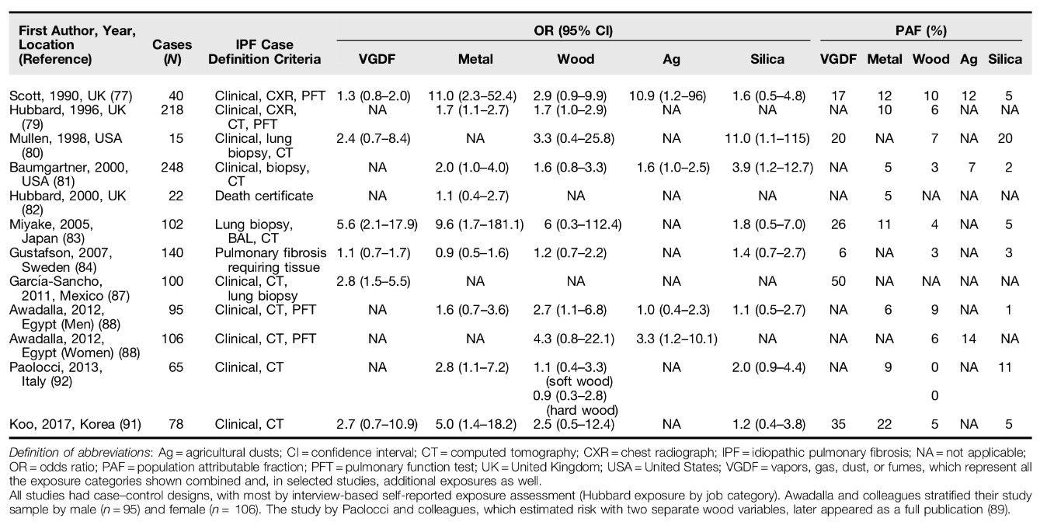

There was considerable heterogeneity in case-control studies of occupational exposure in IPF, for example, I2 95% for the six studies reporting general (vapors, gas, dust and fume) occupational respiratory exposures[26] and to a lesser extent for wood, metal, stone dust, and agricultural dust. See Figures 2.1-5. This may be due to real clinical differences in the populations studied or due to chance, publication bias, or methodological issues. To investigate possible publication bias I looked for funnel plot asymmetry using data from the ERS/ATS taskforce meta-analysis.[26] I found evidence of publication bias for VGDF, and metal dust (Egger’s test p 0.04) but not for wood dust (Egger’s test p 0.1) and not for agricultural dust (Egger’s test p 0.58).

Considering the possibility of methodological issues I tabulated study case and control definitions and exposure measures and assessed the risk of bias using RoB-SPEO[29], a tool for assessing risk of bias in studies estimating the prevalence of exposure to occupational risk factors. Seven[30][46][34][37][40][42][44] of the twelve case-control studies considered in the meta-analysis used population controls. One study[35] used a pension fund record to select cases and controls, one study used an orthopaedic practice list[33], and three studies used respiratory inpatients or a mix of respiratory inpatients and outpatients[36][41][44] Two studies did not match on age or sex[42][36] and one study matched on age only.[37]

Where participation rates were reported for community controls they were generally low, for example one study which mailed a questionnaire to potential participants had a response rate of 32.4% for controls.[33] In another study using a mailed questionnaire 60% of controls returned a completed questionnaire.[30] One study was a cohort study that made use of a company’s pension fund records and was only able to locate occupational records for 40% of cases and 38% of controls.[35]

Seven of the studies used only a questionnaire alone to measure occupational exposures.[30][33][36][37][41][42] Questionnaires reportedly asked directly about exposures of the format ‘‘In your work, have you ever been exposed to y?’’[37] but are unfortunately unpublished. Two studies reported blinding of assessors.[34][44] None of the studies were pre-registered.

Application of the Rob-SPEO tool[29] revealed that in general studies of occupational exposure in IPF to date are at high risk of selection bias due to low participation rates, recruitment from sources likely to be associated with exposures under study e.g respiratory inpatients, and lack of matching. It is recommended that Rob-SPEO tool is used by two independent assessors but this was unfortunately not possible within this work. The majority of studies also had a high risk of bias from exposure misclassification and/or incomplete exposure data through reliance on questionnaires that used yes/no questions for a limited number of specific exposures, bias due to lack of blinding, and possible bias due to differential reporting of exposures given that none of the studies appear to be pre-registered. See Tables 2.2 and 2.3.

### Table 2.2: Overview of occupational IPF studies

|  |  |  |  |  |
| --- | --- | --- | --- | --- |
| Author year | N1 | Case definition2 | Control definition | Exposure measure |
| Scott 1990 | 40 | clinical assessment, CXR, pulmonary function | matched on age and sex of cases using general practice register, ratio 1:4 | questionnaire |
| Hubbard 1996 | 218 | clinical assessment, CXR, CT, pulmonary function | matched on age and sex of cases using general practice register, ratio 1:4 | questionnaire and telephone interview |
| Mullen 1998 | 15 | clinical assessment, lung biopsy, CT | matched on age and sex of cases using orthopaedic practice list, ratio 1:6 | questionnaire |
| Baumgartner 2000 | 248 | clinical assessment, lung biopsy, BAL, CT | matched on age, sex, and geographic region of cases using random digit dialling, ratio 1:2 | telephone interview |
| Hubbard 20003 | 22 | death certificate diagnosis from pension fund records for Rolls Royce | random sample of deceased Roll Royce employees, ratio 1:10 | company records and job group |
| Miyake 2005 | 102 | clinical assessment, lung biopsy, BAL, CT | respiratory department inpatients at 21 participating hospitals, unmatched, 2:1 ratio | questionnaire |
| Gustafson 2007 | 140 | pulmonary fibrosis of unknown aetiology, requiring LTOT, identified from LTOT register | random age matched population sample | questionnaire |
| Garcia-Sancho 2011 | 100 | clinical assessment, CT, lung biopsy | matched on age, sex, and geographic region of using neighbourhood sampling ratio 1:1-3 | questionnaire |
| Awadalla 2012, men | 95 | clinical assessment, CT, pulmonary function, inpatients | matched on age, sex, respiratory inpatients 1:1 | questionnaire |
| Awadalla 2012, women | 106 | clinical assessment, CT, pulmonary function | matched on age, sex, respiratory inpatients 1:1 | questionnaire |
| Paolocci 2013, soft wood (abstract only)) | 65 | clinical assessment and CT | matched on area but not age or sex | questionnaire |
| Paolocci 2013, hard wood (abstract only) | n/a | clinical assessment and CT | matched on area but not age or sex | questionnaire |
| Koo 2017 | 78 | clinical assessment, CT, lung biopsy, recruited from inpatients and outpatients | matched on age, sex, and area, ratio 1:1, recruited from respiratory inpatients and outpatients | interview |

1 N of cases.

2 CXR is chest radiograph, CT is Computed Tomography scan of the thorax, LTOT is Long Term Oxygen Therapy, BAL is Bronchoalveolar lavage.

3 This is a cohort study. All other studies are case-control studies.

### Table 2.3: Rob-SPEO risk of bias scores for occupational IPF studies.

Rob-SPEO risk of bias scores for occupational IPF studies1

|  |  |  |  |  |  |  |  |  |
| --- | --- | --- | --- | --- | --- | --- | --- | --- |
| Author year | S | B | E | I | SR | C | D | O |
| Scott 1990 | 3 | 4 | 2 | 2 | 3 | 1 | 1 | 1 |
| Hubbard 1996 | 3 | 3 | 2 | 2 | 3 | 1 | 1 | 1 |
| Mullen 1998 | 3 | 3 | 2 | 2 | 3 | 1 | 1 | 4 |
| Baumgartner 2000 | 3 | 2 | 2 | 2 | 3 | 1 | 1 | 1 |
| Hubbard 2000 | 4 | 4 | 2 | 3 | 3 | 2 | 1 | 2 |
| Miyake 2005 | 4 | 4 | 2 | 3 | 3 | 1 | 1 | 1 |
| Gustafson 2007 | 4 | 4 | 2 | 3 | 3 | 1 | 1 | 1 |
| Garcia-Sancho 2011 | 3 | 3 | 2 | 3 | 3 | 1 | 1 | 1 |
| Awadalla 2012, men | 4 | 3 | 2 | 3 | 3 | 1 | 1 | 1 |
| Awadalla 2012, women | 4 | 3 | 2 | 3 | 3 | 1 | 1 | 1 |
| Paolocci 2013, soft wood (abstract only) | 4 | 3 | 2 | 3 | 3 | 1 | 1 | 1 |
| Paolocci 2013, hard wood (abstract only) | 4 | 3 | 2 | 3 | 3 | 1 | 1 | 1 |
| Koo 2017 | 4 | 1 | 2 | 2 | 3 | 1 | 1 | 1 |

1 Eight domains of bias were considered: SSelection, Bblinding, Eexposure misclassification, Iincomplete exposure data, SRSelective reporting of exposures, CConflict of interests, DDifferences in the numerator and denominator, OOther bias. Risk of bias was rated in each domain: 1low, 2prob low, 3prob high, 4high, 5no info.

I used 40 risk estimates from 12 publications (1326 IPF cases in total) to perform a meta-analysis.[30] [32] [33] [34] [35] [36] [37] [39] [40] [41] [42] [44] Three studies were not used, one because data was not collected on the proportion of cases with specific occupational exposures[31], one because of methodological differences in exposure assignment (exposure was assigned on the basis of industry worked in rather than job or self report[38], and one because it reported adjusted occupational risk estimates for pulmonary fibrosis rather than IPF[43] and overlapped significantly with an earlier study.[37] Each exposure category was assessed with 5-11 risk estimates (Table 2.4).

### Table 2.4: Pooled population attributable risk factors for occupation and idiopathic pulmonary fibrosis. (Blanc 2019)

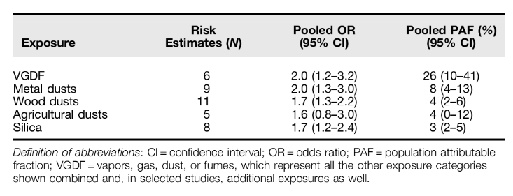

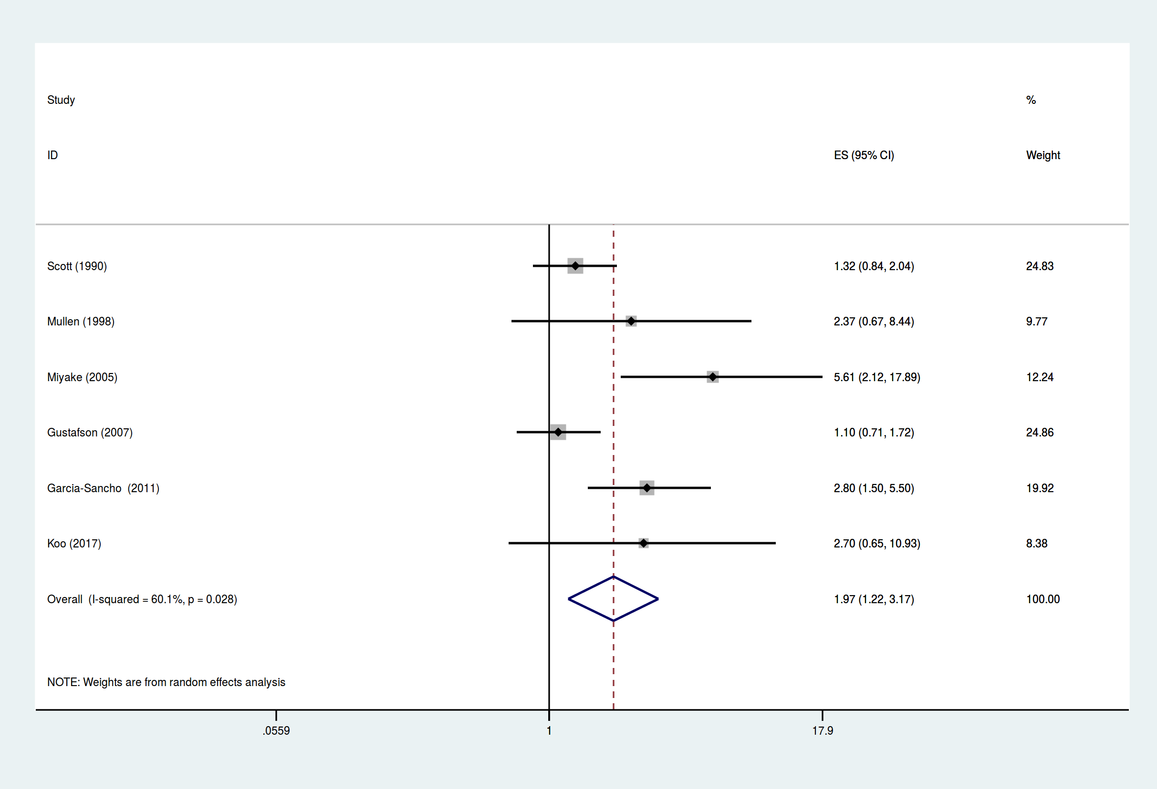

Forrest plot of pooled odds ratio data for occupational VGDF exposure and idiopathic pulmonary fibrosis.

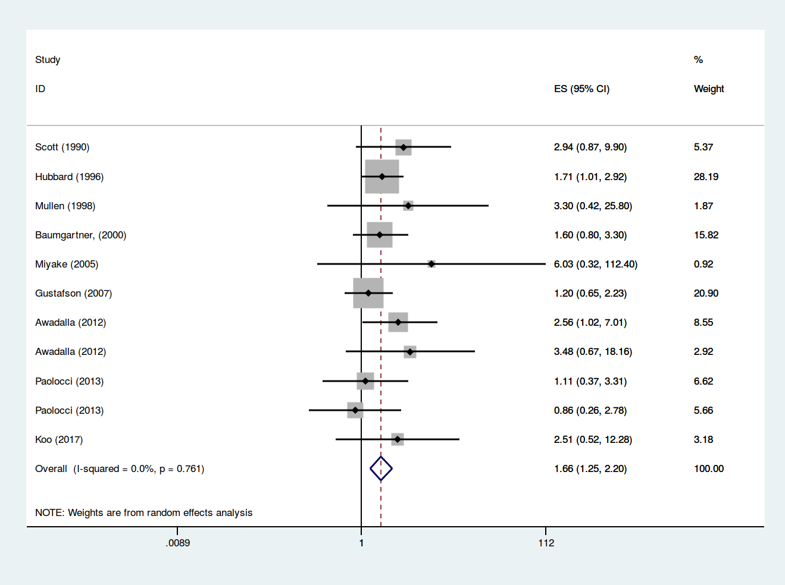

Forrest plot of pooled odds ratio data for occupational wood dust exposure and idiopathic pulmonary fibrosis.

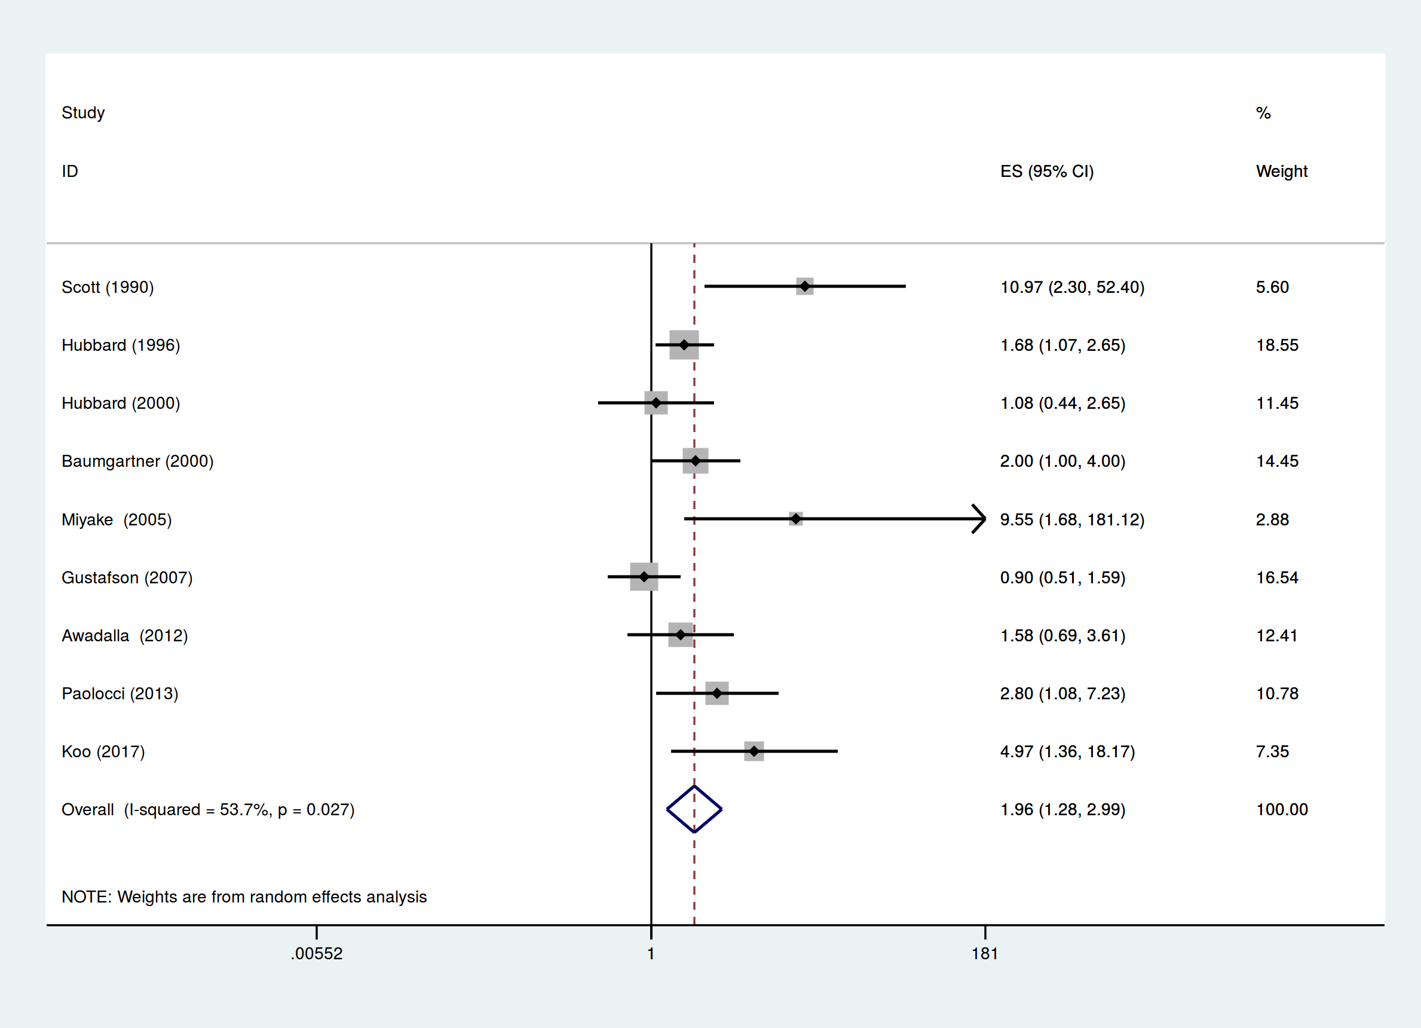

Forrest plot of pooled odds ratio data for occupational metal dust exposure and idiopathic pulmonary fibrosis.

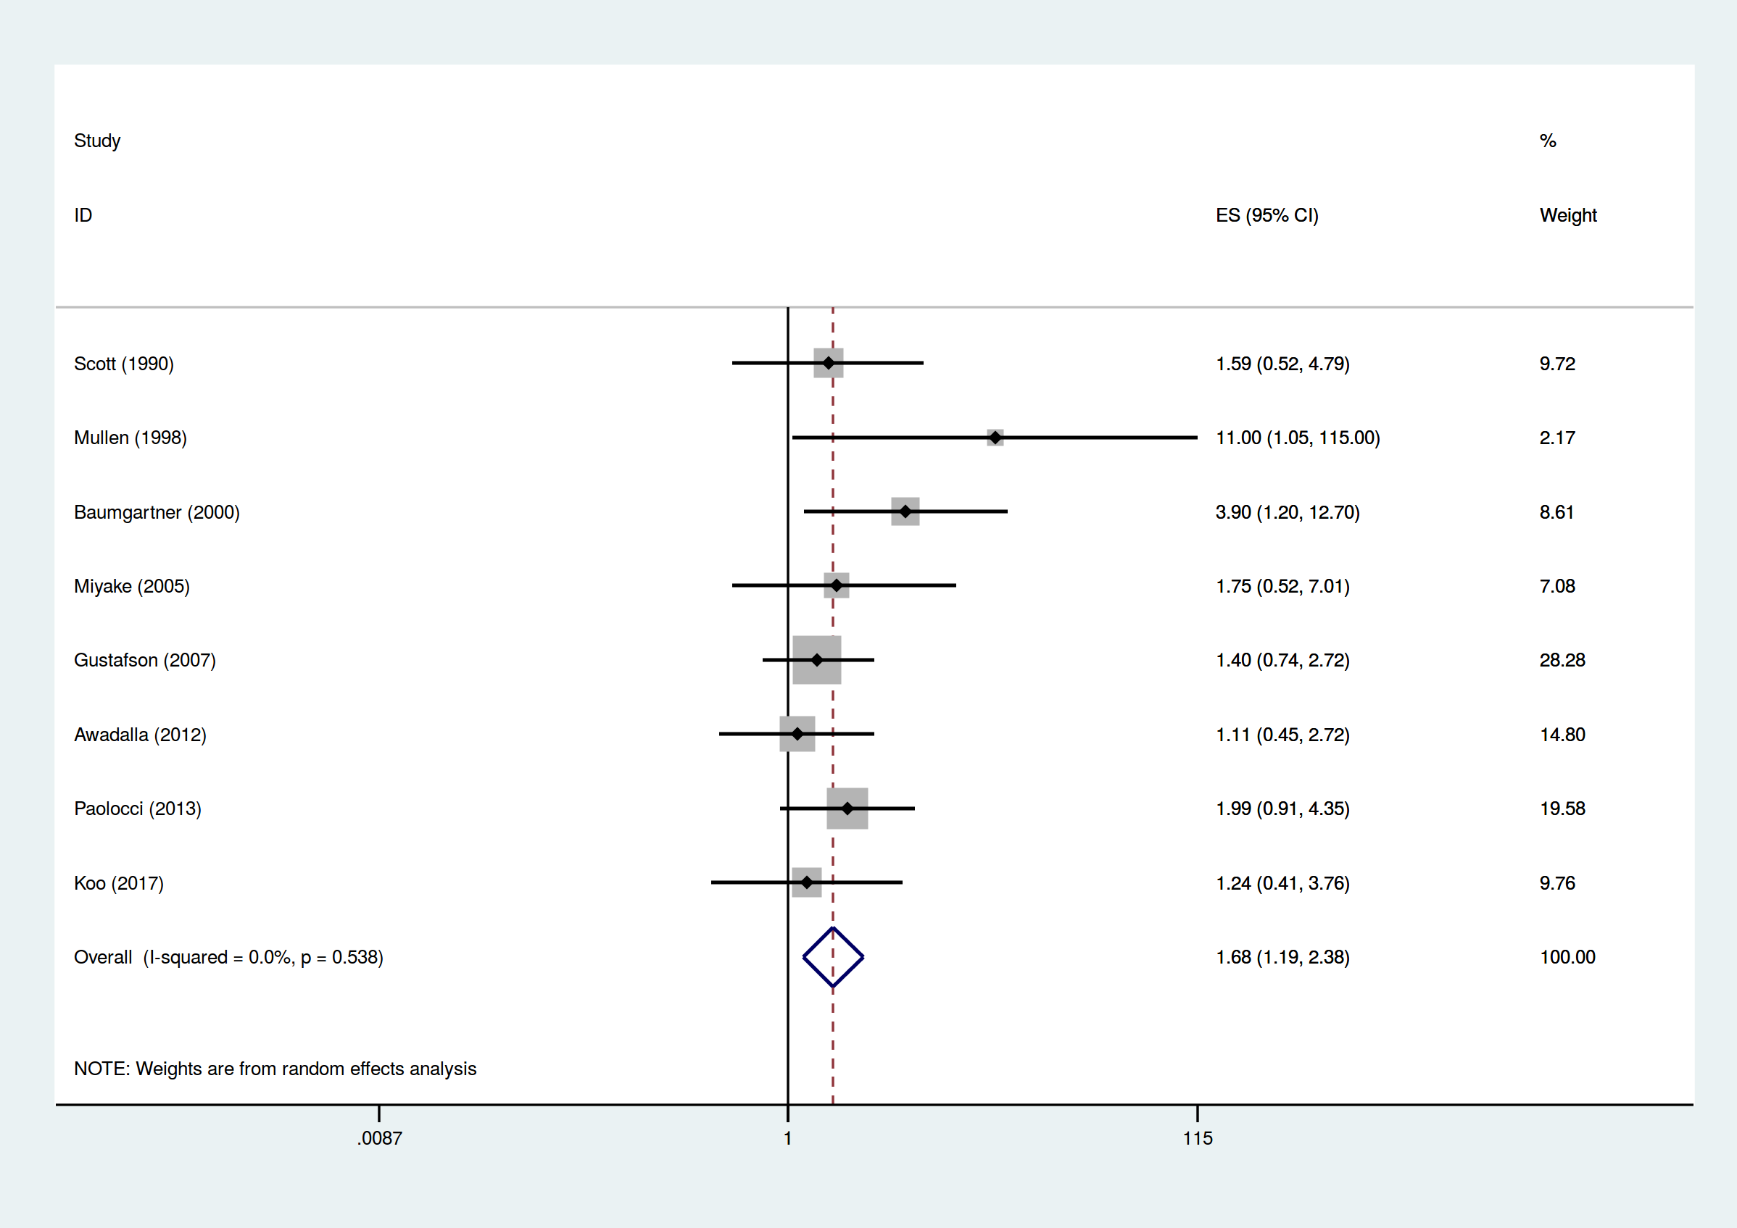

Forrest plot of pooled odds ratio data for occupational stone dust exposure and idiopathic pulmonary fibrosis.

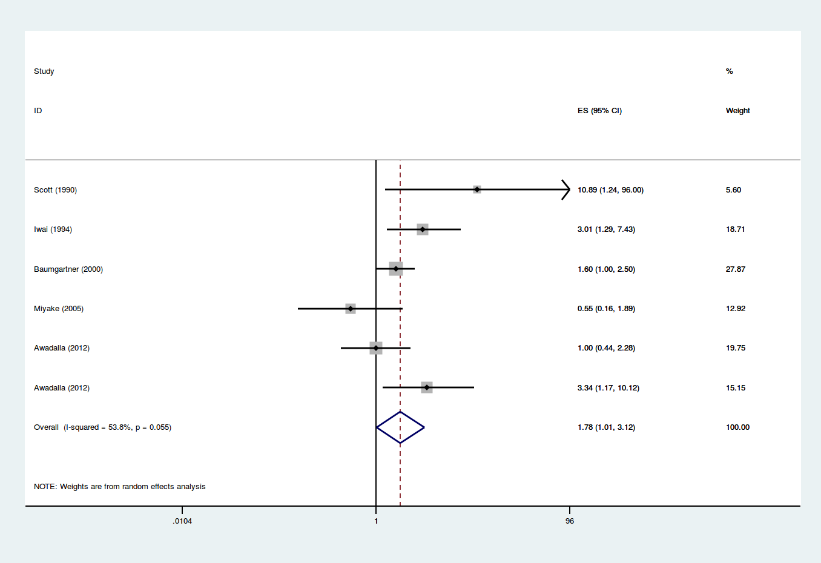

Forrest plot of pooled odds ratio data for occupational agricultural dust exposure and idiopathic pulmonary fibrosis.

## Discussion

My results support the case for a proportion of IPF cases being attributable to occupational exposures. Pooled ORs were significantly elevated for VGDF, metal dust, wood dust, agricultural dust, and silica dust; the pooled PAF estimates by category ranged from 4-23%. This is an important finding for an otherwise idiopathic disease which carries significant morbidity and mortality; identifying causal occupational agents could permit remediation and prevention.

Associations between IPF and wood, metal, and agricultural dust were previously reported in a meta-analysis of six case-control studies by Taskar and Coultas.[24] While my findings are similar I found a smaller effect size for agricultural exposure and a large effect size for non-specific vapors, gases, dust, and fumes (VGDF), see Table 2.4.

Funnel plot asymmetry using Egger’s test, which may be due to publication bias, was present for VGDF (p 0.04) and metal dust (p 0.03) but not for wood dust (p 0.09), silica dust (p 0.2), and agricultural dust (p 0.6). However, caution must be exercised in the interpretation of this since tests of funnel plot asymmetry are underpowered to distinguish chance from real asymmetry when fewer than 10 studies are being considered.[47]

There are several limitations to the meta-analysis that arise from the studies included. Application of the Rob-SPEO tool[29] showed that collectively these studies were at high risk for bias arising from selection, lack of blinding, exposure misclassification, incomplete exposure data, and selective reporting of exposures. Case definitions and sources for cases varied between studies. For example Scott (1990)[30] used a case definition which included a chest radiograph showing bilateral interstitial shadowing whereas most other studies relied on high resolution CT. Four studies used mortality data [31][38][37][35] to identify cases and one study[37] used a national register of patients receiving oxygen therapy. Differences in healthcare coverage and coding practices can result in selection bias in studies making use of mortality data.[48] Nearly all of the studies relied on self-reported exposures rather than life time occupational histories to assess exposure; an approach that is prone to recall bias, does not permit examination of dose-response relationships, and is vulnerable to confounding as a result of co-exposure. For example, several studies have described strong associations between metal work and IPF and specify sheet metal workers[31][30][35], a group who are frequently exposed to dust containing asbestos fibres[49] and who in a recent UK study, had the highest risk of mesothelioma.[50] Several studies used population controls, an approach which risks false positive findings as a result of selection bias. Response rates in case-control studies are known to be lower for more deprived groups. The strength of the response-rate deprivation association is different for population controls than for cases; more deprived population controls, who are more likely to be smokers and to have occupational exposures arising from manual work, are less likely to respond than cases.[51] By contrast, random error arising from exposure misclassification due to reliance on closed questions such as “In your work, have you ever been exposed to asbestos?” to assess exposure would tend to bias towards the null, and risk false-negative findings.

Seven of the IPF case-control studies considered in the meta-analysis did report on occupational asbestos exposure but found no significant association.[30][46][33][34][36][37][44] This may be due to the studies considered being underpowered, not having used sufficiently sensitive asbestos exposure measures, and the methodological shortcomings of study design outlined above.

## Conclusion

The observed excess risk could represent disease misclassification of pneumoconiosis or hypersensitivity pneumonitis, but this is unlikely to fully explain the observed effects. My analysis supports an aetiologic role for occupational exposures in IPF, potentially explaining up to 23% of the burden of disease and highlighting a role for workplace exposure reduction in disease prevention.

Confidence in the meta-analysis results is tempered by the observation that collectively studies investigating occupational exposures were at high risk for bias arising from selection, lack of blinding, exposure misclassification, incomplete exposure data, and selective reporting of exposures.

# Mortality analysis: do mortality trends support an occupational cause?

## Introduction

The incidence of Idiopathic Pulmonary Fibrosis (IPF) has been increasing at an average rate of 5% per annum for the period 1979 to 2016.[2] By definition, the diagnosis of IPF is not made in the presence of an identifiable cause. However, the distribution of the disease in the population (more common in men, manual workers, and those living in more industrial areas of the country) suggests a causal contribution from an occupational or environmental source.

I hypothesised that a proportion of IPF cases are due to occult environmental or occupational exposures to asbestos dust. This would be expected to result in a spatio-temporal association between IPF, mesothelioma, and asbestosis mortality patterns coinciding with asbestos exposure. It would also be expected to produce a birth cohort effect.

I examined regional trends in IPF, mesothelioma, and asbestosis mortality data for evidence of birth cohort effect and association.

## Method

I obtained regional age and sex stratified mortality data for IPF, mesothelioma, and asbestosis for England and Wales from the Office of National Statistics for the period 1974–2012. All statistical analyses were carried out using Python[52], SciPy[53], Statsmodels[54], and Stata (StataCorp. 2015. Stata Statistical Software: Release 14. College Station, TX: StataCorp LP). Data were age-standardised and birth cohort age-specific mortality rates were visualised. For regional analysis adjusted mortality rate ratios were calculated using a multivariate Poisson regression model of region, age and sex.

## Results

IPF, mesothelioma, and asbestosis mortality rates increased through the study period. IPF increased at a rate of approximately 5% per annum. The ratio of female to male deaths for IPF is approximately 1:1.6 and the highest adjusted mortality rate ratios (RR) were in the North West (RR = 1.3, 95%CI 1.26-1.35, p0.001), Wales (RR = 1.28, 95%CI 1.23-1.33, p0.001), and the North East of England (RR = 1.24, 95%CI 1.19-1.29, p0.001). IPF mortality does appear to correlate with mesothelioma mortality (Figure ). There is evidence of a cohort effect with age-specific IPF death rates increasing in successive cohorts, most clearly seen from age 60 (Figure ). While overall rates were higher for men but there were not marked sex differences in cohort mortality trends. There was not a clear pattern in regional mortality for IPF, mesothelioma, and asbestosis (Table 3.1).

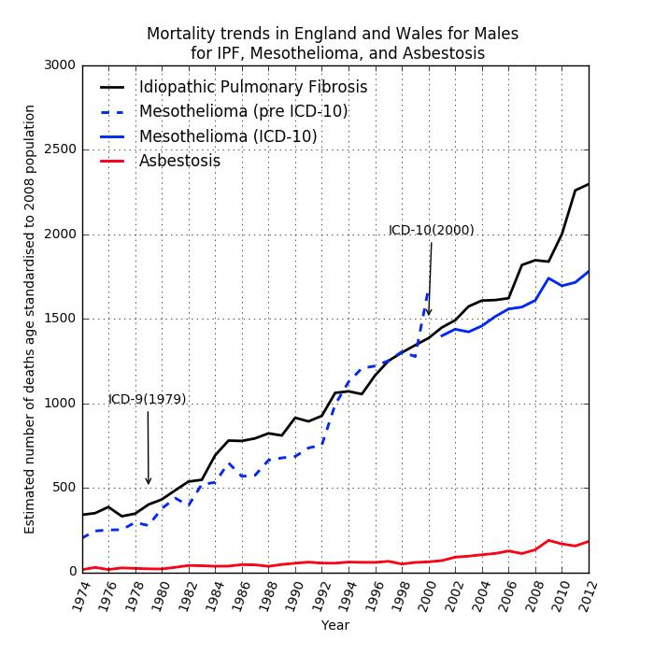

IPF, mesothelioma, and asbestosis mortality trends

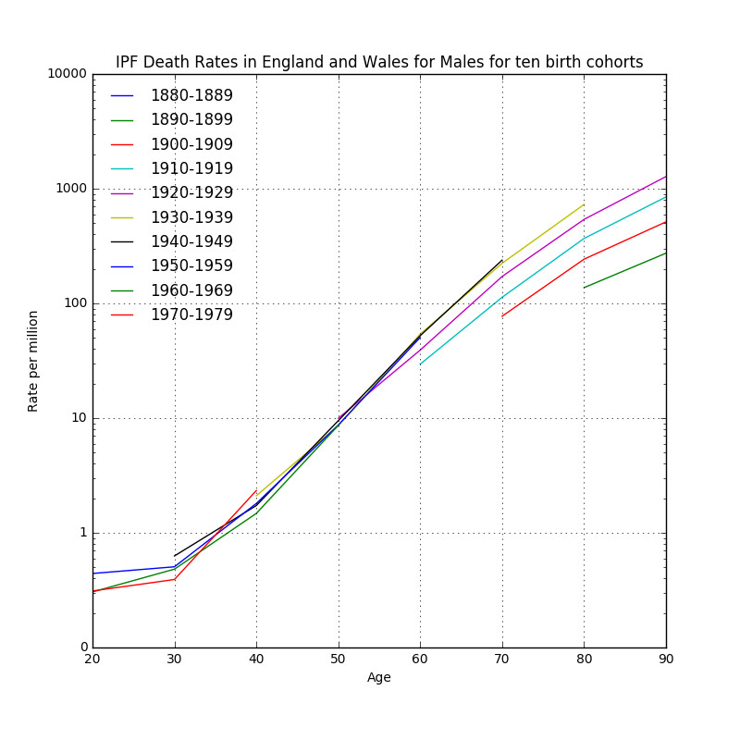

IPF male birth cohort age-specific mortality rates per million 1880-1979

### Table 3.1: Regional IPF, mesothelioma, and asbestosis mortality 1974-2012. Adjusted mortality rate ratios.

Regional IPF, mesothelioma, and asbestosis mortality 1974-2012. Adjusted mortality rate ratios from a multivariate Poisson regression model of region, age and sex. (95%CI)

|  |  |  |  |
| --- | --- | --- | --- |
| Region | IPF | mesothelioma | asbestosis |
| North West | 1.3(1.26-1.35) | 0.99(0.95-1.03) | 2.28(1.89-2.74) |
| Wales | 1.28(1.23-1.33) | 0.61(0.58-0.65) | 1.09(0.84-1.4) |
| North East | 1.24(1.19-1.29) | 1.71(1.64-1.79) | 5.7(4.74-6.86) |
| West Midlands | 1.2(1.16-1.24) | 0.76(0.73-0.8) | 1.19 (0.95-1.48) |
| East Midlands | 1.16(1.12-1.21) | 0.78(0.75-0.82) | 1.4 (1.12-1.74) |
| Yorkshire and the Humber | 1.11(1.07-1.15) | 1.1(1.06-1.15) | 1.62(1.32-1.98) |
| South West | 1.1(1.06-1.13) | 0.87(0.83-0.9) | 1.81(1.49-2.2) |
| London | 1.01(0.97-1.05) | 1(0.96-1.04) | 2.15(1.77-2.6) |
| South East | 0.9(0.87-0.93) | 0.95(0.92-1.31) | 1.31(1.09-1.59) |
| East | 1 | 1 | 1 |

## Discussion

I found evidence of a birth cohort effect whereby age specific-specific IPF death rates have increased in successive cohorts. This finding was replicated by Navaratnam et al [2] for a different range of data (1979 to 2016 rather than 1974-2012) and was similar to a recent mesothelioma birth cohort age adjusted mortality analysis.[55]

IPF adjusted mortality rates were higher for northern, more industrial, regions, which is not a new pattern. Within country geographic variation in IPF mortality, with higher rates in more industrial regions, has been observed in the United States[56] and United Kingdom.[57][1] It is unlikely to be explained by differences in physician behaviour or test availability in the United Kingdom in view of universal health care coverage and national guidelines for diagnosis. It may be explained by differences in regional rates of occupational dust exposure or smoking since these have been identified as risk factors for IPF.[30] [31] [32] [33] [34] [35] [36] [37] [38] [39] [40] [41] [42] [43][44] Indeed, heavy industry such as shipbuilding and steel manafacture in the United Kingdom is located in more northern areas where smoking rates are also higher.[58]

Mortality data for IPF have the advantage of capturing a sufficiently large number of deaths to permit analysis of trends over time with a reasonable degree of confidence. The accuracy of reports over time may have varied, this is a potential consequence of coding changes since prior to 2000, and the use of ICD-10, there was not a unique code for IPF and thus some ambiguity as to how it should be coded. However, a death certification validation study using an IPF cohort of 211 incident cases diagnosed in England and Wales between 2010 to 2012 found that of the 124 deaths occurring in the study period 83(67%) had IPF coded as the underlying cause of death and 102(82%) had it coded anywhere on the death certificate.[6] This is also true of asbestosis mortality, where by 2017 it was the underlying cause of death in less than half of cases it was recorded as a diagnosis on a death certificate (Figure 3.3). Therefore estimates of disease incidence based on mortality are likely to be conservative.

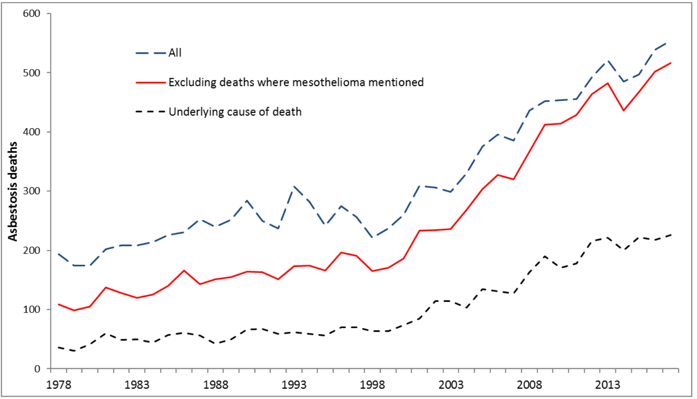

Annual asbestosis deaths 1978-2017. Asbestos-related disease statistics in Great Britain. (HSE 2019)

The close correlation between IPF and mesothelioma mortality in the UK has been observed by others[9] (Figure 3.4) who reported Pearson correlation coefficients of 0.98 (p0.001) for men and 0.97(p0.001) for women and noted that lagged historic asbestos imports also correlate strongly with IPF and mesothelioma mortality in the UK. Clearly this correlation does not prove causation and alternative explanations for the rise in IPF cases include increased recognition of cases[2] and overdiagnosis by radiologists as a result of misapplying CT criteria.[59]

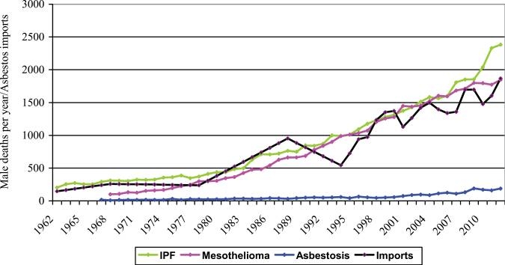

Annual male mortality due to IPF, mesothelioma and asbestosis in England and Wales. Historic annual UK asbestos imports (as hundreds of tonnes 48 years earlier) are shown for comparison (black line). (Barber 2016)

## Conclusion

There is an unexplained sustained increase in the incidence of IPF and a suggestive, if ecological, association with mesothelioma and lagged historic asbestos imports. There does appear to be a birth cohort effect whereby age specific rates are higher in later cohorts that would, for the data considered, be consistent with historic occupational asbestos exposure and a long latency between exposure and disease.

# Historic asbestos exposure assessment: can it be done?

## Introduction

Asbestos related respiratory disease is initiated by inhalation of asbestos fibres. In the UK clinically significant asbestos exposure is largely occupational and, as a result of asbestos control legislation, historic.

Occupational asbestos exposure can be assessed quantitatively by sampling ambient air at a workplace and calculating a fibre count using microscopy. Alternatively, because inhaled asbestos fibres persist in the lung, they can be sampled by lung biopsy, bronchoalveolar lavage, or at autopsy.

Historic workplace measurements are a valuable resource for assessing exposure but are limited in several ways. Measurements are not available for many occupations, and where measurements are available they are dependent on working practices and measurement techniques at the time of assessment; they do not necessarily generalize well.

Measurement of asbestos fibres in lung tissue by means of biopsy or bronchoalveolar lavage is invasive and both procedures carry the risk of serious complication including death. Additionally, the biopersistence of asbestos fibres is variable, the physical characteristics of inhaled fibres may be modified in-situ[60], counts are sensitive to techniques used, and establishing appropriate references ranges is challenging.[61]

Expert assessment and exposure modelling approaches integrate historic workplace measurements with simulated workplace measurements and an individual’s recollection of job processes he or she has carried out during their working life.[62]

Job-exposure matrices (JEMs) are widely used in occupational epidemiology studies to assess exposure to potential hazards. These assign levels of exposure to health hazards on the basis of job title. Industry specific asbestos JEMs have been developed, for example for workers in the gas and electricity industry[63] as well as population asbestos JEMs, for example for all Dutch workers.[64]

Finally, self-reported exposures are a subject’s direct report of what they have been exposed to; these are usually elicited by questionnaire or at interview.

The asbestos exposure assessment literature presents difficulties for review because it is large and recognised to be at risk of bias as a result of its economic importance to powerful industrial and medicolegal actors[65].

Here I critically review different means of historic asbestos exposure assessment and consider their clinical and research utility with a view to informing exposure measurement in the idiopathic pulmonary fibrosis job exposures study (IPFJES).

## Method

I searched Pubmed and Google Scholar for combinations and synonyms of “asbestos”, “exposure assessment”, together with terms for modes of assessment including “lung biopsy”, “bronchoalveolar lavage”, “exposure reconstruction”, and “job-exposure matrix”. When a relevant paper was identified, papers referenced, and papers citing, the paper were reviewed.

## Results

### Lung biopsy and bronchoalveolar lavage

The first report of fibrosis of the lung due to asbestos dust[66] included a description of the post mortem microscopic appearances of the lungs which showed abundant asbestos fibres in areas of fibrosis.

The demonstration of asbestos fibres, or asbestos bodies, on lung biopsy in the context of pulmonary fibrosis can, providing they are present in a quantity in excess of the chosen reference population, support the diagnosis of asbestosis. However, a failure to demonstrate fibres can not be used to rule out asbestos exposure because fibres, particularly chrysotile fibres, may be cleared from the lung and counting methods have a significant false-negative rate.[61] Despite this, recent 2014 Helsinki guidelines[67] and UK Royal College of Pathologists guidelines[68] are written such that they can be interpreted as implying that a clear history of substantial occupational asbestos exposure is insufficient for diagnosis and that the absence of asbestos bodies or fibre counts above a certain threshold may be used to rule out the diagnosis. The shortcomings of such an approach highlighted above are also described by responses to the Helsinki guideline.[69][70][71]

Lung biopsy, and to a lesser extent, bronchoalveolar lavage carry significant health risks, particularly for patients who already have compromised lung function and can not be justified solely on medico-legal grounds.[70] Therefore, the clinical utility of lung biopsy and bronchoalveolar lavage is limited to ruling in asbestosis when a suggestive exposure history and radiology are lacking.

In a research context lung biopsy and bronchoalveolar lavage have provided valuable population level insights. Lung biopsy asbestos fibre counts have been examined in a UK case-control study where mesothelioma cases were compared with lung cancer controls. Fibre counts were found to be higher in groups with greater occupational risk, as defined by occupational proportional mortality rates (PMR) for pleural mesothelioma, providing additional support for the pre-eminence of an occupational history.[50][72] In a follow up study asbestos fibre counts from unselected surgically treated pneumothorax patients were used to demonstrated that population amphibole burden is falling and is proportional to mesothelioma mortality.[73]

A similar correlation between fibre counts and history of occupational exposure, an overall downward trend in fibre counts, and a significant false negative rate has been observed in a recent Belgian study of patients undergoing bronchoscopy with bronchoalveolar lavage sampling for asbestos fibre quantification.[74]

### Historic workplace measurements

Occupational hygienists have recorded a large number of workplace measurements of asbestos in different settings, at different times, using a variety of different means. These measurements reside in national databases such as the HSE National Exposure Database[75], and EV@LUTIL[76], in the published literature, and in unpublished company records.

The use of different means of making workplace assessments results in difficulties with respect to the accuracy and comparability of measurements. For example, instruments that count particles rather than asbestos fibres have been used and there is no established conversion factor.[77] Phase contrast microscopy has also been used which is less sensitive that scanning electron microscopy, which is in turn less sensitive than transmission electron microscopy and energy-dispersive x-ray analysis.[78]

Where era and task specific workplace exposure data matching a particular patient’s occupational history is available and readily obtainable it is a valuable means of assessing exposure history. Unfortunately in practice measurements are usually limited to the subset of jobs thought to be potentially harmful “high” exposure jobs at the time of measurement. Awareness of the sources and harms of asbestos exposure has developed gradually with the consequence that data are skewed to more recent times.[79][80]

Measurements have found greater utility in a research setting where they can help to quantify risk and inform regulatory policy and compliance in specific workplace settings, for example, in car mechanics[81] or skilled craftsmen.[82]

### Exposure reconstruction

Sahmel et al[80] propose a seven-step framework (see Figure ) which they use to enumerate and critique exposure reconstruction approaches.

Reconstruction techniques may be quantitative, semi-quantitative, or qualitative. Quantitative exposure reconstruction bases exposure estimates on data from similar (historic or current) exposure scenarios or simulation studies. Semi-quantitative exposure reconstruction bases exposure estimates on exposure data matrices (using a job-exposure matrix) and/or exposure determinants (using an exposure model). Qualitative exposure reconstruction bases exposure estimates on the expert judgement of an industrial hygienist and self reported exposures.[80]

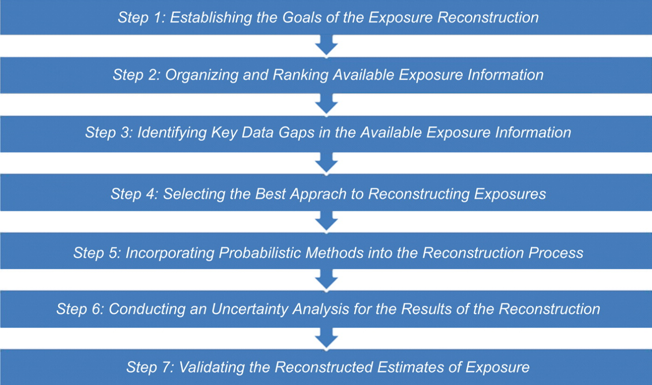

Seven step framework for exposure reconstruction. (Sahmel 2010)

#### Job-exposure matrices

Several job-exposure matrices that deal with asbestos have been reported. Pannett et al’s 1985 job-exposure matrix for use in population studies in England and Wales[83] found good agreement between job-title assigned categories of exposure (none, low, moderate, high) for asbestos and direct review of the original occupational history by an expert. However, according to co-author David Coggon (personal communication) it was based on the Registrar General’s classification of occupations from 1966 and would not be readily applicable in a contemporary study.

Rake et al[50] assigned categories risk of exposure (low, medium, high) using occupational mortality statistics for pleural mesothelioma. Because pleural mesothelioma in men is nearly entirely attributable to occupational asbestos exposure, is rapidly fatal, and UK death certificates record occupation in addition to cause of death, the proportional mortality ratio for pleural mesothelioma (standardised pleural mesothelioma mortality in a given occupation/standardised pleural mesothelioma mortality across all occupations) can serve as proxy for average asbestos exposure in a particular occupation. This approach has been validated in the same cohort by transmission electron microscopy asbestos fibre counts and it has been shown that pleural mesothelioma risk is approximately linearly related to asbestos lung burden.[72]

DOM-JEM[84] was developed for use in a population based multi-centre lung cancer case-control study conducted in seven European countries. It assigns job titles to one of three categories of asbestos exposure (no exposure, low exposure, high exposure) based on the consensus of three independent expert raters. DOM-JEM showed poor agreement with expert assessment ( = 0.17) but less heterogeneity across countries than a population based JEM and expert assessment. A study applying DOM-JEM to the Netherlands Cohort Study (NCS) showed poor agreement with expert assessment ( = 0.29).[85]

The Finish Information System on Occupational Exposure (FINJEM)[86] covers exposure to 84 different agents, including asbestos, for 311 jobs across 9 periods spanning 1945-2015. Era-specific estimates of the mean level of asbestos exposure are available for 27 jobs based on expert assessment and measurement data; the exact details of the grounds for estimates are kept in a proprietary FINJEM database which is sadly not freely available. FINJEM showed poor agreement with expert assessment of asbestos exposure ( = 0.23) but reasonable identification of mesothelioma risk when evaluated using the NCS.[85][87]

AsbJEM[88] was developed in Australia by an expert panel of three industrial hygienists using all available Australian asbestos exposure data. Its development was based on methods used in FINJEM and it provides quantitative estimates of annual exposure for 224 occupations across three time periods spanning 1943 to 2004. It also showed poor agreement with expert assessment of asbestos exposure ( = 0.10).[85]

SYN-JEM[89] describes a JEM developed for four carcinogens. It provides quantified asbestos exposure estimates based on 27958 personal measurements (spanning 1971-2009) from several European countries and Canada, a mixed effects statistical model, and *a priori* categorical assessment of exposure (none, low, high). Cherrie et al[90] point out that SYN-JEM provides little contrast in the modelled exposure level between categories as the geometric mean intensity for low jobs was 0.061 fibres/ml and for high jobs 0.074 fibres/ml and that there are wide variations in country-level estimates which are difficult to explain.

JEMS are generally taken to be superior to direct questions about exposures because they have greater validity and are less vulnerable to differential recall. This is because recall and coding of occupations is not influenced by disease status, and translation of codes into exposure is standardized. Therefore exposure assessment is safeguarded from potential bias arising from knowledge of the subject’s disease status.[91][92][93]

Orlowski et al[94] compared two JEMs with a structured job specific questionnaire (SQ) in a lung cancer case-control study. They found that agreement between the JEMs and the SQ was poor ( = 0.23 - 0.27) and suggested that the sources of error for JEMs were loss of information due to the use of job codes as surrogates for job task descriptions and the insufficiency of published data on occupational asbestos exposure.

JEMs are not routinely used in clinical practice because they are not usually available, or accessible, for specific patients. In a research setting they are frequently helpful though in addition to the strengths and weaknesses outlined above the desirability of reusing an existing JEM vs developing a study specific JEM must be considered. Reasons to develop a new study specific JEM might include the prohibitive cost of existing ones or poor applicability to the population being studied.

#### Exposure modelling approaches

Exposure modelling approaches modify existing measurement data on the basis of knowledge of the determinants of exposure. They may be viewed as the formalization of professional decision criteria used by hygienists in their assessment of workplace exposures.[79]

A common conceptual framework for this is the source-receptor model[95][79] whereby inhalation exposure is considered in terms of an exposure source, a pathway from source to receptor, and the receptor. The model is then used to propose modifying factors such as activity emission potential, substance emission potential, localized control, worker behaviour, surface contamination and respiratory protection.[95].

In the hands of some hygienists, assessment of historic asbestos exposure based on interview can correlate well with amphibole fibre counts.[96] By extension, exposure modelling approaches, using industrial hygienist methods, might be expected to be useful. Exposure modelling approaches make strong intuitive sense; it is known that there is significant within-worker and between-worker variability in occupational exposures[97] and, for example, room size and ventilation have been empirically shown to affect the concentration of airborne chemical exposures.[98] Further, mathematical exposure models that take account of known exposure modifying factors to estimate past exposures have shown a good correlation with measured values.[62]

A quantified, validated historic asbestos exposure model[90] has recently been developed and proposed as a means of for risk-stratifying asbestos exposed workers to optimize mesothelioma screening efforts. The approach has the advantage, compared with job-exposure matrices, of providing a more granular quantified exposure assessment, sensitive to the exposure circumstances of the individual. However, the approach is limited by the fact that the individual must recall their exposure circumstances which due to the latency of asbestos related disease may have occurred over 30 years ago. The approach is also limited by the relatively small number of industry-specific data points used for validation.

Exposure modelling approaches to assessing asbestos exposure have research and clinical utility notwithstanding the limitations outlined above together with the requirement that assessors be appropriately trained.

#### Self-reported exposure

Self-reported exposures are a subject’s direct report of what they have been exposed to. Typically this is elicited by asking about a specific exposure via questionnaire or interview. Differential recall of self-reported exposures according to disease status is a concern but few studies have found evidence of this and it appears to be less of an issue when prompted, rather than volunteered, responses about occupational exposures are used.[99]

Most studies comparing self-reported exposures to industrial hygiene measurements have found significant associations but with wide variation between studies in variance explained by the self-reports. This is not surprising given that it is known there is significant within-worker and between-worker variability in occupational exposures.[92][97]

Studies comparing self-reported exposures to expert assessment find highly variable levels of agreement ( = -0.05 - 0.94) with a median = 0.6. In two studies comparing self-reported exposures with JEMs, self-reported exposures were more sensitive but of similar or worse specificity.[92]

Self-reported exposures have been shown to be more accurate for easily sensed exposures such as solvents with a strong smell, dusts with larger particle sizes, and vibrations that can be felt. Providing a reference point, for example using well known machines from a workplace to gauge noise category also improves accuracy.[92] Clearly this is not possible in asbestos exposure assessment.

Self-reported exposures have clinical utility in that they can suggest or support consideration of an occupational cause for disease. Ideally such self-reports are combined with the clinicians knowledge of the likely occupational exposures given the occupational history and other available data to strengthen or weaken suspicion of an occupational diagnosis as appropriate. Similarly, they have utility in a research setting where they may augment other means of assessment.

## Discussion

The accuracy of historic asbestos exposure assessment, by any means, is limited by the paucity of occupational asbestos measurement data, measurement technique limitations, within and between worker exposure variability, and participant recall. There does not exist a universally agreed “gold standard” against which to evaluate methods. Accurate quantified assessment of historic exposure, where evidence is scarce, may be an impossible task.[100]

Nonetheless, clinically, historic asbestos exposure assessments must be made for attribution. Specifically, to inform whether the required threshold of asbestos exposure (as assessed by various means) has been crossed so it is possible to say that, for example, scarring of the lung with an usual interstitial pneumonia pattern in an individual patient is caused by asbestos exposure. This carries medicolegal in addition to scientific importance and has not been well established by any assessment method.

In the context of mesothelioma case-control studies, fibre-counts do at least provide an objective means of assessing historic asbestos exposure against which other means can be compared. It is encouraging that industrial hygienist assessment and assessment using job title and PMR correlates strongly with fibre counts.[93][72]

Further and more generally, it is encouraging that estimates from explicit asbestos exposure modelling systems such as Cherrie et al’s[90], show good correlation with measurement data.

For a UK research study aiming to measure historic asbestos exposure in older men like IPFJES a JEM based on occupational proportional mortal rates for pleural mesothelioma is particularly attractive because it has been well validated by lung fibre analysis of patients in mesothelioma case-control studies across a wide distribution of exposures.[50][72] Given that pleural mesothelioma is approximately linearly related to occupational asbestos exposure this provides a means of estimating historic exposure. It is also relatively easy to apply once a lifetime occupational history is obtained since the mapping of office for national statistics (ONS) standard occupational classification (SOC) codes to asbestos exposure risk categories[50] and the mapping of job titles to SOC codes are freely available. The major limitation that significant within job title asbestos exposure variation exists can be at least partly overcome by also measuring exposure using a validated source receptor model[90] for patients who recall exposure. The use of more than one exposure measure permits comparison of measures and, depending on their agreement, can serve to increase or decrease confidence in the approach taken.

## Conclusion

Quantitative estimates of historic occupational asbestos exposures will generally have high uncertainty. However, less precise measures, such as the relative difference in exposure among epidemiological groups can be quite certain even though the numerical estimates are only approximate. This is invaluable in studies examining aetiological hypothesis because it permits examination of dose-response through the use of ordinal categories.[79]

For a UK research study aiming to measure historic asbestos exposure in older men like IPFJES the combination of a validated asbestos job exposure matrix with a validated source receptor model is likely to provide the optimal means of exposure assessment.

# MUC5b + environmental insult = IPF?

## Introduction

### Mucus, Mucins, MUC5b: structure, function and evolutionary importance

Mucus is an essential part of the innate immune system, considered to be universal within most phyla of both aquatic and terrestrial metazoans. It plays a pivotal role in the prevention of disease by serving as an antimicrobial barrier, it also has physiological functions including allowing the exchange of oxygen, carbon dioxide, nutrient and metabolites, lubricating surfaces and reducing damage due to sheer, reducing dehydration of the epithelia and providing the polymeric matrix which enables ciliary-mucus particle transport.[101]

Mucus barriers are essential for the separation and protection of an organism from its external environment, and likely a prerequisite for the exclusion of bacteria from bodily tissues and evolution of gastrointestinal and respiratory tracts. The importance of mucus barriers is further underlined when one considers the energy investment continuous mucus production and release requires; for example, corals use mucus to trap particles and transport them towards their mouths and the reef-building coral Acropora acuminata is thought to dedicate up to 40% of its daily net carbon fixation (energy from photosynthesis) to this task alone.[101] Mucins are a key component of mucus, they are highly evolutionary conserved large glycoproteins that date back around 600 million years to Nematostella vectensis, the starlet sea anemone, which is an early marine invertebrate. The earliest human mucin analogue is found in Xenopus tropicalis, the African clawed frog, which evolved about 300 million years ago and mucins are the likely explanation for the observation that frogs show such great resistance to infection during dissection. It has been shown that knockdown of mucin in the skin mucus barrier of Xenopus tropicalis tadpoles leads to susceptibility to infection by the opportunistic pathogen Aeromonas hydrophila.[102]

The mucin family is composed of proteins that contain tandem repeat structures with a high proportion of prolines, threonines, and serines; the PTS domain. It is further defined by extensive glycosylation of the PTS domain through N-Acetylgalactosamine O-linkages at the threonine and serine residues.[103] The resultant oligosaccharide chains and polymeric structure create the viscoelastic properties of mucus which confer its barrier properties and play an important role in storage and secretion. [101] Mucins are 50-90% carbohydrate and they are anionic because most of their terminal sugars contain carboxyl or sulphate groups. Mucin glycan helps to sequester pathogen by acting as a ‘decoy’ and providing sites for microbial adhesins to bind; for example, human salivary MUC5b interacts with streptococcal species, and patterns of glycosylation change during inflammation.[104][105] Mucin barriers can be subverted by pathogens, strategies include production of enzymes to degrade mucin core proteins and mucin carbohydrates, and evolution of effective motility through mucus gels - many mucosal bacterial pathogens are flagellated for this reason. There is evidence that degradative enzymes are required for pathogenesis in species such as Vibrio cholerae and that flagella are required for infectivity in species such as Helicobacter pylori.[104] Intracellular gel-forming mucins are stored in a compact and condensed form in granules within mucus-secreting cells. They are stored in solution with a high concentration of calcium ions and protons which is thought to be necessary to mask the anionic charge and prevent electrostatic repulsion, upon secretion mucins expand 1000-3000 fold taking up water to form a gel as calcium is exchanged for sodium and the pH rises.[101] One consequence of mucins being stored in such a compact form is that when they’re released they can obstruct the airway which in mouse models appears necessary for the clearance of helminth infection[105] and may provide a clue to their evolution.

Normal human airway mucus is a hydrogel composed of approximately 98% water, 0.9% salt, 0.8% globular proteins, and 0.3% high-molecular-weight mucin polymers.[106] Mucin hypersecretion may increase the concentration of solids up to 15% resulting in viscoelastic mucus that is not easily cleared.[107] 17 genes encode mucins in the human genome of which the gene products of seven are secreted and the remainder are membrane bound. Five of the secreted mucins have terminal cysteine rich domains that can form disulfide bonds resulting in polymers that impart the properties of a gel. MUC5AC and MUC5B, two secreted gel-forming mucins, are strongly expressed in the human respiratory tract. MUC5AC is predominantly expressed in the conducting airways and MUC5B is predominantly expressed in the respiratory airways (MUC5b is also expressed in salivary glands, cervix, gallbladder, seminal fluid, and middle ear epithelium). Secreted mucins are large glycoproteins (up to 3106 D per monomer), ranking among the largest molecules encoded in mammalian genomes, and their expression induces and requires an endoplasmic reticulum stress response.[108] Mucin production and secretion are regulated by distinct mechanisms. Production is highly regulated at transcriptional level. The ErbB family of proteins contains four receptor tyrosine kinases, structurally related to the epidermal growth factor receptor (EGFR), its first discovered member. ErbB-receptor signaling appears important for MUC5AC production since inhibition blocks MUC5AC up-regulation by diverse stimuli. Interleukin-13 (IL-13) is a cytokine secreted by T helper type 2 (Th2) cells, natural killer T cell, mast cells, basophils, and eosinophils. IL-13 is a central regulator in IgE synthesis, goblet cell hyperplasia, mucus hypersecretion, airway hyperresponsiveness, fibrosis and chitinase up-regulation. It is a mediator of allergic inflammation and different diseases including asthma. IL-13 appears important because it increases MUC5AC expression (IL-1 appears to be an important stimulus for MUC5b expression[105]). Basal levels of production and secretion of MUC5AC and MUC5B change as part of an allergic response. The production of MUC5AC can increase 40-200 times as high as normal levels in humans with similar findings in mice, MUC5B increases more modestly, 3 to 10 times in mice. The most important stimulus for secretion appears to be ATP which acts on apical membrane purinergic (P2Y2) receptors. Once secreted mucus gel is propelled in a proximal direction towards the mouth, by ciliary beating as part of the mucociliary escalator, where it is expectorated or swallowed. [107]

### MUC5b rs3570950 and respiratory disease

Expression and localisation of MUC5AC and MUC5B is different in patients with lung disease compared with healthy controls. MUC5AC expression is increased in asthma for example, while MUC5B expression is increased in COPD[109] and IPF. In COPD MUC5b expression occurs in more proximal airways, whereas in IPF it is localised to the bronchiole.[110] MUC5b appears to be particularly important in IPF.

The gain of function promoter variant rs5270590, 3.5 kb upstream of the mucin 5b (MUC5B) transcriptional start site, is the strongest identified risk factor (genetic or otherwise) for the development of either sporadic or familial IPF. The largest study to date (1616 non-Hispanic white patients with fibrotic interstitial pneumonias and 4683 controls) estimated that the odds of developing pulmonary fibrosis for those with one copy of the risk allele were 4.5 times (95% CI: 3.9, 5.2) the odds of those with no copies and that the odds for those with two copies are 20.2 times those with no copies (95% CI: 15.2–27.0).[111] The strength of association is substantially higher than for most other common risk variants for complex disease with the exception of the human leukocyte antigen (HLA) region for some autoimmune diseases such as type-1 diabetes mellitus and systemic lupus erythematosus which have OR greater than 10. The association between the minor allele of rs35705950 and IPF has been replicated in 3 genome wide association studies (GWAS) and a total of 10 independent cohorts including a Mexican cohort and two Asian cohorts and is thought to account for about a third of IPF cases.[17] However, penetrance is low with up to 20% of non-Hispanic whites having at least one copy of the variant yet IPF occurring only rarely (prevalence 1%) . The rs35705950 variant is a G-to-T transversion that occurs in an area of the MUC5B 5’ flanking region, a region which has characteristics of being an enhancer subject to epigenetic control via DNA methylation and histone modification.[110] An enhancer is a sequence of DNA that functions to enhance transcription. A promoter is a sequence of DNA that initiates the process of transcription. A promoter has to be close to the gene that is being transcribed while an enhancer does not need to be close to the gene of interest. Publicly available data from the Encyclopedia of DNA Elements (ENCODE) suggest that the MUC5b promoter site is a complex area of the genome with many transcriptional factors showing evidence of binding.[112] In other words MUC5b expression is likely a function of genetic and non-genetic factors.[17] In addition to IPF, rs35705950 has been found to be positively associated with interstitial lung abnormalities (ILA), chronic hypersensitivity pneumonitis (CHP), asbestosis, rheumatoid arthritis associated interstitial lung disease (RA-ILD), and myeloperoxidase-antineutrophil cytoplasmic antibody-associated vasculitis associated interstitial lung disease (AAV-ILD).[113][18] It has also been found to not be associated with cutaneous systemic sclerosis interstitial lung disease (SSc-ILD), sarcoidosis, and myositis-ILD. [114]

### Potential role of rs5270590 variant in IPF pathogenesis

The rs5270590 variant is associated with a 34 fold increase in expression of MUC5b compared with wild type in healthy control populations and a 5 fold increase in patients with IPF (see figure 5.1).[17] In IPF patients distal airway MUC5b is expressed preferentially, compared with MUC5Ac. MUC5b is also expressed in honeycomb cysts, a defining characteristic of the usual interstitial pneumonia CT pattern typically seen in IPF.[16]

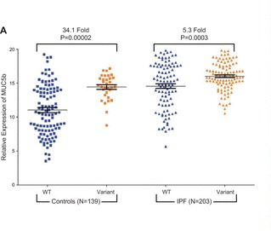

MUC5b expression (Evans 2016)

Proposed mechanisms for the role of the rs5270590 variant in the pathogenesis of IPF include:

1. Excessive production of MUC5B by stem cells that attempt to regenerate injured bronchiolar and alveolar epithelium could disrupt normal development pathways and highjack normal reparative mechanisms of the distal lung resulting in fibroproliferation and honeycomb cyst formation.
2. Excessive MUC5B production leading to reduced mucociliary function, retention of particles, and enhanced lung injury.
3. Interaction between MUC5b and motile cilia since distinct cilium gene expression in IPF lung has been observed.
4. Excessive MUC5b production inducing endoplasmic reticulum stress and the unfolded protein response.[17]

Muc5b has been studied in mice. A muc5b knockout mouse study found that muc5b is essential for mucociliary clearance, for controlling airway and middle ear infections, and maintaining immune homeostasis in the lungs. Knockout mice had airflow limitation and died from infection by multiple bacterial species, including Staphylococcus aureus.[115] A transgenic muc5b mouse model of muc5b overexpression found that overexpression causes mucociliary dysfunction and enhances lung fibrosis in response to bleomycin.[116] Intriguingly, in recent bleomycin lung fibrosis model studies lung fibrosis was attenuated and mortality reduced in both germ-free mice and IL-17B deficient mice supporting the concept that fibrosis in response to epithelial injury is mediated by interaction of the immune system with microbiota.[117][118]

### Infection and immunity

The frequency of the disease associated allele at rs35705950 exceeds 10% in European populations[119] but is less than 1% in African and East Asian populations. Clearly the rs35705950 variant is not subject to negative selection due to IPF risk since onset is well after the reproductive age begins[17]; the variation in frequency observed is consistent with strong positive selection. The increased MUC5b expression in the airways associated with the rs35705950 variant may have conferred a survival advantage by providing protection against lung infection. [108][105] A relation between the rs35705950 variant, disease risk, and infection is also supported by the observation that in a prospective study of 65 IPF patients and 44 COPD and healthy controls, IPF patients had higher bacterial loads than COPD and healthy controls and within IPF patients those that were homozygous (TT) for the variant had significantly lower bacterial loads (p0.01), measured by 16S rRNA quantitative polymerase chain reaction of bronchoalveolar lavage samples. Within IPF those with higher bacterial loads were also at increased risk of death.[120] These finding are consistent with the observation that the rs35705950 variant is associated with improved survival in IPF.[121] In the COPDGene cohort there were fewer acute respiratory disease events in ever-smokers who had interstitial features on and the variant compared with ever-smokers who had interstitial feature alone.[122] However, these studies are vulnerable to index event bias, by which selection of subjects according to disease status creates biased associations if common causes of incidence and prognosis are not properly accounted for.[123] For example, it is known that the rs35705950 variant is associated with interstitial lung abnormalities.[124] Since the diagnosis of IPF relies heavily on radiological appearances individuals with the variant might tend to be diagnosed earlier in the course of their disease giving the false impression, when comparing them to IPF patients without the disease variant, that the variant is associated with improved survival. Further support for the importance of infection in IPF provided by the observation that immunomodulatory therapies such as interferon gamma, etanercept, prednisolone, azathioprine and N-acetylcysteine have failed to prolong survival in IPF[125] to prolong survival in IPF, from a small (N = 181) double blinded randomized controlled study which found reduced symptom burden and improved survival associated with cotrimoxazole[126], as well as evidence from genetic and animal studies. IPF GWAS have identified single nucleotide variants associated with disease susceptibility in the Toll interacting protein (TOLLIP) gene, for example rs111521887. TOLLIP is an inhibitory adapter protein within Toll-like receptors (TLR) and part of the innate immune system recognising pathogen associated molecular patterns (PAMPs)[127] and, intriguingly, in a mouse bleomycin lung fibrosis model the absence of a microbiome protected against mortality.[117]

### Inorganic occupational stimuli

While the disease associated allele at rs35705950 exceeds 10% in European populations[119] its penetrance is low; the median prevalence of IPF for men and women in Europe is approximately 3.75 per 100000 for the period 2001-2013[128], which suggests other genetic or environmental factors must be at play. In addition to responding to PAMPs as outlined above the innate immune system also responds to damage-associated molecular patterns (DAMPs) which can result from inhalation of inorganic respirable toxins such as silica or asbestos. Silica and asbestos are specifically sensed by the NLRP3 inflammasome which, when activated, results in increased IL-1 secretion.[19] Secretion of the inflammatory cytokine IL-1 (which is also a key stimulus for MUC5b expression) is elevated in alveolar macrophages of patients with ILD, including IPF, silicosis, RA-ILD, and asbestosis.[129][130] It is also increased in a dose-dependent fashion in response to smoking.[131] Inflammasomes are multiprotein intracellular complexes that detect pathogenic microorganisms (PAMPs) and sterile stressors (DAMPs). The NLRP3 (NOD-, LRR- and pyrin domain-containing protein 3) inflammasome is an intracellular sensor that detects a broad range of PAMPs and DAMPs leading to caspase 1-dependent release of the pro-inflammatory cytokines IL-1 and IL-18, as well as to gasdermin D-mediated pyroptotic cell death.[132] Interestingly the NLRP3 inflammasome appears to be implicated, albeit with differing activation patterns[133], in all of these conditions (IPF, silicosis, RA-ILD) and interaction between smoking (a risk factor for IPF) and the NLRP3 inflammasome is recognised.[134][135] Recent mouse work has shown age-dependent NLRP3 mediated susceptibility to pulmonary fibrosis in a bleomycin-induced lung injury mouse model which may have parallels with the long-latency response to occupational dust exposure seen in man.[136] Occupational risk factors such as metal, wood, and stone dust exposure are well recognised in IPF, accounting for up to 8% of cases the basis of a meta-analysis of case-control data[26] and it’s likely that innate immune system activation via the NLRP3 inflammasome and other means by occupational exposures mediates this risk.

## Conclusion

The apparently complex interplay between exposure to organic and inorganic respiratory toxins, the mucus barrier, respiratory epithelium and resident cells such as alveolar macrophages in idiopathic pulmonary fibrosis remains incompletely characterised but genetic, epigenetic, gene-expression, and epidemiological studies are beginning to fill in the gaps. Gene-environment interaction between the rs5270590 variant and occupational inorganic respiratory toxins such as asbestos may modulate IPF risk and help to explain the incomplete penetrance observed. Studies to date which have selected patients on the basis of a diagnosis of IPF and then stratified by MUC5b genotype are at risk of index-event bias. A large case-control study of IPF which captures details of occupational exposures, genotype, and potential confounders, whilst also measuring factors likely to affect disease pickup such as disease severity and radiographic changes is required.

# Idiopathic pulmonary fibrosis job exposures study (IPFJES): Is occupational asbestos exposure an under-recognised cause of IPF?

## Introduction

Occult occupational asbestos exposure as a cause for otherwise ‘idiopathic’ pulmonary fibrosis has been an open question for at least 30 years. It arises because of the clinical and radiological similarities of asbestosis and IPF; a usual interstitial pneumonia is observed in both, and patients can present in the same way (chapters 1 and 8). Patients having significant asbestos exposure, that would warrant a diagnosis of asbestosis, may go undetected because they do not recall exposure or because where they do recall exposure it is difficult to assess if it has been sufficient to have caused disease (chapters 4 and 8). A recent meta-analysis of IPF case control studies reporting on occupational exposures found significant associations between metal, wood, and stone dust, and IPF (chapter 2). However, the extent of confounding among groups of workers likely to have significant asbestos co-exposure, for example metal sheet workers and carpenters, is unknown. The majority of these studies are limited by their reliance on self-reported binary exposure which risks recall bias and does not permit investigation of dose-response relationships which would be helpful for establishing causality. Studies to date have also not looked at the possibility of gene-environment interaction; genetic risk factors such as rs5270590 are now well established and interaction with inhaled exposures is suspected but has not yet been proven in humans (chapter 5). The question of asbestos exposure in IPF is a live one globally because countries such as Brazil, Russia, India, and China continue to consume large quantities of asbestos and, closer to home, asbestos related and IPF mortality rates continue to rise. While asbestos related mortality in the UK is driven primarily by pleural mesothelioma and is expected to peak in the next couple of years as a result of effective asbestos exposure control legislation, the sustained rise in IPF mortality rates is unexplained (chapter 3).

## Overview

IPFJES is a multi-centre, hospital-outpatient, incident case-control study conceived to address the question of asbestos exposure having a causal role in IPF. Participants were recruited from a network of 21 hospitals across England, Scotland, and Wales. ‘Cases’ were men who presented with a new MDT-confirmed diagnosis of IPF consistent with standard criteria.[137] Controls were men who attended randomly selected outpatient clinics in the same time period. Over 460 cases and 460 controls, frequency-matched on age, were recruited to achieve a predefined recruitment target of 920 participants. Participants were interviewed by telephone using a bespoke study web application (ipfjes-interview, full source code available, see Appendix 4). Lifetime occupational history, smoking history, drug history, family history, and modified Medical Research Council (mMRC) dyspnoea score were recorded. Each occupation was coded on the basis of the Office for National Statistics (ONS) standardised occupational classification 1990 (SOC90) at the time of the interview. For participants who recalled carrying out tasks with asbestos a detailed assessment of each work task was recorded. SOC90 coded jobs were used to assign asbestos exposure risk to participants using occupational proportional mortality rates for malignant pleural mesothelioma. A fibre-ml.year estimate was calculated for participants recalling asbestos exposure. All participants provided an EDTA venous blood sample from which DNA was extracted and genotyped according to known IPF susceptibility SNP rs35705950 using Q-PCR and a Taqman assay. Unconditional logistic regression was used to analyse ‘any’ vs ‘no’ asbestos exposure and categories of cumulative exposure adjusting for age and smoking status. In a secondary analysis I used unconditional logistic regression to investigate metal, wood, and stone dust exposure (self-reported occupational exposure), and rs35705950 genotype-exposure interactions.

## Method

### Funding, approvals, and registration

I obtained funding from the Wellcome Trust (201291/Z/16/Z) and NHS ethical approval (IRAS project ID 203355, REC reference 17/EM/0021). I also obtained NIHR portfolio status (CPMS ID 203355) and registered the study on clinicaltrials.gov (NCT03211507). See Appendix 1 for study protocol, full study documentation is available online at www.ipfjes.org.

### Selection

Initially 15 hospitals were invited to collaborate as recruiting centres for IPFJES. Centres were selected on the basis of us having a known contact there, the centre having an IPF MDT, geographic dispersion, and confirmation that the centre could recruit 40 cases and 40 controls over two years. Six additional centres were added to ensure the study wide recruitment target was achieved when it became apparent that only seven of the original 15 recruiting centres would meet their agreed target.

Cases were men of any age who were first diagnosed with IPF at the 21 collaborating hospitals across England, Scotland, and Wales between 01/02/2017 and 01/10/2019. The diagnosis of IPF by the referring centres was made at MDT on the basis of clinical history, high-resolution computed-tomography (HRCT), and where necessary lung biopsy in accordance with standard criteria.[137] Referring centres provided HRCT report findings for all cases and histopathology report findings for cases where a biopsy was performed.

At each collaborating hospital an outpatient clinic was randomly selected from a list of all outpatient clinics (not confined to respiratory) to serve as source clinic for the recruitment of controls. If the clinic selected was unsuitable (defined as it not having been possible to recruit four controls over the course of four clinic visits), for example because it did not contain enough men of a similar age to cases then this was recorded and a further random selection made. Controls were men who attended the selected outpatient clinics between 01/02/2017 and 01/10/2019. They were frequency-matched on age to five year age brackets, or where this was not possible ten year age brackets, and recruited in a 1:1 ratio to cases to achieve a predefined recruitment target of 920 participants.

Men who were unable to give informed consent or who had worked outside of the UK for one year or more (not including work as a member of the armed forces or merchant navy) were excluded from the study. Cases and controls were approached by local research teams and provided with the IPFJES participant information sheet. Participants were given the opportunity to read it and ask questions and then invited to sign the consent form and provide their contact details and a blood sample if they wished to take part. Local researchers completed a case report form detailing participant demographic information, CT and biopsy results, and contact details which were sent together with the blood sample by secure post to the central research team.

Collaborating hospitals were provided with screening logs and asked to report monthly the number of eligible participants identified, approached, and recruited.

### Measures

A trained interviewer (RS or CR) who was blind to the case status of participants undertook the study interviews by telephone; interviews were recorded for quality control purposes. The interviewer used a bespoke web application, called ipfjes-interview, to administer a structured interview collecting information on lifetime occupational history, smoking history, drug history, family history of scarring lung disease, mMRC dyspnoea score, comorbidities, and presenting symptoms. For each job, information was collected on the job title, job tasks, employer, start and stop year of employment, and whether employment was full-time (>=35 hour per week) or part time. Smoking history was recorded as start and stop year of smoking, number of cigarettes (or equivalent using https://www.smokingpackyears.com/) per day, and what was smoked - cigarettes/roll-ups/pipe/other. Participants were asked about prior exposure to nine drugs suspected of causing usual interstitial pneumonia (amiodarone, azathioprine, bleomycin, flecainide, gefitinib, ifosfamide, melphalan, and nitrofurantoin).[138] Using the job title and ipfjes-interview each occupation was coded in real time to the Office for National Statistics (ONS) standardised occupational classification 1990 (SOC90).

SOC90 coded jobs were used to assign asbestos exposure risk to participants using occupational proportional mortality rates for malignant pleural mesothelioma.[51] Five main categories were used (See also Figure 6.31):

1. High-risk non-construction
2. High-risk construction
3. Medium risk industrial
4. Low risk industrial
5. Office

For analysis of categories of exposure participants were assigned to the highest risk category they ever had a job in.

For participants who recalled carrying out work with asbestos a detailed assessment of each work task was recorded. An asbestos exposure (AE) estimate was calculated using a source-receptor model[62][90] as follows:

with parameters for the type of asbestos used (substance emission potential, E), what was done with it (activity emission potential, H), and whether there were any local exposure controls, for example wetting (local controls, LC).

AE for each task was then weighted according to the total amount of time spent performing the task and how well ventilated the room the activity was carried out in was (general ventilation parameters, D), to arrive at a task fibre-ml.year exposure estimate.

fibre-ml.years (job task) = AE * task duration * (task frequency / periodicity) * job duration * D

Task fibre-ml.year exposure estimates were then summed at an individual participant level to provide an overall fibre-ml.year estimate. A random sample of five high (top 25% of values), five medium (25-75% centile), and five low (bottom 25% of values) estimates (N=15) were independently assessed by a hygiene assessment expert who was blind to participant case status. The independent assessments tended to be lower than study assessments but there was overall acceptable agreement between assessments assessed using the Bland-Altman method.[62][90]

SOC90 coded jobs were also used to assign National Statistics Socio-Economic analytic classes (NS-SEC). The Office of National Statistics provides a lookup to assign each SOC90 code to one of eight classes:

1. Higher managerial, administrative and professional occupations. 1.1 Large employers and higher managerial and administrative occupations. 1.2 Higher professional occupations.
2. Lower managerial, administrative and professional occupations
3. Intermediate occupations
4. Small employers and own account workers
5. Lower supervisory and technical occupations
6. Semi-routine occupations
7. Routine occupations
8. Never worked and long-term unemployed

We then assigned each individual to a single code by calculating the median code for all of the jobs they had held (see Table 6.31).

Participants were classified as occupationally exposed to stone, wood, and metal dust or not (binary measure) on the basis of the recorded participant provided description of tasks carried out within a job including the words ‘stone’ (or ‘silica’), ‘wood’, or ‘metal’, respectively.

All participants provided an EDTA sample from which DNA was extracted and genotyped according to IPF known susceptibility SNP rs35705950. DNA was extracted using a nucleon dna extraction kit. Genotypes of the MUC5B SNP rs35705950 were determined using TaqMan assays (Life Technologies, Carlsbad, CA). Reactions were performed in 96-well plates, and fluorescence was read using an Applied Biosystems Viia7 Sequence Detection System. See appendix 1 (or ipfjes.org) for full study protocol including standard operating procedures.

### Statistical analysis

Statistical analyses were carried out using Python[52], SciPy[53], Statsmodels[54], and Stata (StataCorp. 2015. Stata Statistical Software: Release 14. College Station, TX: StataCorp LP).

For the primary analysis unconditional logistic regression was used to analyse any vs no asbestos exposure and categories of cumulative exposure adjusting for age and smoking status as part of a prespecified analysis plan (clinicaltrials.gov NCT03211507). Prior data indicated that the probability of exposure among controls is 0.63. If the true OR for disease in exposed subjects relative to unexposed subjects is 1.5, I calculated I would need to recruit 460 case patients and 460 control patients to be able to reject the null hypothesis that this odds ratio equals 1 with = 0.2 and = 0.05; my planned sample size included a margin for model stability and incomplete data. In a planned secondary (exploratory) analysis I investigated gene-environment interaction. The global minor allele frequency of MUC5B rs35705950 is 0.05. With an estimated prevalence of IPF of 20/100000 and with ORs 1.5 for asbestos exposure and 6.8 for rs35705950, 460 cases would be required to detect a minimum interaction OR of 5.0.

In an unplanned secondary analysis I used logistic regression to investigate metal, wood, and stone dust exposure (self-reported occupational exposure), and rs35705950 genotype-exposure interactions. Sensitivity analysis of distance to centre was also performed because I expected cases to live further away from the hospital that controls on average (as IPF care is centralised to a select number of specialist centres) and I hypothesised that distance from the hospital might be associated with likelihood of exposure to asbestos. I used Pearson’s correlation coefficient to investigate associations between individual variables, such as distance from hospital and fibre-ml.year asbestos exposure estimates. I used ordinal logistic regression to investigate the relationship between mMRC dyspnoea score and measures of asbestos exposure.

In the course of this work I learned that the minor allele of rs35705950 was associated with asbestosis[18], that smoking and asbestos exposure interact significantly in asbestosis[135], and that this interaction is likely to be mediated by NLRP3 inflammasome activation[19]; a process which results in increased MUC5b expression. This led me to hypothesise that there may be an interaction between rs35705950, asbestos, and smoking. To test this hypothesis I stratified by genotype and investigated interactions between smoking and occupational asbestos exposure using unconditional logistic regression.

## Results

Five hundred and sixteen cases and 511 controls were recruited to IPFJES in the study period Feb 2017 to October 2019. Twenty two cases(4%), and 45 of 511 controls(9%) were withdrawn because they no longer wished to take part in the study, they did not respond after we called them on three occasions, or we were notified that they had died before the interview took place. The remaining 960 participants (494 cases, 466 controls) comprise the study sample.

The median year of birth and age was 1943 and 76 for cases and 1945 and 74 for controls. Most cases and controls reported their ethnicity as white (97% and 96% respectively). Social economic class and exposure to smoking were similar for cases and controls (see Table 6.1).

Three centres (centres 1, 4, and 10 in Table 6.3) completed monthly screening logs to report monthly the number of eligible participants identified, approached, and recruited. For these fewer than 5% of participants approached declined to enroll in the study with no significant difference between cases and controls.

After enrollment 22 of 516 cases (4%), and 45 of 511 controls (9%) were withdrawn because they no longer wished to take part in the study, did not respond after we called them on three occasions, or died before interview. This suggests an overall participation rate of approximately 91% for cases and 86% for controls.

### Table 6.1: Participant demographic characteristics

|  |  |  |  |  |
| --- | --- | --- | --- | --- |
| Characteristic | Cases (N=494) | % | Controls (N=466) | % |
| Age – yr |  |  |  |  |
| median | 76 |  | 74 |  |
| interquartile range | 71-81 |  | 69-79 |  |
|  |  |  |  |  |
| Ethnicity |  |  |  |  |
| White | 479 | 97 | 449 | 96 |
| Asian/Asian British | 11 | 2 | 8 | 2 |
| Black/African | 2 | 0 | 7 | 2 |
| Mixed/Other | 2 | 0 | 2 | 0 |
|  |  |  |  |  |
| Social class |  |  |  |  |
| 1.1 | 2 | 0 | 11 | 2 |
| 1.2 | 33 | 7 | 28 | 6 |
| 2 | 58 | 12 | 63 | 14 |
| 3 | 73 | 15 | 71 | 15 |
| 4 | 53 | 11 | 50 | 11 |
| 5 | 92 | 19 | 100 | 21 |
| 6 | 117 | 24 | 87 | 19 |
| 7 | 66 | 13 | 56 | 12 |
|  |  |  |  |  |
| Smoking |  |  |  |  |
| Current smoker | 10 | 2 | 30 | 6 |
| Ever smoked | 373 | 76 | 327 | 70 |
| Packyears |  |  |  |  |
| mean | 27 |  | 24 |  |
| median | 20 |  | 19 |  |
| interquartile range | 9-36 |  | 7-34 |  |

All cases had a CT thorax and this was reported as showing definite UIP in 266 (54%) cases, possible UIP in 216 (44%) cases, or ‘other’ in 12 (2%) cases. Nine cases (2%) had a biopsy because the CT was non-diagnostic; all of these were reported as definite UIP. Cases were more breathless than controls as measured by the Medical Research Council (MRC) dyspnoea scale. Known rs3570950 IPF associations were evident (see Table 6.2).

### Table 6.2: Patient clinical features (from case report form) and genotypes

|  |  |  |  |  |
| --- | --- | --- | --- | --- |
|  | Cases (N=494) | % | Controls (N=466) | % |
| CT |  |  |  |  |
| no CT | 0 | 0 | 462 | 99 |
| definite UIP | 266 | 54 | 11 | 0 |
| possible UIP | 216 | 44 | 0 | 0 |
| other | 12 | 2 | 3 | 1 |
|  |  |  |  |  |
| Bx |  |  |  |  |
| no biopsy | 485 | 98 | 466 | 100 |
| definite UIP | 9 | 2 | 0 | 0 |
|  |  |  |  |  |
| mMRC |  |  |  |  |
| 0 | 35 | 7 | 254 | 55 |
| 1 | 94 | 19 | 65 | 14 |
| 2 | 165 | 33 | 80 | 17 |
| 3 | 172 | 35 | 65 | 14 |
| 4 | 28 | 6 | 2 | 0 |
|  |  |  |  |  |
| rs35705950 genotype | N=395 |  | N=423 |  |
| (G;G) | 152 | 38 | 327 | 77 |
| (G;T) | 212 | 54 | 91 | 22 |
| (T;T) | 31 | 8 | 5 | 1 |

1 one control had rheumatoid arthritis associated interstitial lung disease

Recruiting centres were geographically dispersed across England, Scotland, and Wales. See Figure 6.1.

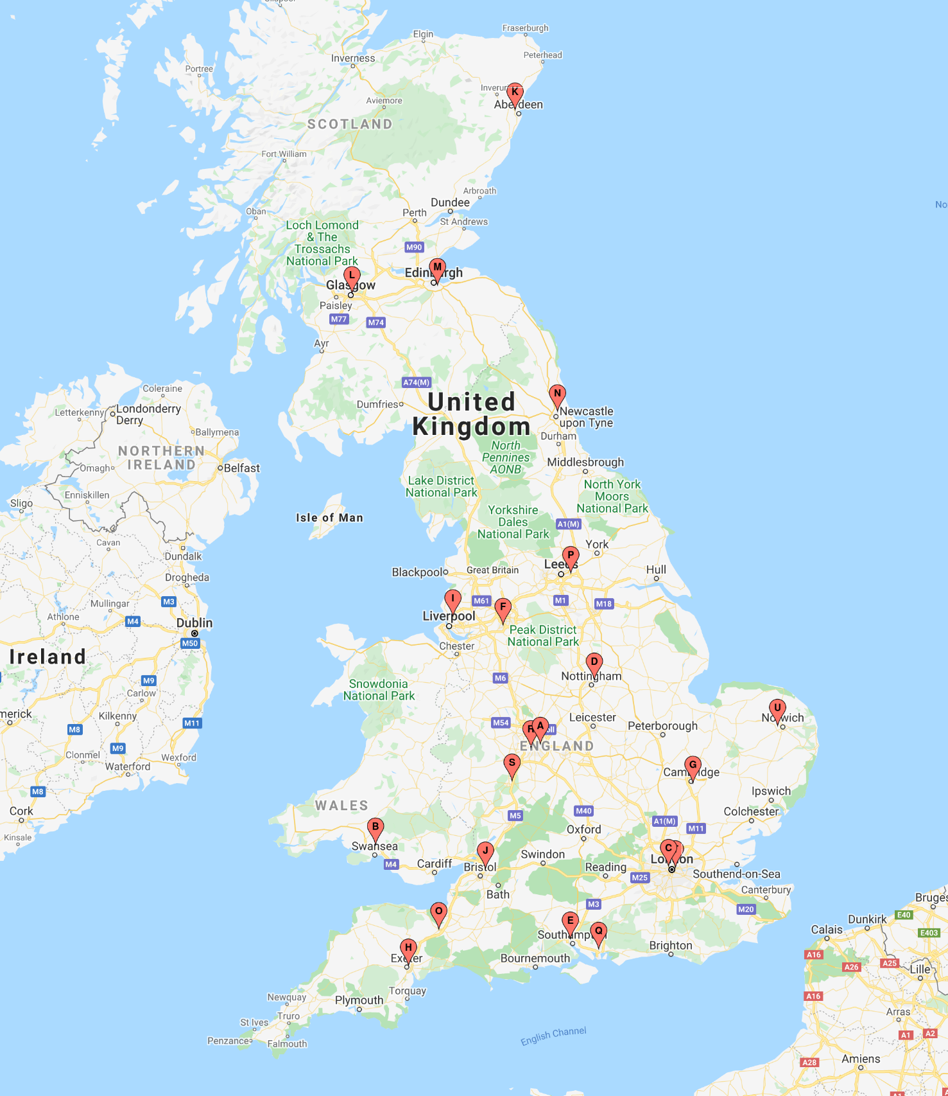

Map showing the 21 IPFJES recruiting centres

Randomly selected control clinics for recruiting centres are shown in Table 6.3. Where more than one clinic is shown this indicates that the random selection process was repeated because of difficulty recruiting adequate numbers of participants (defined as four attendances to the control clinic by the local research team and fewer than four participants recruited).

### Table 6.3: Centre control clinics and recruitment

|  |  |  |
| --- | --- | --- |
|  | Cases (N=494) | Controls (N=466) |
| centre number (control source clinic) |  |  |
| 1 (General Surgery) | 42 | 39 |
| 2 (Gastroenterology/Stroke)1 | 13 | 11 |
| 3 (Cardiology) | 38 | 36 |
| 4 (Urology) | 52 | 52 |
| 5 (Diabetes/Rheumatology)1 | 40 | 31 |
| 6 (Sleep Apnoea) | 34 | 37 |
| 7 (Neurology) | 15 | 16 |
| 8 (ENT) | 40 | 39 |
| 9 (Rheumatology) | 31 | 29 |
| 10 (Oncology) | 21 | 732 |
| 11 (Urology) | 11 | 11 |
| 12 (Haematology) | 4 | 3 |
| 13 (Respiratory) | 13 | 14 |
| 14 (Cardiology) | 20 | 16 |
| 15 (Cardiology) | 15 | 14 |
| 16 (Orthopaedics) | 39 | 23 |
| 17 (Asthma) | 6 | 6 |
| 18 (Hypertension) | 15 | 13 |
| 19 (General Surgery) | 7 | 9 |
| 20 (Urology) | 31 | 25 |
| 21 (Respiratory) | 7 | 2 |

1 The control clinic changed at these two sites because of slow recruitment (defined as fewer than four controls recruited over the course of four clinic attendances). 2 Controls were over-recruited at the local participating centre to help achieve the recruitment target. 3 Controls were under-recruited because of local research staffing shortage.

Two centres had very high ratios of definite UIP to possible UIP but centres were otherwise similar with respect to radiological findings and asbestos exposure measures (see Table 6.4)

### Table 6.4: Radiological findings and occupational asbestos exposure (inferred by job title) by centre (N=960)

|  |  |  |  |  |  |  |
| --- | --- | --- | --- | --- | --- | --- |
| centre | definite UIP | possible UIP | ratio1 | exposed cases2 | exposed controls | ratio3 |
| 1 | 25 | 16 | 1.56 | 30.0 | 29.0 | 0.96 |
| 2 | 10 | 3 | 3.33 | 10.0 | 8.0 | 1.06 |
| 3 | 22 | 16 | 1.38 | 25.0 | 23.0 | 1.03 |
| 4 | 33 | 17 | 1.94 | 35.0 | 32.0 | 1.09 |
| 5 | 14 | 26 | 0.54 | 25.0 | 16.0 | 1.21 |
| 6 | 13 | 21 | 0.62 | 18.0 | 21.0 | 0.93 |
| 7 | 13 | 1 | 13.0 | 10.0 | 12.0 | 0.89 |
| 8 | 19 | 19 | 1.0 | 33.0 | 28.0 | 1.15 |
| 9 | 22 | 8 | 2.75 | 20.0 | 17.0 | 1.10 |
| 10 | 5 | 16 | 0.31 | 11.0 | 40.0 | 0.96 |
| 11 | 6 | 5 | 1.2 | 8.0 | 5.0 | 1.6 |
| 12 | 2 | 2 | 1.0 | 2.0 | 1.0 | 1.50 |
| 13 | 1 | 12 | 0.08 | 8.0 | 10.0 | 0.86 |
| 14 | 13 | 7 | 1.86 | 15.0 | 10.0 | 1.2 |
| 15 | 10 | 5 | 2.0 | 9.0 | 10.0 | 0.84 |
| 16 | 16 | 23 | 0.7 | 26.0 | 1.0 | 1.33 |
| 17 | 2 | 4 | 0.5 | 5.0 | 4.0 | 1.25 |
| 18 | 6 | 6 | 1.0 | 9.0 | 1.0 | 0.6 |
| 19 | 4 | 3 | 1.33 | 5.0 | 5.0 | 1.29 |
| 20 | 27 | 3 | 9.0 | 15.0 | 17.0 | 0.71 |
| 21 | 3 | 3 | 1.0 | 7.0 | 2.0 | 1.0 |

1 Ratio of definite UIP to possible UIP (cases only)

2 Ever asbestos exposed was defined as ever having had a high or medium asbestos exposure risk job, defined on the basis of proportional occupational mortality statistics.(23)

3 Ratio of percentage of cases exposed to percentage of controls exposed

A total of 4299 jobs were recorded. Cases had a mean average of 4.6 (std = 2.4) jobs and controls 4.2 (std = 2.2). The average duration of a job for cases was 9.7 years for cases (std = 11.5) and 10.5 years (std = 12) for controls.

Three hundred and thirty (67%) cases and 295 (63%) controls ever had a high or medium asbestos exposure risk job, defined on the basis of proportional occupational mortality statistics.[51] Ever having a high or medium asbestos exposure risk job was not associated with IPF (see Table 6.5).

### Table 6.5: Occupational asbestos exposure (inferred by job title) and IPF risk (ever vs never)

|  |  |  |  |  |
| --- | --- | --- | --- | --- |
|  | Cases (%) | Controls (%) | Unadjusted OR (95%CI; p-value) | Adjusted OR1 (95%CI; p-value) |
| ever | 330(67) | 295(63) | 1.17(0.9-1.5; 0.28) | 1.09(0.8-1.5; 0.6) |
| never | 164(33) | 171(37) | 1 | 1 |

1 Adjusted for age, smoking, and centre using the logistic regression model ‘case ~ age + ever smoked + centre + ever exposed’

There was a non-statistically significant trend in the unadjusted OR whereby higher exposure categories had higher (non-significant) ORs for disease (see Table 6.6). This was less apparent in adjusted analyses (chi2 test for trend was 1.7, p=0.19).

### Table 6.6: Occupational asbestos exposure (inferred by job title) and IPF risk (categories of exposure)

|  |  |  |  |  |
| --- | --- | --- | --- | --- |
| Category | Cases (%) | Controls (%) | Unadjusted OR (95%CI; p-value) | Adjusted OR1 (95%CI; p-value) |
| high-risk non-construction | 65(13) | 52(11) | 1.30(0.8-2.1;0.3) | 1.10(0.7-1.8; 0.7) |
| high-risk construction | 141(29) | 126(27) | 1.17(0.8-1.8;0.5) | 1.13(0.8-1.7; 0.55) |
| medium risk industrial | 124(25) | 117(25) | 1.11(0.7-1.7;0.64) | 1.06(0.7-1.6; 0.79) |
| low risk industrial | 94(19) | 98(21) | 1(0.7-1.5;0.99) | 0.94(0.6-1.5; 0.78) |
| office | 70(14) | 73(16) | 1 | 1 |

1 Adjusted for age, smoking, and centre

Independent assessments tended to be lower than study assessments of fibre-ml.year exposure but there was overall acceptable agreement between assessments assessed using the Bland-Altman method (see Figure 6.2).

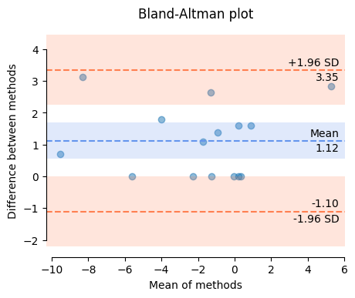

Independent validation of fibre-ml.year exposure assessments

Source receptor model parameter summary statistics are provided in Table 6.7.

### Table 6.7: Source receptor model parameter summary statistics

|  |  |  |  |  |  |  |  |  |  |
| --- | --- | --- | --- | --- | --- | --- | --- | --- | --- |
|  | fml.yr1 | AE | E | H | LC | D | t | f | periodicity |
| count | 454.0 | 454.0 | 454.0 | 454.0 | 454.0 | 454.0 | 454.0 | 454.0 | 454.0 |
| mean | 447.33 | 41.55 | 2.68 | 14.95 | 0.97 | 11.53 | 361.22 | 9.07 | 218301.68 |
| std | 3297.87 | 77.86 | 1.6 | 22.6 | 0.16 | 14.25 | 810.27 | 22.12 | 246253.96 |
| min | 0.0 | 0.04 | 0.6 | 0.1 | 0.1 | 0.05 | 1.0 | 1.0 | 1440.0 |
| 25% | 0.11 | 0.4 | 0.6 | 1.0 | 1.0 | 0.5 | 60.0 | 2.0 | 10080.0 |
| 50% | 1.66 | 7.5 | 4.0 | 3.0 | 1.0 | 4.1 | 180.0 | 3.5 | 43800.05 |
| 75% | 20.99 | 40.0 | 4.0 | 30.0 | 1.0 | 18.0 | 480.0 | 5.0 | 525600.0 |
| max | 50761.9 | 400.0 | 5.0 | 100.0 | 1.0 | 37.0 | 9600.0 | 200.0 | 525600.0 |

1 454 job tasks were recalled in sufficient detail to permit fibre-ml/year exposure estimates. Figures are rounded to 2 decimal places. The lowest job task fibre-ml.year exposure estimate was 0.000012. t is the duration of the task, f is the frequency of the task. t and periodicity are in minutes.

### Illustrative example source receptor model assessment based on a real case

|  |  |  |  |  |  |  |  |  |
| --- | --- | --- | --- | --- | --- | --- | --- | --- |
| fml/yr exposure | AE | E | H | LC | D | t | f | periodicity |
| 1423.28 | 120.0 | 4.0 | 30.0 | 1.0 | 2.7 | 540.0 | 2.0 | week |
| 1405.71 | 120.0 | 4.0 | 30.0 | 1.0 | 6.0 | 480.0 | 1.0 | week |
| 78.09 | 40.0 | 4.0 | 10.0 | 1.0 | 0.1 | 960.0 | 5.0 | week |

Retired shipwright who began working at MOD Davenport dock in the early 1950s. He recalled carrying out three different tasks with asbestos. The first was dry removing lagging that contained amosite or crocidolite by manual scraping without wetting. This task was carried out in a room estimated to be 300m3 with 1 air change per hour. He told us that he spent about 2 days per week on this task throughout his employment as a shipwright. His estimated cumulative fibre-ml/year exposure was 2907. t is the duration of the task, f is the frequency of the task.

The asbestos exposure (AE) estimate was calculated using a source-receptor model[62][90] as follows:

with parameters for the type of asbestos used (substance emission potential, E), what was done with it (activity emission potential, H), and whether there were any local exposure controls, for example wetting (local controls, LC).

AE for each task was then weighted according to the total amount of time spent performing the task and how well ventilated the room the activity was carried out in was (general ventilation parameters, D), to arrive at a task fibre-ml.year exposure estimate.

fibre-ml years (job task) = AE * task_duration * (task_frequency / periodicity) * job_duration * D

Guidance regarding the asbestos exposure model parameter values used above, are provided in the online supplement accompanying Cherrie’s 2018 source receptor model paper.[90]

A total of 454 asbestos exposed job tasks were recalled in sufficient detail to permit a fibre-ml.year estimate of exposure for 229 individual participants. One hundred and twenty two (25%) of cases and 107 (22%) controls recalled occupational asbestos exposure in sufficient detail to permit estimation of cumulative fibre-ml.year exposure. Forty (33%) cases and 35 (32%) controls, which equated to approximately 8% of the total number of cases and 8% of the total number of controls, had cumulative estimates exceeding 25 asbestos fibre-ml.years (see Table 6.8).

### Table 6.8: Occupational asbestos exposure (cumulative fibre ml year estimate) and IPF risk

|  |  |  |  |  |  |  |  |  |
| --- | --- | --- | --- | --- | --- | --- | --- | --- |
|  | N (% total) | median | 0-4 | 5-9 | 10-14 | 15-19 | 20-24 | > 25 |
| cases | 122 (25) | 5.86 | 61 (50) | 10 (8) | 5 (4) | 2 (2) | 4 (3) | 40 (33) |
| controls | 107 (23) | 4.76 | 55 (52) | 4 (4) | 8 (7) | 0 (0) | 5 (5) | 35 (32) |

One hundred and eight (23%) of the 454 asbestos exposed job task fibre-ml.year estimates were in excess of 25 fibre-ml.years. Eighty one (75%) occurred in jobs classified as high risk or medium risk; 17(15%) occurred in high-risk non-construction jobs e.g boiler lagger, 54(50%) in high-risk construction jobs such as carpenter, electrician, and plumber, and 10 (9%) in medium risk industrial jobs such as machinist or fitter. Carpenter was the single most common job title accounting for 6(5%) of estimates in excess of 25 fibre-ml.years (see Figures 6.3 and 6.4).

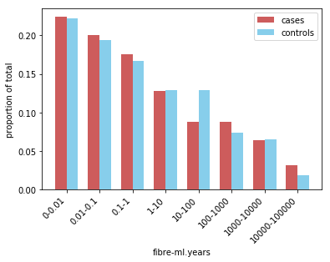

Proportion of exposed participants in fibre-ml.year categories of exposure for those reporting exposure (N=229)

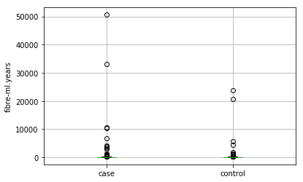

Boxplot of fibre-ml.year asbestos exposure estimates for cases and controls for those reporting exposure (N=229)

Eight hundred and eighteen (85%) of the 960 participants were genotyped for MUC5b rs3570950. Ninety participant samples remain to be genotyped (because of staffing issues) while 52 participants did not provide a sample. Being heterozygous for the disease associated variant (GT) had an odds ratio of 5 (95%CI 3.7-6.8; p 0.001) for disease. Being homozygous for the disease associated variant (TT) had an odds ratio of 13.3 (95%CI 5.1-35, p 0.001) for disease. Ever having smoked was associated with an increased risk of disease, odds ratio 1.4 (95%CI 1-1.8, p 0.03). There was a statistically significant interaction between smoking and having ever been exposed to a high or medium asbestos exposure risk job, odds ratio for interaction 1.9 (95%CI 1.03-3.36, p 0.04). Several non-significant gene-environment interactions were present (see Table 6.9). Similar results were seen when limiting cases to patients with definite UIP only (see Table 6.10).

### Table 6.9: MUC5b rs35705950, occupational asbestos exposure, smoking, and IPF risk

|  |  |
| --- | --- |
| Exposure | OR (95%CI; p-value)1 2 |
| rs35705950 |  |
| GG | 1 |
| GT | 5 (3.7-6.8; 0.001) |
| TT | 13.3 (5.1-35; 0.001) |
|  |  |
| Ever smoked | 1.4 (1-1.8; 0.03)3 |
| EE interaction (smoking and ever exposed) | 1.9 (1.03-3.36; 0.04)3 |
|  |  |
| GE interaction (ever exposed) | 1.4 (0.8-2.6; 0.2) |
| GE interaction (categories of exposure) | 1.1(0.9-1.4; 0.38) |
| GE interaction (fibre-ml years) | 1(0.99-1; 0.34) |
| GE interaction (ever smoked) | 1.2 (0.6-2.2; 0.7) |

1 additive model, adjusted for age and smoking, N=818 for analysis involving genotype and N=960 for analysis not involving genotype  
2 adjusted for age only where smoking is exposure  
3 when adjusting for centre also, ever smoked remains significant but smoking and ever exposed does not, centre is not adjusted for when using an additive genotype model to avoid regression issues that arise because six centres have no TT genotype patients.

### Table 6.10: MUC5b rs35705950, occupational asbestos exposure, smoking, and IPF risk (definite UIP only)

|  |  |
| --- | --- |
| Exposure | OR (95%CI; p-value)1 2 |
| rs35705950 |  |
| GG | 1 |
| GT | 5.6 (3.8-8.1; 0.001) |
| TT | 16.4 (5.9-45.6; 0.001) |
|  |  |
| Ever smoked | 1.4 (1-2; 0.04)3 |
| EE interaction (smoking and ever exposed) | 2.3 (1.1-4.8; 0.02)3 |
|  |  |
| GE interaction (ever exposed) | 1.2 (0.6-2.4; 0.7) |
| GE interaction (categories of exposure) | 1(0.7-1.3; 0.7) |
| GE interaction (fibre-ml years) | 1(1-1; 0.4) |
| GE interaction (ever smoked) | 1.2 (0.5-2.5; 0.7) |

1 additive model, adjusted for age and smoking, N=631 for analysis involving genotype and N=732 for analysis not involving genotype  
2 adjusted for age only where smoking is exposure  
3 when adjusting for centre also, ever smoked remains significant but smoking and ever exposed does not, centre is not adjusted for when using an additive genotype model to avoid regression issues that arise because six centres have no TT genotype patients.

The regression coefficient for MUC5b rs35705950 genotype, using an additive model, age, and centre was significant but ever smoking, asbestos exposure, and the interaction of asbestos exposure and genotype were not. See dot-and-whisker plot of regression coefficients (Figure 6.5 and Table 6.11).

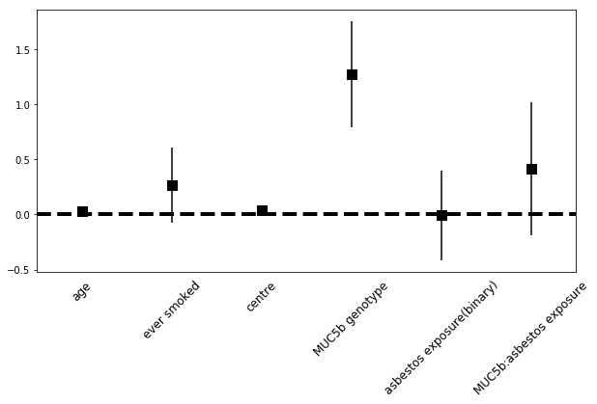

Regression coefficients (and 95% confidence intervals) for logistic regression of case status against age in years, ever having smoked (binary), centre, MUC5b rs35705950 genotype (additive model), asbestos exposure (ever held high or medium risk asbestos exposure job based on job title), and gene-environment interaction (N=818)

### Table 6.11: Unadjusted and adjusted OR for IPF risk factors potential confounders

|  |  |  |
| --- | --- | --- |
| Exposure1 | Unadjusted OR (95%CI; p-value) | Adjusted OR2 (95%CI; p-value) |
| age | 1.03(1.01-1.04; 0.01)) | 1.03(1.01-1.05; 0.01)) |
| ever smoked | 1.4(1.03-1.9; 0.01)) | 1.31(0.93-1.84; 0.12 ) |
| centre | 1.04(1.02-1.07; 0.02) | 1.04(1-1.06; 0.01)) |
| genotype | 4.66(3.5-6.2; 0.01) | 3.64(2.26-5.87; 0.01) |
| ever exposed | 1.18(0.88-1.6;0.46) | 1.02(0.68-1.53;0.9) |
| genotype:ever exposed | 1.43(0.78-2.59; 0.23) | 1.47(0.8-2.67;0.2) |

1 Ever exposed is defined as ever having had a high or medium asbestos exposure risk job, defined on the basis of proportional occupational mortality statistics.[51] Genotype is MUC5B rs35705950 using an additive model.

2 Adjusted OR provided by logistic regression model: ’case ~ age + ever smoked + centre + genotype*ever exposed’

Ever having a job with wood, metal, or stone exposure was associated with disease, odds ratio 1.7 (95%CI 1.2-2.3, p 0.01). Stone dust exposure alone was associated with a statistically significant odds ratio for disease of 2.9 (95%CI 1.3-6.7, p 0.01) but wood and metal dust were not (see Table 6.12). The majority of stone dust exposed jobs were in construction in jobs such as bricklayer, building labourer, and stone mason.

### Table 6.12: Occupational metal, wood, and stone exposure and IPF risk

|  |  |  |  |  |
| --- | --- | --- | --- | --- |
| Exposure | Cases (%) | Controls (%) | Unadjusted OR (95%CI; p-value) | Adjusted OR1 (95%CI; p-value) |
| Wood, metal, stone (any) | 139(28) | 84(18) | 1.8(1.3-2.4; 0.01) | 1.7(1.2-2.3; 0.01) |
| Wood | 48(10) | 31(7) | 1.5(0.9-2.4; 0.09) | 1.4(0.9-2.3; 0.2) |
| Metal | 88(18) | 57(12) | 1.6(1.1-2.2; 0.02) | 1.4(0.9-2.0; 0.1) |
| Stone | 24(5) | 8(2) | 2.9(1.3-6.6; 0.01) | 2.9(1.3-6.7; 0.01) |

1 Adjusted for age, smoking, and centre

As a result of increasing awareness, and regulation, occupational asbestos exposure was significantly less widespread after 1980.[73] To investigate whether occupational asbestos exposure might be associated with IPF during this period I performed a sensitivity analysis by only including participants’ jobs that ended before 1980. I did not observe a significant association (Table 6.13 and 6.14). I also performed sensitivity analyses limiting to jobs that started before 1980, participants born prior to 1965, and considering only jobs before age 45[55]; there was no significant association between asbestos exposure and IPF for these.

### Table 6.13: Sensitivity analysis (limited to jobs that ended before 1980): Occupational asbestos exposure (inferred by job title) and IPF risk (ever vs never) N=779

|  |  |  |  |  |
| --- | --- | --- | --- | --- |
|  | Cases (%) | Controls (%) | Unadjusted OR (95%CI; p-value) | Adjusted OR1 (95%CI; p-value) |
| ever | 250(62) | 220(59) | 1.11(0.8-1.5; 0.46) | 0.97(0.72-1.32; 0.87) |
| never | 156(38) | 153(41) | 1 | 1 |

1 Adjusted for age, smoking, and centre

### Table 6.14: Sensitivity analysis (limited to jobs that ended before 1980): Occupational asbestos exposure (inferred by job title) and IPF risk (categories of exposure) N=779

|  |  |  |  |  |
| --- | --- | --- | --- | --- |
| Category | Cases (%) | Controls (%) | Unadjusted OR (95%CI; p-value) | Adjusted OR1 (95%CI; p-value) |
| high-risk non-construction | 53(13) | 36(10) | 1.55(0.9-2.6;0.62) | 1.09(0.61-1.94;0.77) |
| high-risk construction | 95(23) | 81(22) | 1.22(0.8-1.9;0.88) | 1.01(0.63-1.63;0.97) |
| medium risk industrial | 102(25) | 103(28) | 1.03(0.7-1.6;0.37) | 0.83(0.52-1.33;0.44) |
| low risk industrial | 90(22) | 84(23) | 1.12(0.7-1.8;0.12) | 0.94(0.58-1.52;0.8) |
| office | 66(16) | 69(18) | 1 | 1 |

1 Adjusted for age, smoking, and centre

I considered that a minimum duration in a high or medium risk job might be important and performed a sensitivity analysis limited to jobs of five or more years in duration (See Table 6.15 and 6.16 and Figure 6.6)

### Table 6.15: Sensitivity analysis (limited to jobs that participants spent 5 or more years in): Occupational asbestos exposure (inferred by job title) and IPF risk (ever vs never)

|  |  |  |  |  |
| --- | --- | --- | --- | --- |
|  | Cases (%) | Controls2 (%) | Unadjusted OR (95%CI; p-value) | Adjusted OR1 (95%CI; p-value) |
| ever | 257(52) | 235(51) | 1.06(0.82-1.37; 0.65) | 0.93(0.71-1.22; 0.63) |
| never | 237(48) | 230(49) | 1 | 1 |

1 Adjusted for age, smoking, and centre

2 One control never spent 5 or more years in a job and is excluded from the analysis

### Table 6.16: Sensitivity analysis (limited to jobs that participants spent 5 or more years in): Occupational asbestos exposure (inferred by job title) and IPF risk (categories of exposure)

|  |  |  |  |  |
| --- | --- | --- | --- | --- |
| Category | Cases (%) | Controls2 (%) | Unadjusted OR (95%CI; p-value) | Adjusted OR1 (95%CI; p-value) |
| high-risk non-construction | 34(7) | 32(7) | 0.93(0.55-1.6;0.47) | 0.68(0.38-1.22;0.2) |
| high-risk construction | 115(23) | 98(22) | 1.03(0.71-1.5;0.39) | 0.94(0.64-1.4;0.78) |
| medium risk industrial | 108(22) | 105(23) | 0.9(0.63-1.3;0.26) | 0.72(0.49-1.07;0.11) |
| low risk industrial | 99(20) | 109(23) | 0.79(0.55-1.48;0.14) | 0.73(0.49-1.08;0.34) |
| office | 138(28) | 121(26) | 1 | 1 |

1 Adjusted for age, smoking, and centre

2 One control never spent 5 or more years in a job and is excluded from the analysis

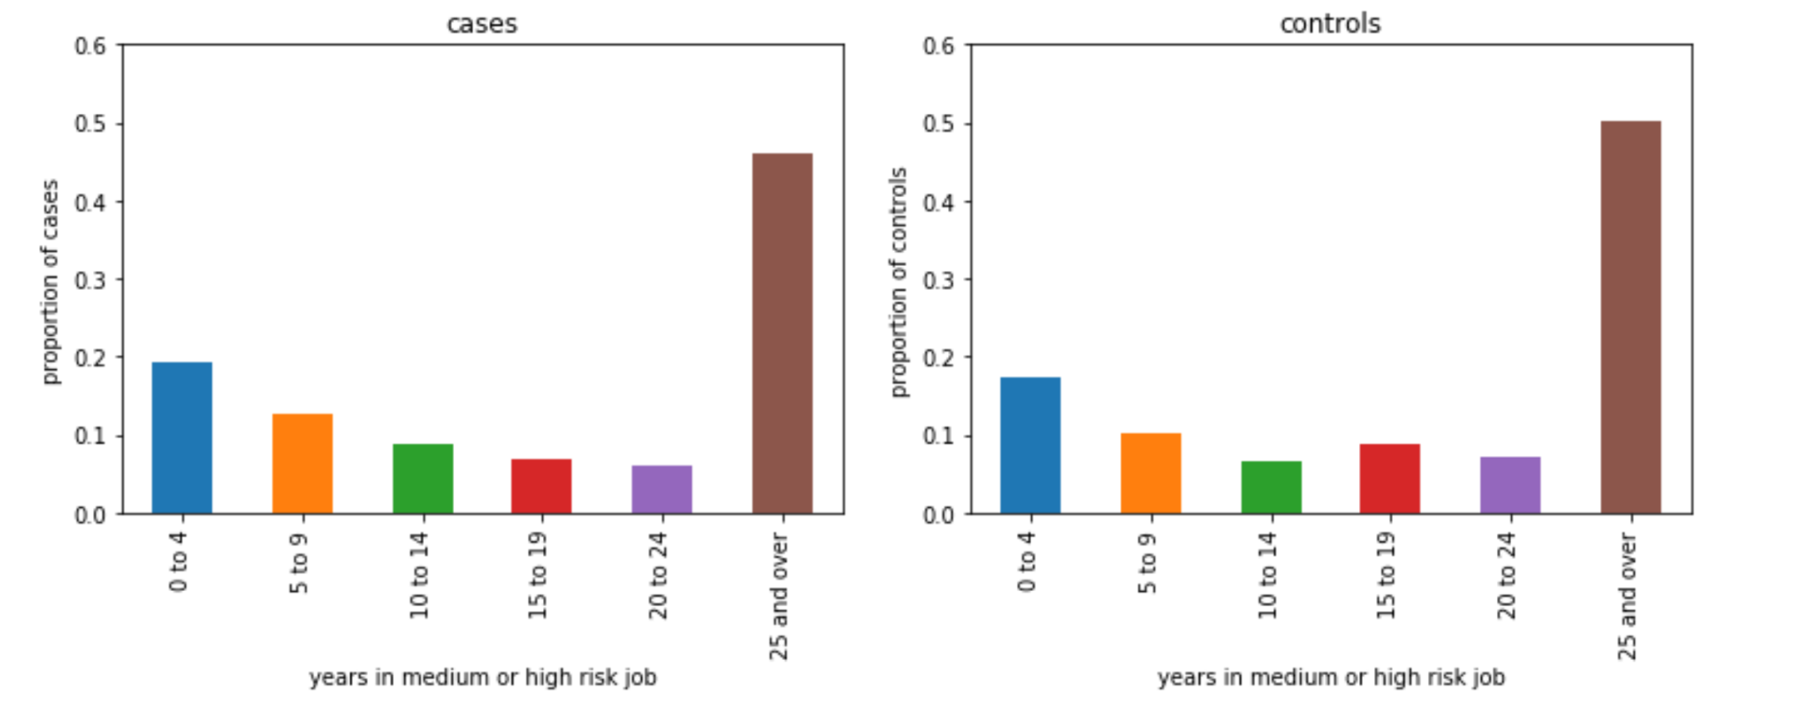

Years in a medium or high risk asbestos exposure job for cases and controls. Analysis limited to participants ever having had a medium or high risk asbestos exposure job (N=492).

Cases and controls lived an average of 28km and 16km respectively from their recruiting hospital, measured by calculating the distance between the postcode centroid of the participants general practice and the postcode centroid of the hospital. Living further away from the hospital correlated with being a case, r0.22, 95% CI = 0.16-0.29, p 0.001 and weakly correlated with reduced asbestos exposure, r=-0.06, 95%CI = -0.13-0, p=0.05. To investigate this further I performed a sensitivity analysis limited to participants living within 10km of their recruiting hospital (Table 6.17 and 6.18) and it did not significantly alter the results.

### Table 6.17: Sensitivity analysis (limited to participants within 10km of the hospital): Occupational asbestos exposure (inferred by job title) and IPF risk (ever vs never)

|  |  |  |  |  |
| --- | --- | --- | --- | --- |
|  | Cases (%) | Controls (%) | Unadjusted OR (95%CI; p-value) | Adjusted OR1 (95%CI; p-value) |
| ever | 111(73) | 180(64) | 1.46(0.95-2.26; 0.08) | 1.33(0.82-2.16; 0.24) |
| never | 42(27) | 100(36) | 1 | 1 |

1 Adjusted for age, smoking, and centre

### Table 6.18: Sensitivity analysis (limited to participants within 10km of the hospital): Occupational asbestos exposure (inferred by job title) and IPF risk (categories of exposure)

|  |  |  |  |  |
| --- | --- | --- | --- | --- |
| Category | Cases (%) | Controls (%) | Unadjusted OR (95%CI; p-value) | Adjusted OR1 (95%CI; p-value) |
| high-risk non-construction | 23(15) | 35(13) | 1.62(0.75-3.51;0.22) | 1.05(0.44-2.52;0.9) |
| high-risk construction | 47(31) | 80(29) | 1.45(0.74-2.83;0.23) | 1.21(0.58-2.52;0.62) |
| medium risk industrial | 41(27) | 65(23) | 1.55(0.78-3.09;0.21) | 0.93(0.43-2.04;0.86) |
| low risk industrial | 25(16) | 58(21) | 1.06(0.51-2.21;0.87) | 0.69(0.31-1.59;0.39) |
| office | 17(11) | 42(15) | 1 | 1 |

1 Adjusted for age, smoking, and centre

To investigate cumulative ‘dose’ of exposure based on job title a score was assigned based on asbestos exposure risk category. Participants were already assigned to the highest asbestos exposure risk category they ever worked in using their job titles on the basis of proportional occupational mortality statistics for pleural mesothelioma.[51] Risk categories were then weighted as follows:

* high-risk non-construction : 2
* high-risk construction : 2
* medium risk industrial : 1
* low risk industrial : 0
* office : 0

To reflect that, on average, cumulative exposure is expected to be higher for higher risk categories.

Scores were then multiplied for each job by the duration in years of the job and then summed at participant level. See Table 6.19 and Figure 6.7. This was done because, on average, it would be expected that greater exposure to a risk category (i.e a greater number of years worked in it), would be associated with higher cumulative exposure.

### Table 6.19: Cumulative ‘dose’ based on occupational asbestos exposure (inferred by job title)

|  |  |  |  |  |  |  |  |  |
| --- | --- | --- | --- | --- | --- | --- | --- | --- |
|  | N | mean | std | min | 25% | 50% | 75% | max |
| cases | 494 | 23.9 | 30.8 | 0 | 0 | 9 | 40 | 126 |
| controls | 466 | 24 | 30.4 | 0 | 0 | 6.5 | 42 | 118 |

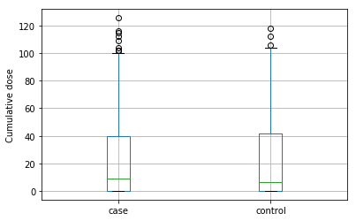

Boxplot of cumulative asbestos exposure estimates (inferred from job title) for cases and controls (N=960)

Three hundred and ten (63%) IPF cases initially presented to their doctor with cough and 306 (62%) with breathlessness (91 patients presented with cough and breathlessness). Fifteen (3%) cases and 42 (9%) controls reported ever taking a medication suspected of causing usual interstitial pneumonia (amiodarone, azathioprine, bleomycin, flecainide, gefitinib, ifosfamide, melphalan, and nitrofurantoin).[138]

Four hundred and fourteen (83%) cases and 441 (95%) controls reported one or more comorbidities. The most commonly reported comorbidities (occurring in at least 10 cases or controls) occurred at a similar frequency in cases and controls and included hypertension, type II diabetes mellitus, hypercholesterolemia, ischaemic heart disease, atrial fibrillation, COPD, osteoarthritis, and prostate cancer. Rheumatoid arthritis was reported in 18 cases, approximately 2% of cases reporting a comorbidity, and in 9 controls, approximately 1% of controls reporting a comorbidity. Gastro-oesophageal reflux disease (GORD) was reported in 14 cases, approximately 1.5% of cases reporting a comorbidity, and in 2 controls, approximately 0.5% of controls reporting a comorbidity.

Dyspnoea, as measured by the mMRC dyspnoea scale was associated with case-status, smoking status, genotype, and asbestos exposure. Pearson’s correlation coefficient for IPF was 0.49 (95%CI 0.44-0.53, p0.001), ever smoking was 0.16 (95%CI 0.09-0.23, p0.001), pack-years smoked was 0.2 (95%CI 0.13-0.26, p0.001), genotype 0.2 (95%CI 0.13-0.27, p0.001), ever held a medium or high risk asbestos exposure job title 0.09 (95%CI 0.02-0.16, p=0.02), and 0.15 (95%CI 0.08-0.21, p0.001) for having a fibre-ml.year estimate > 25. See Table 6.20 and 6.21 for ordinal logistic regression results.

### Table 6.20: Ordinal logistic regression for mMRC score and ever exposed to asbestos

|  |  |  |
| --- | --- | --- |
|  | Unadjusted OR (95%CI; p-value) | Adjusted OR1 (95%CI; p-value) |
| case | 6.94(5.38-9; 0.001) | 6.8 (5.25-8.8; 0.001) |
| pack-years | 1.01(1-1.02;0.001) | 1.02(1.01-1.02; 0.001) |
| ever exposed2 | 1.48(1.17-1.87; 0.001) | 1.44(1.12-1.84; 0.004) |

1 Adjusted for age, smoking (pack-years), and case status 2 Ever exposed to a high or medium asbestos exposure job (inferred from job title)

### Table 6.21: Ordinal logistic regression for mMRC score and for categories of asbestos exposure

|  |  |  |
| --- | --- | --- |
| Category | Unadjusted OR(95%CI;p-value) | Adjusted OR1(95%CI;p-value) |
| high-risk non-construction | 2.21(1.43-3.44;0.001) | 1.92(1.2-3.03;0.006) |
| high-risk construction | 1.9(1.31-2.74;0.001) | 1.89(1.29-2.78;0.001) |
| medium risk industrial | 1.36(0.94-1.98;0.103) | 1.28(0.87-1.89;0.21) |
| low risk industrial | 1.29(0.88-1.9;0.19) | 1.24(0.82-1.87;0.29) |
| office | 1 | 1 |

1 Adjusted for age, smoking (pack-years), and case status

Among the 818 genotyped participants the MUC5b rs35705950 minor allele frequency (MAF) was 35% in cases (N=395) and 12% in controls (N=423). Subsets of genotyped cases with asbestos and smoking exposure had higher MAFs than did genotyped cases who had exposure to asbestos or smoking alone. See Table 6.22.

### Table 6.22: rs35705950 MAF for genotyped cases, case subsets, and controls (N=818)

rs35705950 MAF for genotyped cases, case subsets, and controls (N)1

|  |  |  |  |  |  |  |  |
| --- | --- | --- | --- | --- | --- | --- | --- |
|  | IPF (395) | IPF smoker (299) | IPF asbestos exposed (267) | IPF >25 fml-yrs (35) | IPF asbestos exposed AND smoker (214) | IPF >25 fml-yrs AND smoker (27) | Hospital controls (423) |
| GG | 152 | 112 | 101 | 11 | 76 | 9 | 327 |
| GT | 212 | 161 | 142 | 20 | 117 | 15 | 91 |
| TT | 31 | 26 | 24 | 4 | 21 | 3 | 5 |
| MAF | 35 | 36 | 36 | 40 | 37 | 39 | 12 |

1 Genotype of MUC5Brs35705950, T is minor allele. MAF is minor allele frequency (%).

A history of ever having smoked and ever having had a high or medium risk job for asbestos exposure was associated with increased risk of IPF when participants also had the minor allele of MUC5b rs35705950, OR 4.6(1.5-14, p=0.01). No significant risk was observed for ever smoking or ever being asbestos exposed alone when stratifying for genotype. See Table 6.23, 6.24, and 6.25.

### Table 6.23: Logistic regression of ever smoking and ever exposed to occupational asbestos (inferred by job title) stratified by MUC5B rs35705950 genotype

|  |  |
| --- | --- |
| Exposure | OR (95% CI; p-value)1 2 |
| Ever smoker and ever asbestos exposed (all) | 1.73 (0.91-3.3, 0.09) |
| Ever smoker and ever asbestos exposed, GT or TT3 | 4.6 (1.5-14, 0.01) |
| Ever smoker and ever asbestos exposed, GG3 | 0.94 (0.38-2.3, 0.9) |

1 additive model, adjusted for age and smoking 2 analysis limited to genotyped participants (N=818) 3 Genotype of MUC5B rs35705950, T is minor allele

### Table 6.24: Logistic regression of ever smoking stratified by MUC5B rs35705950 genotype

|  |  |
| --- | --- |
| Exposure | OR (95% CI; p-value)1 2 |
| Ever smoker (all) | 1.45 (1.06-1.99, 0.02) |
| Ever smoker, GT or TT3 | 1.66 (0.97-2.84, 0.06) |
| Ever smoker, GG3 | 1.27 (0.83-1.96, 0.28) |

1 additive model, adjusted for age 2 analysis limited to genotyped participants (N=818) 3 Genotype of MUC5B rs35705950, T is minor allele

### Table 6.25: Logistic regression of ever having been exposed to occupational asbestos (inferred by job title) stratified by MUC5B rs35705950 genotype

|  |  |
| --- | --- |
| Exposure | OR (95% CI; p-value)1 2 |
| Ever asbestos exposed (all) | 1.17 (0.88-1.57, 0.29) |
| Ever asbestos exposed, GT or TT3 | 1.62 (0.99-2.64, 0.06) |
| Ever asbestos exposed, GG3 | 1.02 (0.68-1.53, 0.94) |

1 additive model, adjusted for age and smoking 2 analysis limited to genotyped participants (N=818) 3 Genotype of MUC5B rs35705950, T is minor allele

A history of never having had a high or medium risk job for asbestos exposure was associated with a non-significantly reduced risk of IPF which was greatest for participants who were carriers of the minor allele of MUC5B rs35705950, see Table 6.26.

### Table 6.26: Logistic regression of never having been exposed to occupational asbestos (inferred by job title) stratified by MUC5B rs35705950 genotype

|  |  |
| --- | --- |
| Exposure | OR (95% CI; p-value)1 2 |
| Never asbestos exposed (all) | 0.89 (0.66-1.20, 0.45) |
| Never asbestos exposed, GT or TT3 | 0.79 (0.47-1.32, 0.37) |
| Never asbestos exposed, GG3 | 0.98 (0.64-1.48, 0.92) |

1 additive model, adjusted for age and smoking 2 analysis limited to genotyped participants (N=818) 3 Genotype of MUC5B rs35705950, T is minor allele

A history of never having smoked was associated with a non-significantly reduced risk of IPF which was greatest for participants who were carriers of the minor allele of MUC5B rs35705950, see Table 6.27.

### Table 6.27: Logistic regression of never having smoked stratified by MUC5B rs35705950 genotype

|  |  |
| --- | --- |
| Exposure | OR (95% CI; p-value)1 2 |
| Never smoked (all) | 0.7 (0.51-0.96, 0.03) |
| Never smoked, GT or TT3 | 0.6 (0.37-1.1, 0.1) |
| Never smoked, GG3 | 0.8 (0.51-1.21, 0.28) |

1 additive model, adjusted for age and asbestos exposure 2 analysis limited to genotyped participants (N=818) 3 Genotype of MUC5B rs35705950, T is minor allele

A history of ever having smoked and ever having had a high or medium risk job for asbestos exposure was associated with increased risk of IPF when analysis was limited to include only cases with definite UIP, OR 2.33 (95%CI 1.13-4.8, p=0.02), see Table 6.28. The association of ever smoking and ever having a medium of high risk job for asbestos exposure with IPF risk was stronger when analysis was limited to include only cases with definite UIP, OR 8.56 (95%CI 2.39-30.69, p=0.001), see Table 6.29 and 6.30.

### Table 6.28: Sensitivity analysis logistic regression of ever smoking and ever exposed to occupational asbestos (inferred by job title) radiology (definite UIP/possible UIP)

|  |  |
| --- | --- |
| Exposure | OR (95% CI; p-value)1 |
| Ever smoker and ever asbestos exposed (all)2 | 1.85 (1.02-3.36, 0.04) |
| Ever smoker and ever asbestos exposed, definite UIP2 | 2.33 (1.13-4.8, 0.02) |
| Ever smoker and ever asbestos exposed, possible UIP2 | 1.71 (0.81-3.62, 0.16) |

1 additive model, adjusted for age and smoking 2 N=960 for all, 494 cases, 466 controls. 266 cases had definite UIP, 216 had possible UIP, and 12 cases had ‘other’.

### Table 6.29: Sensitivity analysis of possible UIP logistic regression of ever smoking and ever exposed to occupational asbestos (inferred by job title) stratified by MUC5B rs35705950 genotype

|  |  |
| --- | --- |
| Exposure | OR (95% CI; p-value)1 2 |
| Ever smoker and ever asbestos exposed (all)2 | 1.44 (0.63-3.28, 0.38) |
| Ever smoker and ever asbestos exposed, GT or TT3 | 2.87 (0.77-10.65, 0.12) |
| Ever smoker and ever asbestos exposed, GG3 | 1.15 (0.35-3.68, 0.82) |

1 additive model, adjusted for age and smoking 2 analysis limited to all genotyped controls (N=423) and genotyped cases with possible UIP (N=117) (total N=600) 3 Genotype of MUC5B rs35705950, T is minor allele

### Table 6.30: Sensitivity analysis of definite UIP logistic regression of ever smoking and ever exposed to occupational asbestos (inferred by job title) stratified by MUC5B rs35705950 genotype

|  |  |
| --- | --- |
| Exposure | OR (95% CI; p-value)1 2 |
| Ever smoker and ever asbestos exposed (all)2 | 2.54 (1.14-5.65, 0.02) |
| Ever smoker and ever asbestos exposed, GT or TT3 | 8.56 (2.39-30.69, 0.001) |
| Ever smoker and ever asbestos exposed, GG3 | 0.84 (0.24-2.89, 0.9) |

1 additive model, adjusted for age and smoking 2 analysis limited to all genotyped controls (N=423) and genotyped cases with definite UIP (N=208) (total N=631) 3 Genotype of MUC5B rs35705950, T is minor allele

### Table 6.31: Classification of job categories with average national mesothelioma PMRs. Table 2.3.2 in Occupational, domestic and environmental mesothelioma risks in Britain. (HSE 2009)

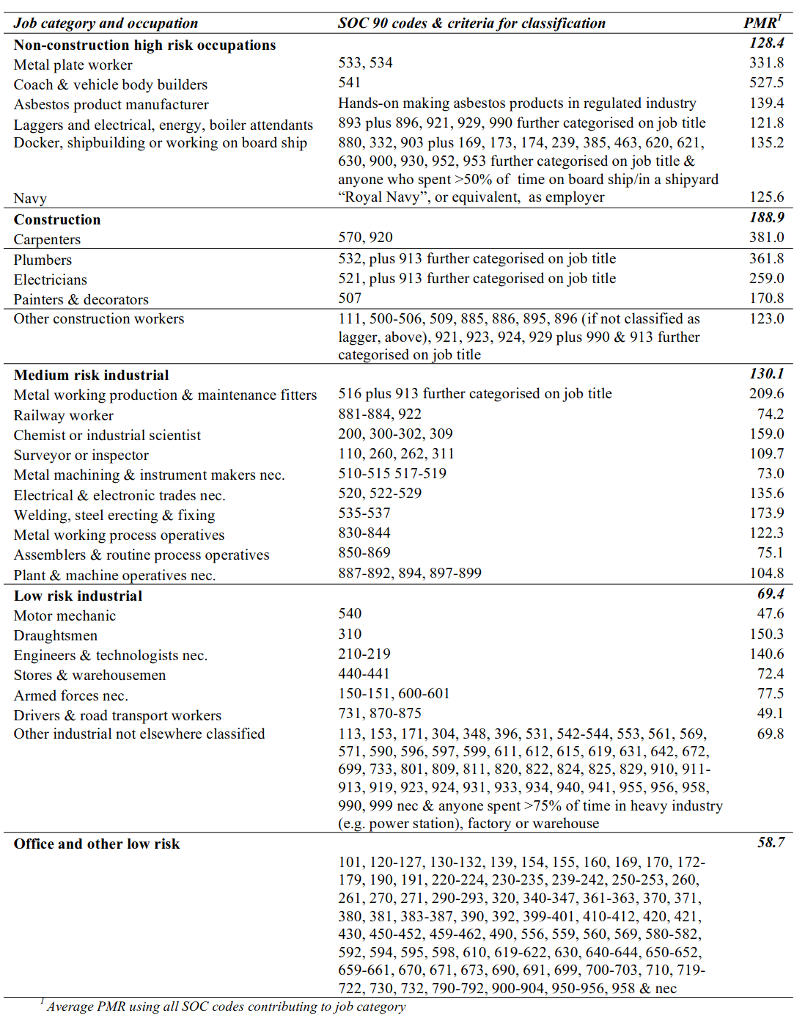

## Discussion

### Findings, interpretation, implications, relations to others work, limitations, strengths

Ever being exposed to an occupation at medium or high risk for asbestos exposure was common for both cases (67%) and controls (63%) and the difference in the proportion exposed between cases and controls was not significant (Table 6.5). A similar pattern was observed for categories of exposure (Table 6.6). Eight percent of both cases and controls had estimated cumulative asbestos fibre-ml.year exposures in excess of 25 fibre-ml.years, the Helsinki criteria exposure threshold at which cases of asbestosis may occur.[67] The majority of these participants had high or medium risk occupations as defined by job title with carpenter being the single most common job title accounting for 5% of all estimates in excess of 25 fibre-ml.years.

Levels of exposure seen in controls IPFJES were strikingly similar to those seen in a recent pleural mesothelioma case-control study (Peto 2009).[51] In Peto’s study 65% of male controls ever worked in a medium or high risk for asbestos exposure compared with 63% in IPFJES. Data provided by Peto for occupations held by males controls for five or more years by highest risk category held (Table 3.2.2a of Peto 2009[51]) were also similar to the IPFJES findings (Table 6.16). For 9% of controls in the Peto study and 7% of controls in IPFJES the highest risk category worked in was high-risk non-construction, 21% and 22% for high-risk construction, 23% and 23% for medium risk industrial, 15% and 23% for low risk industrial, and 32% and 26% for office work.

In common with numerous previous studies I found MUC5b rs3570950 to be strongly associated with disease in a risk allele dose-dependent fashion OR 5 (95% CI 3.7-6.8, p 0.001) for GT, OR 13.3 (95% CI 5.1-35, p 0.001) for TT (see Table 6.9). I found no evidence of interaction between asbestos exposure and MUC5b rs3570950. However, I did find a significant association for having ever smoked, OR 1.4 (95%CI 1-1.8, p = 0.03) and for having ever smoked and having ever had a high or medium asbestos exposure risk based on job title, OR 1.9 (95%CI 1.03-3.36, p = 0.04). Sensitivity analyses including limiting jobs considered to only those that ended before 1980, considering only jobs with a duration greater than five years, considering only participants living within 10km of their recruiting hospital, and considering cumulative exposure ‘dose’ based on summing years in different asbestos exposure risk categories (assigned by job title) at participant level, were all non-significant. In an unplanned secondary analysis I also found a significant association for self reported occupational exposure to stone dust and IPF, OR 2.9(1.3-6.7; 0.01).

After controlling for case and smoking status a high or medium risk job for asbestos exposure was associated with dyspnoea, measured using ordinal logistic regression and mMRC dyspnoea score, OR 1.44(1.12-1.84; p=0.004), see Tables 6.20 and 6.21. The strength of association between asbestos exposure and dyspnoea increased with increasing categories of asbestos exposure risk.

Exertional dyspnoea and restrictive spirometry are typical findings in asbestosis but obstructive spirometry has also been observed. A recent meta-analysis of lung function in asbestos-exposed workers focusing on spirometric parameters concluded that, even in the absence of radiographically apparent parenchymal disease, there are modest excesses of both restrictive and obstructive impairments.[139] In addition to being strongly associated with restrictive lung impairment in patients with asbestosis dyspnoea is associated with restrictive lung impairment in asbestos exposed workers[140] and in the general population.[141]

Dyspnoea, measured by response to the question item are you “Slower than people of the same age on level ground” from The American Thoracic Society Division of Lung Diseases questionnaire (ATS-DLD-78A) has been reported to be strongly associated with restrictive ventilatory impairment (OR 2.6, 95%CI 2-3.3) in a US cross-sectional study of 816 asbestos exposed workers who were recruited to participate in a chemoprevention trial between 1985 and 1988.[140] Dyspnoea, measured by the mMRC dyspnoea score is strongly associated with a restrictive spirometry pattern defined as post bronchodilator FVC measured below the lower limit of normal together with an FEV1/FVC ratio measured above the lower level of normal. This association remains when age, sex, smoking habit, and BMI are adjusted for, and was measured using cross-sectional data from population based samples in 15 countries in the Burden of Obstructive Lung Disease (BOLD) study.[141]

To my knowledge the association between occupational asbestos exposure and mMRC dyspnoea score found has not previously been demonstrated in cohorts similar to the older male hospital attendees who participated in IPFJES. It provides another data point for this group having relatively heavy occupational asbestos exposures and suggests that, even without a diagnosis or IPF, or asbestosis, these exposures are associated with dyspnoea.

I found evidence suggesting an interaction between asbestos exposure, as measured by ever having a job at medium or high risk for asbestos exposure, and ever having smoked, on IPF risk, OR 1.9 (95%CI 1.03-3.36, p=0.04). I found evidence supporting the risk of the interaction between ever smoking and ever having a high or medium risk asbestos exposure job, being mediated by MUC5b promoter variant rs3505950 genotype, OR 4.6 (95%CI 1.5-14, p=0.01) by stratifying for genotype, see Table 6.23. In a sensitivity analysis using a strict case definition of definite UIP the OR for IPF for those exposed to smoking and asbestos was 2.33 (95%CI 1.13-4.8, p=0.02). When using the strict case definition and stratifying by genotype the OR for IPF for participants who had at least one copy of the minor allele of the MUC5b promoter variant and were exposed to smoking and asbestos was 8.56 (95%CI 2.39-30.69, 0.001).

Eight percent of cases apparently meet the Helsinki criteria for a diagnosis of asbestosis.[67] This criterion has been criticised for failing to reflect the linear dose-response relationship, and lack of threshold, observed in the published literature.[142][143][70] Strictly, IPF is a diagnosis of exclusion that should not be made until exposures to asbestos, and other known causes of fibrosis, have been excluded.[137][70] Taken to its logical conclusion this line of argument may result in no diagnoses of IPF in the UK since asbestos exposure is ubiquitous; the average asbestos lung burden in men and women without occupational asbestos exposure was recently measured at approximately 1 fibre/mg of lung tissue.[73] In IPFJES the population attributable fraction (PAF) calculated using the adjusted, non-significant, odds ratio (OR) for ever exposed and proportion of cases ever exposed (pc) and the equation: PAF = pc(OR - 1)/OR[26] is about 5%. Of note asbestosis is not necessarily fatal[144] and may not even be symptomatic since diagnostic criteria require evidence of scarring of the lungs and evidence of asbestos exposure but not the presence of symptoms.[67] In this context a cut off below which exposure is unlikely to cause significant morbidity or mortality seems reasonable. Asbestosis can have a latency of upwards of 40 years[145] and rates have not yet peaked in the UK.[146] From 1900 until around 1960 (see Figure 6.8), when asbestos consumption in the United Kingdom peaked, the United Kingdom had the third highest per capita asbestos consumption in the world with only to the United States and later Australia having higher rates of consumption.[147] My results are likely to generalize well globally where, with the exception of Brazil, Russian, India, Iran, and China which continue to consume asbestos, consumption has been lower and peaked later. Intriguingly, my results support the concept of asbestos exposure being associated with dyspnoea independent of having IPF and smoking which may represent a previous unrecognised patient group.

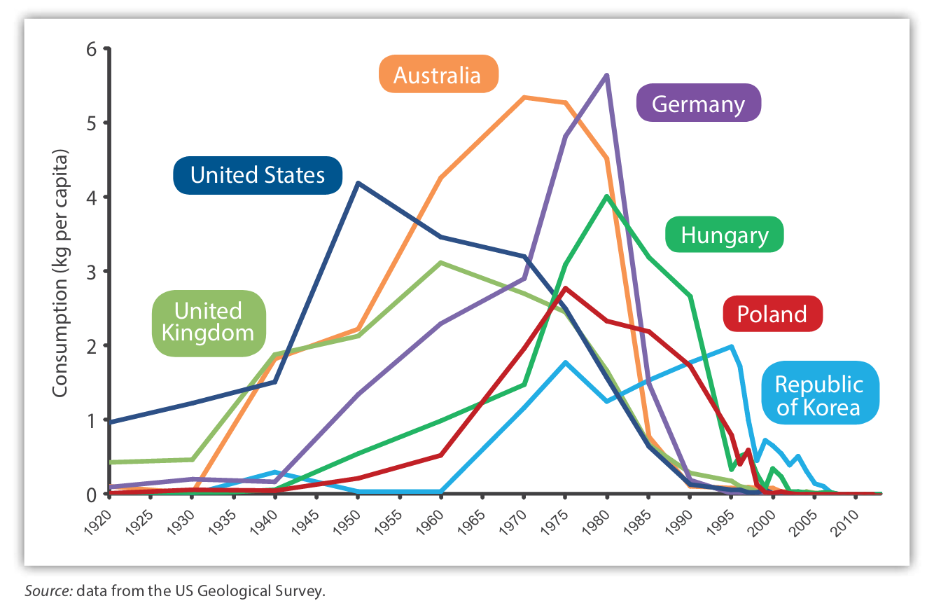

Global asbestos consumption per capita 1920-2013. (WHO 2016)

In epidemiological studies the death rate from asbestosis and prevalence of signs and symptoms from it are both higher in cigarette smokers than non-smokers.[144] In mouse studies cigarette smoke and asbestos exposure increase the production of reactive oxygen species that are thought to be important in the pathogenesis of asbestosis.[148] I found evidence supporting an interaction between ever smoking and ever having a high or medium risk asbestos exposure job, OR 4.6 (95%CI 1.5-14, p=0.01) when stratifying for genotype, see Table 6.23. It is known that the minor allele of the MUC5b promoter variant, the strongest IPF risk factor, is associated with markedly increased MUC5b expression and that MUC5b is a dominant constituent of the honeycomb cysts that characterise IPF.[16] It is also known that asbestos exposure activates the NLRP3 inflammasome and results in increased IL-1 release (as does smoking), and that IL-1 release is a potent stimulus for increased MUC5b expression.[19][135][149][131] This would add to the accumulating evidence for a MUC5b driven pulmonary fibrosis endotype.

There is a precedent for the importance of genetic susceptibility in the development of disease in response to asbestiform fibre inhalation; specifically germline BAP1 mutations were discovered to be important together with erionite exposure in the Cappadocia mesothelioma epidemic.[150][151] It is possible that there are unmeasured genetic modifiers of asbestos exposure risk the presence, or absence, of which is necessary for the development of disease.

Seven previous IPF case-control studies that reported on occupational asbestos exposure found no significant association.[30][46][33][34][36][37][44] Five of these studies used population controls[30][46][33][34][37] Where participation rates were reported for community controls they were generally low, for example one study which mailed a questionnaire to potential participants had a response rate of 32.4% for controls.[33] In another study using a mailed questionnaire 60% of controls returned a completed questionnaire.[30] Controls for one of the studies were recruited from orthopaedics practice list.[33] This may be undesirable as the sole source of controls in a study of occupational exposures since, for example, dust exposed manual workers might be over-represented because they have more orthopaedic problems, or under-represented because they lack healthcare access, introducing bias. Two studies recruited respiratory inpatients.[36][44] One study did not match cases and controls on age or sex[36], and another matched on age but not sex.[37] Four studies[30][33][36][37] relied solely on questionnaires for exposure assessment; these asked directly about exposures, for example ‘‘In your work, have you ever been exposed to y?’’[37] Only two studies reported blinding of assessors.[34][44] None of the studies were pre-registered. None of these studies attempted to quantify asbestos exposure or looked at gene-environment or environment-environment interactions. Collectively these studies were at high risk for bias arising from selection, lack of blinding, exposure misclassification, incomplete exposure data, and selective reporting of exposures. These studies were included in a recent meta-analysis reporting on occupational exposures in IPF that found significant associations occupational metal, wood, and stone dust exposures.[26] The possibility of asbestos co-exposure confounding the observed association with metal and wood dust is intriguing; carpenters and metalplate workers, who have significant wood and metal dust exposure are known to be high risk groups for pleural mesothelioma, a disease almost entirely attributable to occupational asbestos exposure.[152][50]

There is accumulating evidence for a MUC5B driven endotype of pulmonary fibrosis in ILD. The common MUC5b promoter variant rs35705950 is the strongest identified genetic risk factor for IPF; minor allele frequency > 0.1 in Caucasian populations, OR 4.84 (95%CI 4.37-5.36, p=1.1810-203) in a recent genome wide association study (GWAS) meta-analysis (total 2,668 IPF cases and 8,591 controls).[153] Its main effect is to increase airway expression of a distal airway glycopeptide called MUC5b (>30-fold).[17] MUC5b is a dominant constituent of the honeycomb cysts that characterise IPF[16] and it has recently emerged that rs3505950 is also a risk factor for asbestosis[18], chronic hypersensitivity pneumonitis, and rheumatoid arthritis associated ILD.[113] As outlined above asbestos (and silica) exposure results in production of IL-1 via the NLRP3 inflammasome; smoking also increases airway IL-1 levels, and IL-1 is known to be a key proinflammatory cytokine in IPF and a potent stimulus for MUC5b expression.[131][19][154] Genetic variants in the NLRP3 inflammasome (e.g rs35829419) have been found to be associated asbestosis[155] and coal workers pneumoconiosis[156], and are likely to be important mediators of IPF risk due to inhaled particles. Of note, the lungs can also be an initiating site of rheumatoid arthritis.[157] Occupational exposure to respirable crystalline silica is associated with an increased risk of rheumatoid arthritis in men[158], and rheumatoid arthritis associated ILD (which causes UIP) is more common in men despite rheumatoid arthritis being more common in women.[159] Genetic variants in the NLRP3 inflammasome (e.g rs35829419) have been found to be associated with increased risks of rheumatoid arthritis.[160]

One limitation of my study is that I lack comprehensive data on participation rates. Recruiting centres were provided with screening logs and asked to report monthly the number of eligible participants identified, approached, and recruited. For the centres that did provide monthly data (N=3) participation rates were high; fewer than 5% of participants approached declined to enroll in the study with no significant difference between cases and controls. After enrollment 22 of 516 cases(4%), and 45 of 511 controls(9%) were withdrawn because they no longer wished to take part in the study, did not respond after we called them on three occasions, or died before the interview took place. This gives an overall participation rate of approximately 91% for cases and 86% for controls. However, recruitment was poor at several centres; this is likely to mean that many eligible participants were not invited to participate due to, for example, research staff shortages. Another limitation of my study is that some of the control participants may have had undiagnosed interstitial lung disease. Incidental interstitial lung abnormalities are increasingly recognised as a common feature on CT of the lung in older individuals, occurring in 4-9% of smokers and 2-7% of non-smokers.[161] Many interstitial lung abnormalities may be described as having an indeterminate for UIP pattern[162] compatible with a diagnosis of IPF[163] (or asbestosis) which would impair the ability of IPFJES to find exposure-disease associations.

My study has several strengths in comparison to previous case-control studies that have investigated occupational asbestos exposure in IPF. I assessed occupational asbestos exposure in 466 male participants, the largest previous study assessed 149 male participants[34], and I surpassed the recruitment target required for adequate power. Risk of selection bias was minimised through the use of hospital controls and randomly sampling outpatient clinics. Assessors were blinded to case-status during the asbestos exposure assessment process and study design and pre-specified analyses were registered on clincialtrial.gov (NCT03211507). Participants were genotyped for MUC5b promoter variant rs3505950 and two validated means of assessing asbestos exposure were used to permit quantitative and semi-quantitative analysis, and allow assessment for gene-environment and environment-environment interaction.

There is now a need to make use of modern techniques such as Mendelian randomisation (MR) within a population of IPF patients with well characterised occupational exposures. MR is a technique that uses randomly distributed genetic variants as natural experiments to provide evidence about putative causal relations between modifiable risk factors and disease.[164] Through its use of genetic variance it can overcome problems of confounding and reverse causality. MR can be used within a case-control study design to help triangulate suspected causal associations.[165] It could be usefully applied to IPFJES, or similar case-control study data, to investigate interactions between occupational silica and asbestos exposure, smoking, and NLRP3 inflammasome variants, with respect to IPF risk, in order to better understand the aetiology of IPF and potentially identify new therapeutic targets. See Figures 6.9[154] and 6.10.

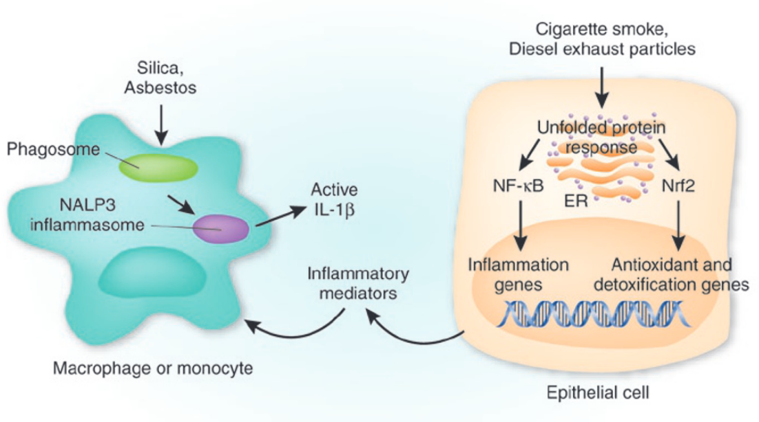

Proposed pathway for particulate-induced lung inflammation and IL-1 production. (Adair-Kirk 2008)

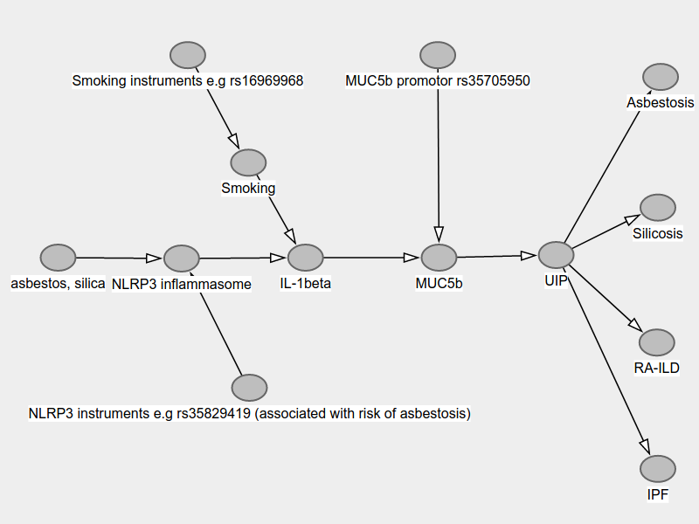

Proposed pathway for particulate-induced NLRP3, IL-1 mediated MUC5b driven pulmonary fibrosis endotype.

## Conclusion

The majority of men in their 70s in the UK who attend hospital have held a high or medium risk for asbestos exposure job during their working lifetime; estimated asbestos exposure based on validated means inferred by job title or historic asbestos exposure reconstruction methods does not significantly affect risk of IPF. Nonetheless, about 8% of IPF cases have a history of heavy occupational asbestos exposure (>25 fibre-ml.years) that would support a diagnosis of asbestosis based on the Helsinki criteria. Asbestos exposure alone does not appear to be an important cause of IPF. However, asbestos exposure does appear to interact with smoking and the minor allele of the MUC5b promoter variant rs35705950 to increase IPF risk and this effect is larger when analysis is limited to cases with definite UIP. Asbestos exposure also appears to be associated with MRC dyspnoea in my study and this association is independent of case and smoking status.

# Conclusion

## Thesis summary

This thesis presents the findings of an analysis of UK mortality trends for IPF and asbestos related disease, a review of previous occupational case-control studies of IPF that have investigated occupational exposures in IPF, a review of historic asbestos exposure assessment methods, a review of the IPF genetic susceptibility factor MUC5b promoter region SNP rs35705950, and the idiopathic pulmonary fibrosis job exposures study (IPFJES).

IPF mortality and asbestos related disease are strongly, if ecologically, correlated and there are several *prima facie* reasons to suppose that occupational asbestos exposure is an under-recognised cause of IPF, namely: it is more common in men and manual workers, it has been associated with occupational metal, wood, and stone dust exposures in several previous studies, and heavy asbestos fibre burdens have been identified in the lung tissue of IPF patients in a small case series.

Historic asbestos exposure assessment is challenging because of a paucity of historic data and variable biopersistence and in vitro modification of asbestos fibres. Among the best current validated means are assessment based on job title and the use of known job title related pleural mesothelioma risk as a proxy, and historic exposure reconstruction using source receptor models that provide validated estimates of cumulative asbestos exposure.

The MUC5b promoter region SNP rs357950 is the strongest identified risk factor for IPF. It is associated with higher levels of distal airway MUC5b and is thought to mediate disease by reduced airway clearance and through interaction with airway microbiota.

IPFJES, a large multicentre hospital based case-control study of occupational exposures in IPF, demonstrates that the majority of men in the UK have at least one high or medium risk for asbestos exposure job during their lifetime and about 8% have heavy (25 fibre-ml.year) asbestos exposure, that this is not significantly associated with IPF risk, and that this association is not modified by rs357950 genotype. IPFJES finds a significant association between occupational asbestos exposure and dyspnoea which is independent of case and smoking status. IPFJES finds a significant interaction between occupational asbestos exposure and smoking which increases risk of IPF, is more marked in patients with definite UIP, and appears to require a minor allele of the MUC5b promoter variant rs357950.

## Future work

I plan to investigate my current hypothesis that occupational asbestos and respirable crystalline silica induced activation of the NLRP3 inflammasome causes IPF via IL-1 stimulated MUC5b hypersecretion in smokers. I will do this by assessing silica exposure in IPFJES through well validated quantitative means and genotyping the IPFJES cohort for SNPs in the NLRP3 inflammasome associated with enhanced IL-1 release. I will also carry out two-sample mendelian randomisation studies of risk factors in IPF (to isolate the NLRP3 inflammasome) including smoking, gastro-oesophageal reflux disease, iron status, and cytokine profiles in IPF using existing IPF GWAS data and exposure GWAS data.[153][166][167][168][169]

# Epilogue

## IPFJES in context, radiological UIP with a history of occupational asbestos exposure: IPF, asbestosis, and 25 fibre/ml.years

### Introduction

Diagnostic criteria for IPF and asbestosis can be difficult to apply in patients with a history of radiological UIP and occupational asbestos exposure. Here I briefly review how IPF and asbestosis are diagnosed and how this has changed. Then I examine the history of ‘25 fibre-ml’ years in relation to asbestosis and appraise its utility in attributing UIP to asbestos in the context of the IPFJES findings.

### How IPF is diagnosed

Historically, that which is now called IPF has been otherwise known. For example, in 1971 cryptogenic fibrosing alveolitis (CFA) was defined by Turner-Warwick and Haslam[170] as applying to patients with:

1. no identifiable cause for lung fibrosis identified on the basis of detailed occupational and clinical history
2. widespread irregular shadowing on chest xray and widespread crackles on auscultation
3. if a biopsy was performed then histological features of alveolar fibrosis and the absence of granuloma or intra alveolar organisation or evidence of pneumoconiosis

Turner-Warwick[22] acknowledges potential difficulties in establishing attribution and causality in IPF. She observes that there is variation in clinical practice with respect to the standard applied to exclude IPF; some clinicians exclude IPF when exposure to a potential cause is identified, others only when there is clear exposure to an established cause.

As technologies such as high resolution computed tomography (HRCT) became widely available and our understanding of idiopathic interstitial pneumonias developed diagnostic nomenclature have been updated. Most significantly, in 2000, an international consensus definition of IPF as UIP on HRCT +/- biopsy in an idiopathic setting was reached. Wells 2018[171] provides a detailed discussion of the evolution of modern IPF nomenclature. The 2011 joint ERS/ATS guidelines[137], current at the initiation of IPFJES, state that the diagnosis of IPF requires:

1. exclusion of other known causes of ILD (e.g., domestic and occupational environmental exposures, connective tissue disease, and drug toxicity).
2. the presence of a UIP pattern on HRCT in patients not subjected to surgical lung biopsy
3. specific combinations of HRCT and surgical lung biopsy pattern in patients subjected to surgical lung biopsy

Surgical lung biopsy for the diagnosis of IPF has been much less frequently performed since it was shown to be unnecessary in the context of typical radiological and clinical findings[172] and to carry a significant mortality and morbidity risk.[173][174]

In the UK, National Institute for Clinical Excellence (NICE) clinical practice guidelines recommend that the diagnosis of IPF is made at a multidisciplinary team meeting which (minimally) includes a chest physician, a radiologist, and a histopathologist, with expertise in ILD. This approach resulted in moderate inter-rater agreement among UK physicians in a international case-cohort study, weighted kappa 0.61 (0.50-0.67), and good prognostic accuracy, median hazards ratio for death comparing IPF to non-IPF ILD was 2.76 (1.97-3.69).[175]

### How asbestosis is diagnosed

The first report of fibrosis of the lungs due to inhalation of asbestos dust[66] appeared in the British Medical Journal in 1924 and described the case of Nellie Kershaw, an English textile worker from who worked for Turner Brothers Asbestos spinning raw asbestos fibre into yarn. Kershaw died aged 33 years and was found to have extensive lung fibrosis and asbestos fibres at post mortem, having worked with asbestos textiles since age 13. The inquest into her death led to a parliamentary enquiry that formally acknowledged the existence of asbestosis and this in turn led to the introduction of asbestos industry regulations in 1931.[176]

Asbestos industry regulations included the provision of independent medical boards to diagnose asbestosis. By the 1960s asbestosis was diagnosed by medical boards based on a history of asbestos exposure from working in a “scheduled area”, part of an asbestos factory where a manufacturing process such as carding was carried out, plus two positive findings from the following:

1. the presence of basal rales
2. finger-clubbing
3. radiological appearances and pulmonary function studies

The medical boards have been subject to criticism for their conservatism, financial links to asbestos industry, and failure to protect workers.[177]

In 1963, a statement from the Committee on the Pneumoconiosis of the Council of on Occupational Health of the American Medical Association discusses asbestosis and suggests diagnosis should be, as with other pneumoconiosis, based on:

1. an appropriate occupational history; hazardous substance is present in patients work environment and they have been significantly exposed to it
2. abnormal roentgen shadows
3. compatible clinical picture (accepting that symptoms, for example progressive exertional dyspnoea, will rarely be distinctive enough to support diagnosis)

In 1986, a statement from the American Thoracic Society on the diagnosis of nonmalignant diseases related to asbestos[178] recommended that the term asbestosis should be reserved for interstitial fibrosis of the pulmonary parenchyma in which asbestos bodies or fibres may be demonstrated. However, they acknowledge that clinically the diagnosis of asbestosis must be made without the benefit of histological examination of lung tissue since lung biopsy is rarely indicated or carried out. They suggest that indirect methods of asbestos exposure must be used and that the diagnosis does not require any measurable impairment of lung function or physical disability to be present. Specific necessary clinical diagnostic criteria suggested are:

1. A reliable history of exposure
2. An appropriate time interval between exposure and detection

Optional additional criteria suggested are:

1. Chest roentgenographic evidence of type “s”, “t”, “u”, small irregular opacifications of profusion 1/1 or greater
2. A restrictive pattern of lung impairment with a forced vital capacity below the lower limit of normal
3. Bilateral late or pan inspiratory crackles at the posterior lung bases not cleared by cough

with a recommendation that emphasis be given to radiological findings.

In 1997 The International Expert Meeting on Asbestos, Asbestosis, and Cancer was convened in Helsinki to discuss asbestos related lung and pleural disorders and to agree diagnostic criteria.[179] They point out that neither asbestos associated clinical features nor architectural tissue abnormalities sufficiently differ from other causes of interstitial fibrosis to allow confident diagnosis without a history of significant asbestos exposure or the detection of asbestos fibres or bodies in the lung greatly in excess of that commonly seen in the general population. The 1997 guideline introduces cumulative occupational asbestos exposure of 25 fibre-ml years as the being associated with a 2-fold increase in lung cancer risk and the level at which clinical cases of asbestosis may occur.

The 1997 report[179] also recommends adoption of the Roggli-Pratt modification of the CAP-NIOSH system for the histological grading of asbestosis[180] and, in relation to histological grading, the 2014 update[67] cites 2010 diagnostic criteria from the Asbestosis Committee of the College of American Pathologists and Pulmonary Pathology Society.[181] These diagnostic criteria include discussion of a 25 fibre-ml years exposure threshold for diagnosis of asbestosis. The authors acknowledge that biopsy is seldom required but argue that when it is undertaken asbestos bodies are required for a histological diagnosis of asbestosis. The 2014 update[67] has been criticised for claiming that a confident diagnosis of asbestosis can not be made without the presence of a history of asbestos exposure or the presence of asbestos bodies. The inclusion of reference to a cumulative exposure 25 fibre-ml years is criticised both because of uncertainties about the evidence base for the threshold and because of concern that it is impractical for clinicians to implement, there not being a well established means to arrive at a fibre-ml year estimate. The requirement for demonstration of asbestos bodies is criticised because of known variability in the biopersistence of inhaled asbestos fibres and limitations of quantification methods.[70]

### Radiological UIP with a history of occupational asbestos exposure: IPF, asbestosis, and 25 fibre/ml.years

If one accepts that IPF is a diagnosis of exclusion and can only be made after alternative causes of lung fibrosis such as asbestosis are excluded then making a confident diagnosis of asbestosis becomes key. Writing in Thorax over 20 years ago Turner-Warwick[22] raised an important potential difficulty in IPF diagnosis. Specifically, that there is variation in clinical practice with respect to the standard applied to exclude IPF; some clinicians exclude IPF when exposure to a potential cause is identified, others only when there is clear exposure to an established cause.

Determining if asbestos exposure is a potential or established cause of an individual’s UIP is non-trivial. Successive asbestosis diagnosis guidelines have consistently recognised that the clinical features of and radiological findings in seen in asbestosis are insufficiently distinct from other causes of interstitial fibrosis to allow confident diagnosis without a history of significant asbestos exposure or the detection of asbestos fibres in the lung. They have also acknowledged both that individual genetic susceptibility factors are important determinants of disease risk, but these are not well characterised and not tested in routine clinical practice, and that it is seldom justified to obtain tissue biopsy for the purposes of asbestosis diagnosis. The result is that assessing whether a patient has a history of significant asbestos exposure becomes the key diagnostic criteria.

Logically, there are four prerequisites to assessing whether an individual patient has a history of significant (enough to cause fibrosis) asbestos exposure.

1. The relationship between asbestos exposure and asbestosis risk must be known, specifically how much exposure is required for how much risk?
2. A means of assessing the amount of asbestos exposure an individual patient has had
3. Knowledge of individual susceptibility factors and the magnitude of risk that they carry
4. An agreed level of risk for attributing fibrosis to asbestos exposure rather than calling it idiopathic or attributing it to another inhaled fibrogenic exposure e.g silica

Issues include unreliability of historic measurements and diagnoses, changed workplace exposure and demographic of potential cases, lack of good comparator group data to compare the exposure of cases against, and incomplete data on individual genetic susceptibility factors, particularly in relation to gene-environment interaction, severely limit the task.

The 1984 report of the Royal Commissionon on matters of health and safety arising from the use of asbestos in Ontario[182] suggests 25 fibre-ml years as a ‘best guess’ for the level of exposure below which fibrotic process cannot advance to the point of clinical manifestation based on previous studies.

However the report also admits significant the limitations of studies of asbestos exposure and asbestosis incidence including instruments used to measure ambient exposure, duration of follow up, and measurement of co-exposures such as silica or smoking. And recognises the importance of host susceptibility:

“We recognize that among some cohorts studied, even workers in the lower cumulative exposure categories have died as a result of asbestosis. We recognize too that variations in susceptibility among individuals make it difficult to have any confidence in a no-effect or threshold level.”

It is interesting to consider whether in such a circumstance (of lower levels of asbestos exposure in the population) host susceptibility factors become more important. IPFJES data appear to support this. The majority of individuals with UIP in IPFJES do not have ‘heavy’, defined as greater than 25 fibre-ml years, asbestos exposure, in line with progressive asbestos exposure regulation leading to a reduction in population asbestos exposure.

We find evidence of interaction between carriage of the minor allele of MUC5b rs35705950, smoking,and asbestos exposure, to increase risk of UIP. Furthermore, we find that the magnitude of this risk is greater for those with ‘heavy’ exposure. This has parallels with the Geofrey Roses’ prevention paradox; the majority of cases of disease come from a population at low or moderate risk of that disease, and only a minority of cases come from the high risk population (of the same disease) because the number of people at high risk is small.[183]

But what to do pragmatically with respect to diagnosis?

The approach taken potentially affects a large number of people. Interstitial lung abnormalities including UIP are increasingly recognised as a common feature on CT of the lung in older individuals, occurring in 4-9% of smokers and 2-7% of non-smokers.[161] Many interstitial lung abnormalities may be described as having an indeterminate for UIP pattern[162] compatible with a diagnosis of IPF[163] (or asbestosis).

IPFJES found the majority (over 60%) of cases, and controls, to have been ever exposed to asbestos, defined as ever having a job that was medium or high risk for asbestos exposure on the basis of proportional mortality data for pleural mesothlioma.[51]

It’s possible that genetic susceptibility factors are interacting with asbestos to cause UIP which, if known, might be properly called asbestosis. This appears to be the case with the minor allele of MUC5b rs35705950 and smoking in IPFJES. However, something other than asbestos might also be causing UIP, which, if it can’t be known, is properly called IPF. With no observable difference in rates of asbestos exposure between cases and controls, and no knowledge of individual susceptibility, diagnosing IPF seems the more parsimonious thing to do. Further study of potential genetic-asbestos interaction in patients with UIP is needed to fully understand the contribution asbestos makes to disease risk.

### Conclusion

IPF and asbestosis are hard to distinguish because there are frequently few or no distinguishing features clinically, including on the basis of an exposure history, or on CT, and a biopsy is not usually done. There is clear practice variation in the standard applied to exclude IPF; is identification of a potential cause sufficient or is clear exposure to an established cause necessary?

When the potential cause being considered is asbestos difficulties arise because it is difficult to quantify asbestos exposure (and relatedly to accurately diagnose asbestosis) so the relationship between asbestos exposure and risk of asbestosis is ill-defined, host susceptibility to asbestos is known to be important but gene-environment interactions are poorly characterised and patients are not usually genotyped, and there is not clear agreement on the level of risk asbestosis (and corresponding exposure) required for diagnosis.

One might argue that an individual with UIP who has any degree of asbestos exposure has asbestosis due to asbestos interacting with assumed host susceptibility factors. One might equally argue that an individual with UIP who has any degree of asbestos exposure does not have asbestosis because asbestos exposure alone does not appear to make any significant contribution to UIP at a population level for current levels of asbestos exposure and there is insufficient evidence for asbestos interaction with host susceptibility factors being an important contributor to UIP.

IPFJES tells us that a history of asbestos exposure alone does not increase risk of UIP but that in concert with smoking and genetic susceptibility factors it does increase risk, and the increase in risk is greater for more heavily exposed individuals. We are left to decide our thresholds for using the identification of asbestos as a potential cause of UIP in an individual as a reason to exclude IPF, and to diagnose asbestosis, with limited data.

# Appendix 1: IPFJES study documentation

[IPFJES study documentation](https://github.com/drcjar/ipfjes/)

# Appendix 2: IPF epidemiology code

[IPF epidemiology](https://github.com/drcjar/pypf)

python code for mortality analysis of IPF, asbestosis, and mesothelioma

**https://github.com/drcjar/pypf**

# Appendix 3: IPFJES meta-analysis code

[IPFJES study analysis code](https://github.com/drcjar/occ-burden-ipf-and-other-interstitial-pneumonia)

data and stata code for meta-analysis

**https://github.com/drcjar/occ-burden-ipf-and-other-interstitial-pneumonia**

# Appendix 4: IPFJES interview application code

[IPFJES interview application code](https://github.com/drcjar/ipfjes-interview/)

**https://github.com/drcjar/ipfjes-interview/**

# Appendix 5: IPFJES study website and analysis code

[IPFJES study analysis code](https://github.com/drcjar/ipfjes/tree/master/notebooks)

* diagrams.ipynb - script to generate diagrams for IPFJES study documentation
* genotyping_prep.ipynb - script to calculate relevant dilutions required from extracted dna concentration data in order to make working stock for genotyping
* genotype_cleaning.ipynb - genotype data cleaning
* male-meso-pmr-1991-2000.ipynb - script to analyse male mesothelioma proportional mortality rate data
* soc2000vol1extraction.ipynb - script to scrape SOC coding information from a PDF and make it machine readable

1. ipfjes-analysis-quality.ipynb - script to check quality of recorded IPFJES-interview data
2. ipfjes-analysis-centre-stats.ipynb - script to generate centre level statistics
3. ipfjes-analysis-centre-stats-detailed.ipynb - script to generate detailed centre level statistics
4. ipfjes-analysis-gp-letter.ipynb - script to automatically generate letters to be printed out and mailed to GPs to inform them of their patients participation
5. ipfjes-analysis-cpms.ipynb - script to automatically generate required study data upload for the NIHR The Central Portfolio Management System (CPMS)
6. ipfjes-analysis - 1.ipynb - main analysis script, data preparation and analysis at job task level, job level, participant level
7. ipfjes-analysis - 2.ipynb - logistic regressions
8. ipfjes-analysis - 3.ipynb - logistic regressions (gene-environment interactions)
9. ipfjes-analysis - 4.ipynb - regression coefficient plots
10. ipfjes-analysis2.ipynb - regression diagnostics

**https://github.com/drcjar/ipfjes/tree/master/notebooks**

[IPFJES website code](https://github.com/drcjar/ipfjes/tree/master/notebooks)

**https://github.com/drcjar/ipfjes/tree/gh-pages**

Website

**www.ipfjes.org**

# References

1 Navaratnam V, Fleming K, West J *et al.* The rising incidence of idiopathic pulmonary fibrosis in the uk. *Thorax* 2011;**66**:462–7.

2 Navaratnam V, Hubbard RB. The mortality burden of idiopathic pulmonary fibrosis in the united kingdom. *American journal of respiratory and critical care medicine* 2019;**200**:256–8. doi:[10.1164/rccm.201902-0467LE](https://doi.org/10.1164/rccm.201902-0467LE)

3 Maher TM. Idiopathic pulmonary fibrosis: Pathobiology of novel approaches to treatment. *Clin Chest Med* 2012;**33**:69–83. doi:[10.1016/j.ccm.2011.11.002](https://doi.org/10.1016/j.ccm.2011.11.002)

4 Ley B, Collard HR. Epidemiology of idiopathic pulmonary fibrosis. *Clinical epidemiology* 2013;**5**:483.

5 Spagnolo P, Grunewald J, Bois RM du. Genetic determinants of pulmonary fibrosis: Evolving concepts. *The Lancet Respiratory Medicine* 2014;**2**:416–28.

6 Hutchinson JP, McKeever TM, Fogarty AW *et al.* Increasing global mortality from idiopathic pulmonary fibrosis in the twenty-first century. *Annals of the American Thoracic Society* 2014;**11**:1176–85. doi:[10.1513/AnnalsATS.201404-145OC](https://doi.org/10.1513/AnnalsATS.201404-145OC)

7 Hubbard R, Johnston I, Britton J. Survival in patients with cryptogenic fibrosing alveolitis a population-based cohort study. *CHEST Journal* 1998;**113**:396–400.

8 Vancheri C, Failla M, Crimi N *et al.* Idiopathic pulmonary fibrosis: A disease with similarities and links to cancer biology. *Eur Respir J* 2010;**35**:496–504. doi:[10.1183/09031936.00077309](https://doi.org/10.1183/09031936.00077309)

9 Barber C, Wiggans R, Young C *et al.* UK asbestos imports and mortality due to idiopathic pulmonary fibrosis. *Occup Med* 2015;kqv142.

10 Corrin B, Dewar A, Rodriguez-Roisin R *et al.* Fine structural changes in cryptogenic fibrosing alveolitis and asbestosis. *The Journal of pathology* 1985;**147**:107–19. doi:[10.1002/path.1711470206](https://doi.org/10.1002/path.1711470206)

11 Copley SJ, Wells AU, Sivakumaran P *et al.* Asbestosis and idiopathic pulmonary fibrosis: Comparison of thin-section ct features. *Radiology* 2003;**229**:731–6. doi:[10.1148/radiol.2293020668](https://doi.org/10.1148/radiol.2293020668)

12 Monso E, Tura JM, Marsal M *et al.* Mineralogical microanalysis of idiopathic pulmonary fibrosis. *Arch Environ Health* 1990;**45**:185–8. doi:[10.1080/00039896.1990.9936714](https://doi.org/10.1080/00039896.1990.9936714)

13 Monsó E, Tura J, Pujadas J *et al.* Lung dust content in idiopathic pulmonary fibrosis: A study with scanning electron microscopy and energy dispersive x ray analysis. *Br J Ind Med* 1991;**48**:327–31.

14 Glazer C, Maier L. Occupational interstitial lung disease. *Eur Respir Monograph* 2009;**46**:265–86.

15 Ghio A, Sangani R, Roggli V. Expanding the spectrum of particle-and fiber-associated interstitial lung diseases. *Turk Toraks Derg* 2014;**15**:1–8.

16 Seibold MA, Smith RW, Urbanek C *et al.* The idiopathic pulmonary fibrosis honeycomb cyst contains a mucocilary pseudostratified epithelium. *PloS one* 2013;**8**:e58658. doi:[10.1371/journal.pone.0058658](https://doi.org/10.1371/journal.pone.0058658)

17 Evans CM, Fingerlin TE, Schwarz MI *et al.* Idiopathic pulmonary fibrosis: A genetic disease that involves mucociliary dysfunction of the peripheral airways. *Physiological reviews* 2016;**96**:1567–91. doi:[10.1152/physrev.00004.2016](https://doi.org/10.1152/physrev.00004.2016)

18 Platenburg MGJP, Wiertz IA, Vis JJ van der *et al.* The muc5b promotor risk allele for idiopathic pulmonary fibrosis predisposes to asbestosis. *The European respiratory journal* Published Online First: January 2020. doi:[10.1183/13993003.02361-2019](https://doi.org/10.1183/13993003.02361-2019)

19 Dostert C, Pétrilli V, Van Bruggen R *et al.* Innate immune activation through nalp3 inflammasome sensing of asbestos and silica. *Science (New York, NY)* 2008;**320**:674–7. doi:[10.1126/science.1156995](https://doi.org/10.1126/science.1156995)

20 Travis WD, Costabel U, Hansell DM *et al.* An official american thoracic society/european respiratory society statement: Update of the international multidisciplinary classification of the idiopathic interstitial pneumonias. *American journal of respiratory and critical care medicine* 2013;**188**:733–48.

21 Reynolds CJ, Blanc PD. Organising pneumonia and other uncommon interstitial disorders. In: *Parkes’ occupational lung disorders, fourth edition*. 2018.

22 Turner-Warwick M. In search of a cause of cryptogenic fibrosing alveolitis (cfa): One initiating factor or many? *Thorax* 1998;**53**:S3–9.

23 Hubbard R. Occupational dust exposure and the aetiology of cryptogenic fibrosing alveolitis. *Eur Respir J* 2001;**18**:119s–21s.

24 Taskar VS, Coultas DB. Is idiopathic pulmonary fibrosis an environmental disease? *Proc Am Thorac Soc* 2006;**3**:293–8.

25 Gulati M, Redlich CA. Asbestosis and environmental causes of usual interstitial pneumonia. *Current opinion in pulmonary medicine* 2015;**21**:193–200. doi:[10.1097/MCP.0000000000000144](https://doi.org/10.1097/MCP.0000000000000144)

26 Blanc PD, Annesi-Maesano I, Balmes JR *et al.* The occupational burden of nonmalignant respiratory diseases. An official american thoracic society and european respiratory society statement. *American journal of respiratory and critical care medicine* 2019;**199**:1312–34. doi:[10.1164/rccm.201904-0717ST](https://doi.org/10.1164/rccm.201904-0717ST)

27 Fontaine J-F, Barbosa-Silva A, Schaefer M *et al.* MedlineRanker: Flexible ranking of biomedical literature. *Nucleic acids research* 2009;**37**:W141–6. doi:[10.1093/nar/gkp353](https://doi.org/10.1093/nar/gkp353)

28 Reynolds C, De Matteis S, Cullinan P *et al.* Pubmed mining for occupational idiopathic pulmonary fibrosis papers. *European Respiratory Journal* 2017;**50**. doi:[10.1183/1393003.congress-2017.PA406](https://doi.org/10.1183/1393003.congress-2017.PA406)

29 Pega F, Norris SL, Backes C *et al.* RoB-speo: A tool for assessing risk of bias in studies estimating the prevalence of exposure to occupational risk factors from the who/ilo joint estimates of the work-related burden of disease and injury. *Environment international* 2020;**135**:105039. doi:[10.1016/j.envint.2019.105039](https://doi.org/10.1016/j.envint.2019.105039)

30 Scott J, Johnston I, Britton J. What causes cryptogenic fibrosing alveolitis? A case-control study of environmental exposure to dust. *BMJ* 1990;**301**:1015.

31 Iwai K, Mori T, Yamada N *et al.* Idiopathic pulmonary fibrosis. Epidemiologic approaches to occupational exposure. *Am J Respir Crit Care Med* 1994;**150**:670–5. doi:[10.1164/ajrccm.150.3.8087336](https://doi.org/10.1164/ajrccm.150.3.8087336)

32 Hubbard R, Lewis S, Richards K *et al.* Occupational exposure to metal or wood dust and aetiology of cryptogenic fibrosing alveolitis. *The Lancet* 1996;**347**:284–9.

33 Mullen J, Hodgson MJ, DeGraff CA *et al.* Case-control study of idiopathic pulmonary fibrosis and environmental exposures. *J Occup Environ Med* 1998;**40**:363–7.

34 Baumgartner KB, Samet JM, Coultas DB *et al.* Occupational and environmental risk factors for idiopathic pulmonary fibrosis: A multicenter case-control study. Collaborating centers. *Am J Epidemiol* 2000;**152**:307–15.

35 Hubbard R, Cooper M, Antoniak M *et al.* Risk of cryptogenic fibrosing alveolitis in metal workers. *The Lancet* 2000;**355**:466–7.

36 Miyake Y, Sasaki S, Yokoyama T *et al.* Occupational and environmental factors and idiopathic pulmonary fibrosis in japan. *The Annals of occupational hygiene* 2005;**49**:259–65. doi:[10.1093/annhyg/meh090](https://doi.org/10.1093/annhyg/meh090)

37 Gustafson T, Dahlman-Höglund A, Nilsson K *et al.* Occupational exposure and severe pulmonary fibrosis. *Respir Med* 2007;**101**:2207–12.

38 Pinheiro GA, Antao VC, Wood JM *et al.* Occupational risks for idiopathic pulmonary fibrosis mortality in the united states. *Int J Occup Environ Health* 2008;**14**:117–23.

39 García-Sancho Figueroa MC, Carrillo G, Pérez-Padilla R *et al.* Risk factors for idiopathic pulmonary fibrosis in a mexican population. A case-control study. *Respir Med* 2010;**104**:305–9.

40 García-Sancho C, Buendía-Roldán I, Fernández-Plata MR *et al.* Familial pulmonary fibrosis is the strongest risk factor for idiopathic pulmonary fibrosis. *Respiratory medicine* 2011;**105**:1902–7. doi:[10.1016/j.rmed.2011.08.022](https://doi.org/10.1016/j.rmed.2011.08.022)

41 Awadalla NJ, Hegazy A, Elmetwally RA *et al.* Occupational and environmental risk factors for idiopathic pulmonary fibrosis in egypt: A multicenter case-control study. *Int J Occup Environ Med* 2012;**3**:107–16.

42 Paolocci G, Nicolic V, Folletti I *et al.* Risk factors for idiopathic pulmonary fibrosis in southern europe: A case-control study. 2013.

43 Ekstrom M, Gustafson T, Boman K *et al.* Effects of smoking, gender and occupational exposure on the risk of severe pulmonary fibrosis: A population-based case-control study. *BMJ open* 2014;**4**:e004018.

44 Koo J-W, Myong J-P, Yoon H-K *et al.* Occupational exposure and idiopathic pulmonary fibrosis: A multicentre case-control study in korea. *The international journal of tuberculosis and lung disease : the official journal of the International Union against Tuberculosis and Lung Disease* 2017;**21**:107–12. doi:[10.5588/ijtld.16.0167](https://doi.org/10.5588/ijtld.16.0167)

45 Paolocci G, Folletti I, Torén K *et al.* Occupational risk factors for idiopathic pulmonary fibrosis in southern europe: A case-control study. *BMC pulmonary medicine* 2018;**18**:75. doi:[10.1186/s12890-018-0644-2](https://doi.org/10.1186/s12890-018-0644-2)

46 Hubbard R, Johnston I, Coultas DB *et al.* Mortality rates from cryptogenic fibrosing alveolitis in seven countries. *Thorax* 1996;**51**:711–6.

47 Deeks JJ, Higgins JP, Altman DG *et al.* Analysing data and undertaking meta-analyses. *Cochrane handbook for systematic reviews of interventions* 2019;241–84.

48 Caminati A, Madotto F, Cesana G *et al.* Epidemiological studies in idiopathic pulmonary fibrosis: Pitfalls in methodologies and data interpretation. *European respiratory review : an official journal of the European Respiratory Society* 2015;**24**:436–44. doi:[10.1183/16000617.0040-2015](https://doi.org/10.1183/16000617.0040-2015)

49 Welch LS, Michaels D, Zoloth SR. The national sheet metal worker asbestos disease screening program: Radiologic findings. National sheet metal examination group. *Am J Ind Med* 1994;**25**:635–48.

50 Rake C, Gilham C, Hatch J *et al.* Occupational, domestic and environmental mesothelioma risks in the british population: A case-control study. *Br J Cancer* 2009;**100**:1175–83. doi:[10.1038/sj.bjc.6604879](https://doi.org/10.1038/sj.bjc.6604879)

51 Peto J, Rake C, Gilham C *et al.* Occupational, domestic and environmental mesothelioma risks in britain: A case-control study. *Health and Safety Executive: Norwich, UK* 2009.

52 Van Rossum G, Drake Jr FL. *Python reference manual*. Centrum voor Wiskunde en Informatica Amsterdam 1995.

53 Virtanen P, Gommers R, Oliphant TE *et al.* SciPy 1.0: Fundamental Algorithms for Scientific Computing in Python. *Nature Methods* Published Online First: 2020. doi:[https://doi.org/10.1038/s41592-019-0686-2](https://doi.org/https://doi.org/10.1038/s41592-019-0686-2)

54 Seabold S, Perktold J. Statsmodels: Econometric and statistical modeling with python. In: *9th python in science conference*. 2010.

55 Darnton A, Hodgson J, Benson P *et al.* Mortality from asbestosis and mesothelioma in britain by birth cohort. *Occup Med* 2012;**62**:549–52.

56 Olson AL, Swigris JJ, Lezotte DC *et al.* Mortality from pulmonary fibrosis increased in the united states from 1992 to 2003. *American journal of respiratory and critical care medicine* 2007;**176**:277–84. doi:[10.1164/rccm.200701-044OC](https://doi.org/10.1164/rccm.200701-044OC)

57 Gribbin J, Hubbard RB, Le Jeune I *et al.* Incidence and mortality of idiopathic pulmonary fibrosis and sarcoidosis in the uk. *Thorax* 2006;**61**:980–5. doi:[10.1136/thx.2006.062836](https://doi.org/10.1136/thx.2006.062836)

58 Beard E, Brown J, West R *et al.* Healthier central england or north-south divide? Analysis of national survey data on smoking and high-risk drinking. *BMJ open* 2017;**7**:e014210. doi:[10.1136/bmjopen-2016-014210](https://doi.org/10.1136/bmjopen-2016-014210)

59 Wells AU. The revised ATS/ERS/JRS/ALAT diagnostic criteria for idiopathic pulmonary fibrosis (IPF)-practical implications. *Respir Res* 2013;**14**:S2.

60 Mossman BT, Lippmann M, Hesterberg TW *et al.* Pulmonary endpoints (lung carcinomas and asbestosis) following inhalation exposure to asbestos. *Journal of Toxicology and Environmental Health, Part B* 2011;**14**:76–121.

61 De Vuyst P, Karjalainen A, Dumortier P *et al.* Guidelines for mineral fibre analyses in biological samples: Report of the ers working group. European respiratory society. *The European respiratory journal* 1998;**11**:1416–26.

62 Cherrie JW, Schneider T. Validation of a new method for structured subjective assessment of past concentrations. *Ann Occup Hyg* 1999;**43**:235–45.

63 Imbernon E, Goldberg M, Bonenfant S *et al.* Occupational respiratory cancer and exposure to asbestos: A case-control study in a cohort of workers in the electricity and gas industry. *American journal of industrial medicine* 1995;**28**:339–52. doi:[10.1002/ajim.4700280304](https://doi.org/10.1002/ajim.4700280304)

64 Burdorf A, Swuste P. An expert system for the evaluation of historical asbestos exposure as diagnostic criterion in asbestos-related diseases. *The Annals of occupational hygiene* 1999;**43**:57–66.

65 Nemery B, Nuyts V, Nackaerts K. Quantifying asbestos in lung tissue: What debate? *The European respiratory journal* 2017;**49**. doi:[10.1183/13993003.00861-2017](https://doi.org/10.1183/13993003.00861-2017)

66 Cooke WE. FIBROSIS of the lungs due to the inhalation of asbestos dust. *British medical journal* 1924;**2**:147–140.2.

67 Wolff H, Vehmas T, Oksa P *et al.* Asbestos, asbestosis, and cancer, the helsinki criteria for diagnosis and attribution 2014: Recommendations. *Scandinavian journal of work, environment & health* 2015;**41**:5–15. doi:[10.5271/sjweh.3462](https://doi.org/10.5271/sjweh.3462)

68 Williamson L. Guidelines on autopsy practice industrial/occupational-related lung disease deaths including asbestos june 2017. 2017.

69 Hammar SP, Abraham JL. Commentary on pathologic diagnosis of asbestosis and critique of the 2010 asbestosis committee of the college of american pathologists (cap) and pulmonary pathology society’s (pps) update on the diagnostic criteria for pathologic asbestosis. *American journal of industrial medicine* 2015;**58**:1034–9. doi:[10.1002/ajim.22512](https://doi.org/10.1002/ajim.22512)

70 Baur X, Frank AL, Budnik LT *et al.* Collegium ramazzini: Comments on the 2014 helsinki consensus report on asbestos. *American journal of industrial medicine* 2016;**59**:591–4. doi:[10.1002/ajim.22595](https://doi.org/10.1002/ajim.22595)

71 Baur X, Woitowitz H-J, Budnik LT *et al.* Asbestos, asbestosis, and cancer: The helsinki criteria for diagnosis and attribution. Critical need for revision of the 2014 update. *American journal of industrial medicine* 2017;**60**:411–21. doi:[10.1002/ajim.22709](https://doi.org/10.1002/ajim.22709)

72 Gilham C, Rake C, Burdett G *et al.* Pleural mesothelioma and lung cancer risks in relation to occupational history and asbestos lung burden. *Occupational and environmental medicine* 2016;**73**:290–9. doi:[10.1136/oemed-2015-103074](https://doi.org/10.1136/oemed-2015-103074)

73 Gilham C, Rake C, Hodgson J *et al.* Past and current asbestos exposure and future mesothelioma risks in britain: The inhaled particles study (tips). *International Journal of Epidemiology* 2018.

74 Nuyts V, Vanhooren H, Begyn S *et al.* Asbestos bodies in bronchoalveolar lavage in the 21st century: A time-trend analysis in a clinical population. *Occupational and environmental medicine* 2017;**74**:59–65. doi:[10.1136/oemed-2016-103710](https://doi.org/10.1136/oemed-2016-103710)

75 Burns D, Beaumont P. The hse national exposure database—(nedb). *The Annals of occupational hygiene* 1989;**33**:1–14.

76 Orlowski E, Audignon-Durand S, Goldberg M *et al.* EV@LUTIL: An open access database on occupational exposures to asbestos and man-made mineral fibres. *American journal of industrial medicine* 2015;**58**:1059–74. doi:[10.1002/ajim.22498](https://doi.org/10.1002/ajim.22498)

77 Peto J. Problems in dose response and risk assessment: The example of asbestos. In: *Epidemiology and quantitation of environmental risk in humans from radiation and other agents*. Springer 1985. 175–85.

78 Toxic Substances A for, (ATSDR). DR. Agency for toxic substances and disease registry (atsdr). 2001. Toxicological profile for asbestos. U.S. Department of Health; Human Services, Public Health Service. 2001. <https://www.atsdr.cdc.gov/toxprofiles/TP.asp?id=30&tid=4#bookmark16>

79 Smith TJ, Hammond SK, Hallock M *et al.* Exposure assessment for epidemiology: Characteristics of exposure. *Applied Occupational and Environmental Hygiene* 1991;**6**:441–7.

80 Sahmel J, Devlin K, Paustenbach D *et al.* The role of exposure reconstruction in occupational human health risk assessment: Current methods and a recommended framework. *Critical reviews in toxicology* 2010;**40**:799–843. doi:[10.3109/10408444.2010.501052](https://doi.org/10.3109/10408444.2010.501052)

81 Blake CL, Dotson GS, Harbison RD. Assessment of airborne asbestos exposure during the servicing and handling of automobile asbestos-containing gaskets. *Regulatory toxicology and pharmacology : RTP* 2006;**45**:214–22. doi:[10.1016/j.yrtph.2006.04.007](https://doi.org/10.1016/j.yrtph.2006.04.007)

82 Williams PRD, Phelka AD, Paustenbach DJ. A review of historical exposures to asbestos among skilled craftsmen (1940-2006). *Journal of toxicology and environmental health Part B, Critical reviews* 2007;**10**:319–77. doi:[10.1080/10937400601034191](https://doi.org/10.1080/10937400601034191)

83 Pannett B, Coggon D, Acheson ED. A job-exposure matrix for use in population based studies in england and wales. *British journal of industrial medicine* 1985;**42**:777–83.

84 Peters S, Vermeulen R, Cassidy A *et al.* Comparison of exposure assessment methods for occupational carcinogens in a multi-centre lung cancer case-control study. *Occupational and environmental medicine* 2011;**68**:148–53. doi:[10.1136/oem.2010.055608](https://doi.org/10.1136/oem.2010.055608)

85 Offermans NSM, Vermeulen R, Burdorf A *et al.* Comparison of expert and job-exposure matrix-based retrospective exposure assessment of occupational carcinogens in the netherlands cohort study. *Occupational and environmental medicine* 2012;**69**:745–51. doi:[10.1136/oemed-2011-100556](https://doi.org/10.1136/oemed-2011-100556)

86 Kauppinen T, Toikkanen J, Pukkala E. From cross-tabulations to multipurpose exposure information systems: A new job-exposure matrix. *American journal of industrial medicine* 1998;**33**:409–17.

87 Offermans NSM, Vermeulen R, Burdorf A *et al.* Occupational asbestos exposure and risk of pleural mesothelioma, lung cancer, and laryngeal cancer in the prospective netherlands cohort study. *Journal of occupational and environmental medicine* 2014;**56**:6–19. doi:[10.1097/JOM.0000000000000060](https://doi.org/10.1097/JOM.0000000000000060)

88 Oyen SC van, Peters S, Alfonso H *et al.* Development of a job-exposure matrix (asbjem) to estimate occupational exposure to asbestos in australia. *The Annals of occupational hygiene* 2015;**59**:737–48. doi:[10.1093/annhyg/mev017](https://doi.org/10.1093/annhyg/mev017)

89 Peters S, Vermeulen R, Portengen L *et al.* SYN-jem: A quantitative job-exposure matrix for five lung carcinogens. *The Annals of occupational hygiene* 2016;**60**:795–811. doi:[10.1093/annhyg/mew034](https://doi.org/10.1093/annhyg/mew034)

90 Cherrie JW, McElvenny D, Blyth KG. Estimating past inhalation exposure to asbestos: A tool for risk attribution and disease screening. *International journal of hygiene and environmental health* 2018;**221**:27–32. doi:[10.1016/j.ijheh.2017.09.013](https://doi.org/10.1016/j.ijheh.2017.09.013)

91 Ahrens W, Jöckel KH, Brochard P *et al.* Retrospective assessment of asbestos exposure–i. Case-control analysis in a study of lung cancer: Efficiency of job-specific questionnaires and job exposure matrices. *International journal of epidemiology* 1993;**22 Suppl 2**:S83–95.

92 Teschke K, Olshan AF, Daniels JL *et al.* Occupational exposure assessment in case-control studies: Opportunities for improvement. *Occup Environ Med* 2002;**59**:575–93; discussion 594.

93 Gramond C, Rolland P, Lacourt A *et al.* Choice of rating method for assessing occupational asbestos exposure: Study for compensation purposes in france. *Am J Ind Med* 2012;**55**:440–9. doi:[10.1002/ajim.22008](https://doi.org/10.1002/ajim.22008)

94 Orlowski E, Pohlabeln H, Berrino F *et al.* Retrospective assessment of asbestos exposure–ii. At the job level: Complementarity of job-specific questionnaire and job exposure matrices. *International journal of epidemiology* 1993;**22 Suppl 2**:S96–105.

95 Tielemans E, Schneider T, Goede H *et al.* Conceptual model for assessment of inhalation exposure: Defining modifying factors. *The Annals of occupational hygiene* 2008;**52**:577–86. doi:[10.1093/annhyg/men059](https://doi.org/10.1093/annhyg/men059)

96 Rödelsperger K, Jöckel KH, Pohlabeln H *et al.* Asbestos and man-made vitreous fibers as risk factors for diffuse malignant mesothelioma: Results from a german hospital-based case-control study. *American journal of industrial medicine* 2001;**39**:262–75.

97 Symanski E, Maberti S, Chan W. A meta-analytic approach for characterizing the within-worker and between-worker sources of variation in occupational exposure. *The Annals of occupational hygiene* 2006;**50**:343–57. doi:[10.1093/annhyg/mel006](https://doi.org/10.1093/annhyg/mel006)

98 Cherrie JW. The effect of room size and general ventilation on the relationship between near and far-field concentrations. *Applied occupational and environmental hygiene* 1999;**14**:539–46. doi:[10.1080/104732299302530](https://doi.org/10.1080/104732299302530)

99 Teschke K, Smith JC, Olshan AF. Evidence of recall bias in volunteered vs. Prompted responses about occupational exposures. *American journal of industrial medicine* 2000;**38**:385–8.

100 Burstyn I. The ghost of methods past: Exposure assessment versus job-exposure matrix studies. *Occup Environ Med* 2011;**68**:2–3. doi:[10.1136/oem.2009.054585](https://doi.org/10.1136/oem.2009.054585)

101 Bakshani CR, Morales-Garcia AL, Althaus M *et al.* Evolutionary conservation of the antimicrobial function of mucus: A first defence against infection. *NPJ biofilms and microbiomes* 2018;**4**:14. doi:[10.1038/s41522-018-0057-2](https://doi.org/10.1038/s41522-018-0057-2)

102 Dubaissi E, Rousseau K, Hughes GW *et al.* Functional characterization of the mucus barrier on the , javax.xml.bind.JAXBElement@55345ef3, skin surface. *Proceedings of the National Academy of Sciences of the United States of America* 2018;**115**:726–31. doi:[10.1073/pnas.1713539115](https://doi.org/10.1073/pnas.1713539115)

103 Kufe DW. Mucins in cancer: Function, prognosis and therapy. *Nature reviews Cancer* 2009;**9**:874–85. doi:[10.1038/nrc2761](https://doi.org/10.1038/nrc2761)

104 Linden SK, Sutton P, Karlsson NG *et al.* Mucins in the mucosal barrier to infection. *Mucosal immunology* 2008;**1**:183–97. doi:[10.1038/mi.2008.5](https://doi.org/10.1038/mi.2008.5)

105 Jaramillo AM, Azzegagh Z, Tuvim MJ *et al.* Airway mucin secretion. *Annals of the American Thoracic Society* 2018;**15**:S164–70. doi:[10.1513/AnnalsATS.201806-371AW](https://doi.org/10.1513/AnnalsATS.201806-371AW)

106 Boucher RC. Muco-obstructive lung diseases. *The New England journal of medicine* 2019;**380**:1941–53. doi:[10.1056/NEJMra1813799](https://doi.org/10.1056/NEJMra1813799)

107 Fahy JV, Dickey BF. Airway mucus function and dysfunction. *The New England journal of medicine* 2010;**363**:2233–47. doi:[10.1056/NEJMra0910061](https://doi.org/10.1056/NEJMra0910061)

108 Dickey BF, Whitsett JA. Understanding interstitial lung disease: It’s in the mucus. *American journal of respiratory cell and molecular biology* 2017;**57**:12–4. doi:[10.1165/rcmb.2017-0116ED](https://doi.org/10.1165/rcmb.2017-0116ED)

109 Kesimer M, Ford AA, Ceppe A *et al.* Airway mucin concentration as a marker of chronic bronchitis. *The New England journal of medicine* 2017;**377**:911–22. doi:[10.1056/NEJMoa1701632](https://doi.org/10.1056/NEJMoa1701632)

110 Helling BA, Gerber AN, Kadiyala V *et al.* Regulation of muc5b expression in idiopathic pulmonary fibrosis. *American journal of respiratory cell and molecular biology* 2017;**57**:91–9. doi:[10.1165/rcmb.2017-0046OC](https://doi.org/10.1165/rcmb.2017-0046OC)

111 Fingerlin TE, Murphy E, Zhang W *et al.* Genome-wide association study identifies multiple susceptibility loci for pulmonary fibrosis. *Nat Genet* 2013;**45**:613–20. doi:[10.1038/ng.2609](https://doi.org/10.1038/ng.2609)

112 Selman M, Pardo A, Barrera L *et al.* Gene expression profiles distinguish idiopathic pulmonary fibrosis from hypersensitivity pneumonitis. *American journal of respiratory and critical care medicine* 2006;**173**:188–98. doi:[10.1164/rccm.200504-644OC](https://doi.org/10.1164/rccm.200504-644OC)

113 Namba N, Kawasaki A, Sada K-E *et al.* Association of muc5b promoter polymorphism with interstitial lung disease in myeloperoxidase-antineutrophil cytoplasmic antibody-associated vasculitis. *Annals of the rheumatic diseases* 2019;**78**:1144–6. doi:[10.1136/annrheumdis-2018-214263](https://doi.org/10.1136/annrheumdis-2018-214263)

114 Adegunsoye A, Vij R, Noth I. Integrating genomics into management of fibrotic interstitial lung disease. *Chest* 2019;**155**:1026–40. doi:[10.1016/j.chest.2018.12.011](https://doi.org/10.1016/j.chest.2018.12.011)

115 Roy MG, Livraghi-Butrico A, Fletcher AA *et al.* Muc5b is required for airway defence. *Nature* 2014;**505**:412–6. doi:[10.1038/nature12807](https://doi.org/10.1038/nature12807)

116 Hancock LA, Hennessy CE, Solomon GM *et al.* Muc5b overexpression causes mucociliary dysfunction and enhances lung fibrosis in mice. *Nature communications* 2018;**9**:5363. doi:[10.1038/s41467-018-07768-9](https://doi.org/10.1038/s41467-018-07768-9)

117 O’Dwyer DN, Ashley SL, Gurczynski SJ *et al.* Lung microbiota contribute to pulmonary inflammation and disease progression in pulmonary fibrosis. *American journal of respiratory and critical care medicine* 2019;**199**:1127–38. doi:[10.1164/rccm.201809-1650OC](https://doi.org/10.1164/rccm.201809-1650OC)

118 Yang D, Chen X, Wang J *et al.* Dysregulated lung commensal bacteria drive interleukin-17B production to promote pulmonary fibrosis through their outer membrane vesicles. *Immunity* 2019;**50**:692–706.e7. doi:[10.1016/j.immuni.2019.02.001](https://doi.org/10.1016/j.immuni.2019.02.001)

119 Sherry ST, Ward MH, Kholodov M *et al.* DbSNP: The ncbi database of genetic variation. *Nucleic acids research* 2001;**29**:308–11. doi:[10.1093/nar/29.1.308](https://doi.org/10.1093/nar/29.1.308)

120 Molyneaux PL, Cox MJ, Willis-Owen SAG *et al.* The role of bacteria in the pathogenesis and progression of idiopathic pulmonary fibrosis. *American journal of respiratory and critical care medicine* 2014;**190**:906–13. doi:[10.1164/rccm.201403-0541OC](https://doi.org/10.1164/rccm.201403-0541OC)

121 Peljto AL, Zhang Y, Fingerlin TE *et al.* Association between the muc5b promoter polymorphism and survival in patients with idiopathic pulmonary fibrosis. *JAMA* 2013;**309**:2232–9.

122 Ash SY, Harmouche R, Putman RK *et al.* Association between acute respiratory disease events and the , javax.xml.bind.JAXBElement@24470b74, promoter polymorphism in smokers. *Thorax* 2018;**73**:1071–4. doi:[10.1136/thoraxjnl-2017-211208](https://doi.org/10.1136/thoraxjnl-2017-211208)

123 Dudbridge F, Allen RJ, Sheehan NA *et al.* Adjustment for index event bias in genome-wide association studies of subsequent events. *Nature communications* 2019;**10**:1561. doi:[10.1038/s41467-019-09381-w](https://doi.org/10.1038/s41467-019-09381-w)

124 Hunninghake GM, Hatabu H, Okajima Y *et al.* MUC5B promoter polymorphism and interstitial lung abnormalities. *The New England journal of medicine* 2013;**368**:2192–200. doi:[10.1056/NEJMoa1216076](https://doi.org/10.1056/NEJMoa1216076)

125 Warheit-Niemi HI, Hult EM, Moore BB. A pathologic two-way street: How innate immunity impacts lung fibrosis and fibrosis impacts lung immunity. *Clinical & translational immunology* 2019;**8**:e1065. doi:[10.1002/cti2.1065](https://doi.org/10.1002/cti2.1065)

126 Shulgina L, Cahn AP, Chilvers ER *et al.* Treating idiopathic pulmonary fibrosis with the addition of co-trimoxazole: A randomised controlled trial. *Thorax* 2013;**68**:155–62. doi:[10.1136/thoraxjnl-2012-202403](https://doi.org/10.1136/thoraxjnl-2012-202403)

127 Noth I, Zhang Y, Ma S-F *et al.* Genetic variants associated with idiopathic pulmonary fibrosis susceptibility and mortality: A genome-wide association study. *The Lancet Respiratory medicine* 2013;**1**:309–17. doi:[10.1016/S2213-2600(13)70045-6](https://doi.org/10.1016/S2213-2600(13)70045-6)

128 Marshall DC, Salciccioli JD, Shea BS *et al.* Trends in mortality from idiopathic pulmonary fibrosis in the european union: An observational study of the who mortality database from 2001-2013. *The European respiratory journal* 2018;**51**. doi:[10.1183/13993003.01603-2017](https://doi.org/10.1183/13993003.01603-2017)

129 Byrne AJ, Maher TM, Lloyd CM. Pulmonary macrophages: A new therapeutic pathway in fibrosing lung disease? *Trends in molecular medicine* 2016;**22**:303–16. doi:[10.1016/j.molmed.2016.02.004](https://doi.org/10.1016/j.molmed.2016.02.004)

130 Howrylak JA, Nakahira K. Inflammasomes: Key mediators of lung immunity. *Annual review of physiology* 2017;**79**:471–94. doi:[10.1146/annurev-physiol-021115-105229](https://doi.org/10.1146/annurev-physiol-021115-105229)

131 Kuschner WG, D’Alessandro A, Wong H *et al.* Dose-dependent cigarette smoking-related inflammatory responses in healthy adults. *The European respiratory journal* 1996;**9**:1989–94. doi:[10.1183/09031936.96.09101989](https://doi.org/10.1183/09031936.96.09101989)

132 Swanson KV, Deng M, Ting JP-Y. The nlrp3 inflammasome: Molecular activation and regulation to therapeutics. *Nature reviews Immunology* 2019;**19**:477–89. doi:[10.1038/s41577-019-0165-0](https://doi.org/10.1038/s41577-019-0165-0)

133 Lasithiotaki I, Giannarakis I, Tsitoura E *et al.* NLRP3 inflammasome expression in idiopathic pulmonary fibrosis and rheumatoid lung. *The European respiratory journal* 2016;**47**:910–8. doi:[10.1183/13993003.00564-2015](https://doi.org/10.1183/13993003.00564-2015)

134 Baumgartner KB, Samet JM, Stidley CA *et al.* Cigarette smoking: A risk factor for idiopathic pulmonary fibrosis. *Am J Respir Crit Care Med* 1997;**155**:242–8. doi:[10.1164/ajrccm.155.1.9001319](https://doi.org/10.1164/ajrccm.155.1.9001319)

135 Mossman BT, Churg A. Mechanisms in the pathogenesis of asbestosis and silicosis. *Am J Respir Crit Care Med* 1998;**157**:1666–80.

136 Stout-Delgado HW, Cho SJ, Chu SG *et al.* Age-dependent susceptibility to pulmonary fibrosis is associated with nlrp3 inflammasome activation. *American journal of respiratory cell and molecular biology* 2016;**55**:252–63. doi:[10.1165/rcmb.2015-0222OC](https://doi.org/10.1165/rcmb.2015-0222OC)

137 Raghu. An official ATS/ERS/JRS/ALAT statement: idiopathic pulmonary fibrosis: evidence-based guidelines for diagnosis and management, author=Raghu, Ganesh and Collard, Harold R and Egan, Jim J and Martinez, Fernando J and Behr, Juergen and Brown, Kevin K and Colby, Thomas V and Cordier, Jean-François and Flaherty, Kevin R and Lasky, Joseph A and others. *Am J Respir Crit Care Med* 2011;**183**:788–824.

138 Bonniaud P, Georges M, Favrolt N *et al.* [Drug-induced interstitial lung diseases]. *La Revue du praticien* 2014;**64**:951–6.

139 Wilken D, Velasco Garrido M, Manuwald U *et al.* Lung function in asbestos-exposed workers, a systematic review and meta-analysis. *Journal of occupational medicine and toxicology (London, England)* 2011;**6**:21. doi:[10.1186/1745-6673-6-21](https://doi.org/10.1186/1745-6673-6-21)

140 Brodkin CA, Barnhart S, Anderson G *et al.* Correlation between respiratory symptoms and pulmonary function in asbestos-exposed workers. *The American review of respiratory disease* 1993;**148**:32–7. doi:[10.1164/ajrccm/148.1.32](https://doi.org/10.1164/ajrccm/148.1.32)

141 Grønseth R, Vollmer WM, Hardie JA *et al.* Predictors of dyspnoea prevalence: Results from the bold study. *The European respiratory journal* 2014;**43**:1610–20. doi:[10.1183/09031936.00036813](https://doi.org/10.1183/09031936.00036813)

142 Stayner L, Smith R, Bailer J *et al.* Exposure-response analysis of risk of respiratory disease associated with occupational exposure to chrysotile asbestos. *Occupational and environmental medicine* 1997;**54**:646–52. doi:[10.1136/oem.54.9.646](https://doi.org/10.1136/oem.54.9.646)

143 Hein MJ, Stayner LT, Lehman E *et al.* Follow-up study of chrysotile textile workers: Cohort mortality and exposure-response. *Occupational and environmental medicine* 2007;**64**:616–25. doi:[10.1136/oem.2006.031005](https://doi.org/10.1136/oem.2006.031005)

144 Doll R, Peto J. *Effects on health of exposure to asbestos*. Health & Safety Commission 1985.

145 Harding A-H, Darnton AJ. Asbestosis and mesothelioma among british asbestos workers (1971-2005). *American journal of industrial medicine* 2010;**53**:1070–80. doi:[10.1002/ajim.20844](https://doi.org/10.1002/ajim.20844)

146 Health, Executive S. Asbestos related diseases in great britain, 2019. Health; Safety Executive 2019. <http://www.hse.gov.uk/statistics/causdis/asbestos-related-disease.pdf>

147 Allen L, Baez J, Stern M *et al.* Asbestos-economic assessment of bans and declining production and consumption. *World Health Organization Regional Office for Europe: Copenhagen, Denmark* 2017.

148 Liu G, Cheresh P, Kamp DW. Molecular basis of asbestos-induced lung disease. *Annual review of pathology* 2013;**8**:161.

149 Fujisawa T, Chang MM-J, Velichko S *et al.* NF- $κB$ mediates il-1 $β$- and il-17A-induced muc5b expression in airway epithelial cells. *American journal of respiratory cell and molecular biology* 2011;**45**:246–52. doi:[10.1165/rcmb.2009-0313OC](https://doi.org/10.1165/rcmb.2009-0313OC)

150 Testa JR, Cheung M, Pei J *et al.* Germline bap1 mutations predispose to malignant mesothelioma. *Nature genetics* 2011;**43**:1022–5. doi:[10.1038/ng.912](https://doi.org/10.1038/ng.912)

151 Emri SA. The cappadocia mesothelioma epidemic: Its influence in turkey and abroad. *Annals of translational medicine* 2017;**5**:239. doi:[10.21037/atm.2017.04.06](https://doi.org/10.21037/atm.2017.04.06)

152 McElvenny DM, Darnton AJ, Price MJ *et al.* Mesothelioma mortality in great britain from 1968 to 2001. *Occup Med (Lond)* 2005;**55**:79–87. doi:[10.1093/occmed/kqi034](https://doi.org/10.1093/occmed/kqi034)

153 Allen RJ, Guillen-Guio B, Oldham JM *et al.* Genome-wide association study of susceptibility to idiopathic pulmonary fibrosis. *American journal of respiratory and critical care medicine* Published Online First: November 2019. doi:[10.1164/rccm.201905-1017OC](https://doi.org/10.1164/rccm.201905-1017OC)

154 Adair-Kirk TL, Atkinson JJ, Senior RM. Smoke particulates stress lung cells. *Nature medicine* 2008;**14**:1024–5. doi:[10.1038/nm1008-1024](https://doi.org/10.1038/nm1008-1024)

155 Kukkonen MK, Vehmas T, Piirilä P *et al.* Genes involved in innate immunity associated with asbestos-related fibrotic changes. *Occupational and environmental medicine* 2014;**71**:48–54. doi:[10.1136/oemed-2013-101555](https://doi.org/10.1136/oemed-2013-101555)

156 Ji X, Hou Z, Wang T *et al.* Polymorphisms in inflammasome genes and risk of coal workers’ pneumoconiosis in a chinese population. *PloS one* 2012;**7**:e47949. doi:[10.1371/journal.pone.0047949](https://doi.org/10.1371/journal.pone.0047949)

157 Catrina AI, Joshua V, Klareskog L *et al.* Mechanisms involved in triggering rheumatoid arthritis. *Immunological reviews* 2016;**269**:162–74. doi:[10.1111/imr.12379](https://doi.org/10.1111/imr.12379)

158 Stolt P, Yahya A, Bengtsson C *et al.* Silica exposure among male current smokers is associated with a high risk of developing acpa-positive rheumatoid arthritis. *Annals of the rheumatic diseases* 2010;**69**:1072–6. doi:[10.1136/ard.2009.114694](https://doi.org/10.1136/ard.2009.114694)

159 Rosenman KD. Rheumatoid arthritis and pneumoconiosis. *American journal of respiratory and critical care medicine* 2012;**185**:1024; author reply 1025–1024; author reply 1026. doi:[10.1164/ajrccm.185.9.1024a](https://doi.org/10.1164/ajrccm.185.9.1024a)

160 Mathews RJ, Robinson JI, Battellino M *et al.* Evidence of nlrp3-inflammasome activation in rheumatoid arthritis (ra); genetic variants within the nlrp3-inflammasome complex in relation to susceptibility to ra and response to anti-tnf treatment. *Annals of the rheumatic diseases* 2014;**73**:1202–10. doi:[10.1136/annrheumdis-2013-203276](https://doi.org/10.1136/annrheumdis-2013-203276)

161 Hatabu H, Hunninghake GM, Richeldi L *et al.* Interstitial lung abnormalities detected incidentally on ct: A position paper from the fleischner society. *The Lancet Respiratory medicine* 2020;**8**:726–37. doi:[10.1016/S2213-2600(20)30168-5](https://doi.org/10.1016/S2213-2600(20)30168-5)

162 Hunninghake GM. Interstitial lung abnormalities: Erecting fences in the path towards advanced pulmonary fibrosis. *Thorax* 2019;**74**:506–11. doi:[10.1136/thoraxjnl-2018-212446](https://doi.org/10.1136/thoraxjnl-2018-212446)

163 Raghu G, Remy-Jardin M, Myers JL *et al.* Diagnosis of idiopathic pulmonary fibrosis. An official ats/ers/jrs/alat clinical practice guideline. *American journal of respiratory and critical care medicine* 2018;**198**:e44–68. doi:[10.1164/rccm.201807-1255ST](https://doi.org/10.1164/rccm.201807-1255ST)

164 Davies NM, Holmes MV, Davey Smith G. Reading mendelian randomisation studies: A guide, glossary, and checklist for clinicians. *BMJ (Clinical research ed)* 2018;**362**:k601. doi:[10.1136/bmj.k601](https://doi.org/10.1136/bmj.k601)

165 Lawlor DA, Tilling K, Davey Smith G. Triangulation in aetiological epidemiology. *International journal of epidemiology* 2016;**45**:1866–86. doi:[10.1093/ije/dyw314](https://doi.org/10.1093/ije/dyw314)

166 Wootton RE, Richmond RC, Stuijfzand BG *et al.* Evidence for causal effects of lifetime smoking on risk for depression and schizophrenia: A mendelian randomisation study. *Psychological medicine* 2019;1–9. doi:[10.1017/S0033291719002678](https://doi.org/10.1017/S0033291719002678)

167 An J, Gharahkhani P, Law MH *et al.* Gastroesophageal reflux gwas identifies risk loci that also associate with subsequent severe esophageal diseases. *Nature communications* 2019;**10**:4219. doi:[10.1038/s41467-019-11968-2](https://doi.org/10.1038/s41467-019-11968-2)

168 Gill D, Benyamin B, Moore LSP *et al.* Associations of genetically determined iron status across the phenome: A mendelian randomization study. *PLoS medicine* 2019;**16**:e1002833. doi:[10.1371/journal.pmed.1002833](https://doi.org/10.1371/journal.pmed.1002833)

169 Georgakis MK, Gill D, Rannikmäe K *et al.* Genetically determined levels of circulating cytokines and risk of stroke. *Circulation* 2019;**139**:256–68. doi:[10.1161/CIRCULATIONAHA.118.035905](https://doi.org/10.1161/CIRCULATIONAHA.118.035905)

170 Turner-Warwick M, Haslam P. Antibodies in some chronic fibrosing lung diseases. I. Non organ-specific autoantibodies. *Clinical allergy* 1971;**1**:83–95. doi:[10.1111/j.1365-2222.1971.tb02450.x](https://doi.org/10.1111/j.1365-2222.1971.tb02450.x)

171 Wells AU, Brown KK, Flaherty KR *et al.* What’s in a name? That which we call ipf, by any other name would act the same. *The European respiratory journal* 2018;**51**. doi:[10.1183/13993003.00692-2018](https://doi.org/10.1183/13993003.00692-2018)

172 Hunninghake GW, Zimmerman MB, Schwartz DA *et al.* Utility of a lung biopsy for the diagnosis of idiopathic pulmonary fibrosis. *American journal of respiratory and critical care medicine* 2001;**164**:193–6. doi:[10.1164/ajrccm.164.2.2101090](https://doi.org/10.1164/ajrccm.164.2.2101090)

173 Utz JP, Ryu JH, Douglas WW *et al.* High short-term mortality following lung biopsy for usual interstitial pneumonia. *The European respiratory journal* 2001;**17**:175–9. doi:[10.1183/09031936.01.17201750](https://doi.org/10.1183/09031936.01.17201750)

174 Lettieri CJ, Veerappan GR, Helman DL *et al.* Outcomes and safety of surgical lung biopsy for interstitial lung disease. *Chest* 2005;**127**:1600–5. doi:[10.1378/chest.127.5.1600](https://doi.org/10.1378/chest.127.5.1600)

175 Walsh SLF. Multidisciplinary evaluation of interstitial lung diseases: Current insights: Number 1 in the series "radiology" edited by nicola sverzellati and sujal desai. *European respiratory review : an official journal of the European Respiratory Society* 2017;**26**. doi:[10.1183/16000617.0002-2017](https://doi.org/10.1183/16000617.0002-2017)

176 Tweedale G. *Magic mineral to killer dust: Turner & newall and the asbestos hazard*. Oxford University Press 2000.

177 Tweedale G, Hansen P. Protecting the workers: The medical board and the asbestos industry, 1930s-1960s. *Medical history* 1998;**42**:439–57. doi:[10.1017/s0025727300064346](https://doi.org/10.1017/s0025727300064346)

178 Murphy RL, Becklake MR, Brooks SM *et al.* The diagnosis of nonmalignant diseases related to asbestos. *American Review of Respiratory Disease* 1986;**134**:363–8.

179 Tossavainen reporter A. Asbestos, asbestosis, and cancer: The helsinki criteria for diagnosis and attribution. *Scandinavian journal of work, environment & health* 1997;**23**:311–6.

180 Sporn TA, Roggli VL. Asbestosis. In: *Pathology of asbestos-associated diseases*. Springer 2004. 71–103.

181 Roggli VL, Gibbs AR, Attanoos R *et al.* Pathology of asbestosis- an update of the diagnostic criteria: Report of the asbestosis committee of the college of american pathologists and pulmonary pathology society. *Arch Pathol Lab Med* 2010;**134**:462–80. doi:[10.1043/1543-2165-134.3.462](https://doi.org/10.1043/1543-2165-134.3.462)

182 Dupré JS. *Report of the royal commission on matters of health and safety arising from the use of asbestos in ontario*. Ontario Ministry of the Attorney General 1984. <https://collections.ola.org/mon/25006/23505.pdf>

183 Rose G. Strategy of prevention: Lessons from cardiovascular disease. *British medical journal (Clinical research ed)* 1981;**282**:1847.